
-------------------------------------------------------------------------------------------------
ANATOMY RESEARCH DEVELOPMENT AWARD
------------------------------------------------------------------------------------------------------
Project Resume Form 2023/24
(1st October 2023 -30th September 2024)
at the start of the project for publicity

Brief Résumé of your Project for the Society’s Website:
The title of your project and a brief 200-250 word description of the project. The description should include sufficient detail to be of general interest to a broad readership including scientists and non-specialists. Please also try to include 1-2 graphical images (minimum 75dpi) of can be included on the site next to your abstract. Colourful, impressive graphics will further enhance the site.
NB: Authors should NOT include sensitive material or data that they do not want disclosed at this time.

Title: Darkest just before the dawn: the role of the calcified cartilage in osteoarthritis
Description
Osteoarthritis is a worldwide healthcare burden with no effective treatment currently available. The mechanism in which cartilage degrades must be elucidated in order to provide new therapeutic targets. The calcified cartilage of joints, sandwiched between the underlying bone and superficial non-calcified articular cartilage, is very much understudied in osteoarthritis research. The study of human articular cartilage is mostly restricted to imaging modalities and donated tissue that is typically very diseased. This project will examine the knee joints from a combination of two mouse models that both exhibit calcified cartilage pathology. STR/Ort mice, which spontaneously develop osteoarthritis, show larger calcified cartilage chondrocytes (hypertrophy) before osteoarthritis develops. In the rare metabolic disease alkaptonuria, early and severe osteoarthritis is caused by pigmentation of cartilage due to increased levels of homogentisic acid, which is observed as calcified cartilage chondrocyte pigmentation in alkaptonuric mice known as Hgd^{-/-}. How cartilage pigmentation causes severe degeneration in alkaptonuria is unknown. Here, we plan to study joints of mice that have both the STR/Ort and alkaptonuria phenotypes, by using a novel gene silencing approach. An alkaptonuria metabolic phenotype will be induced in STR/Ort mice by using silencing RNA targeted to homogentisate 1,2-dioxyegenase, which increases circulating homogentisic acid. The osteoarthritic and pigmentation phenotypes will be assessed histologically within the knee joints, to determine if tissue pre-disposed to osteoarthritis is more likely to pigment, and if pigmentation in turn worsens the severity of osteoarthritis.
[233 words]
Data Protection/GDPR: I consent to the data included in this submission being collected, processed, and stored by the Anatomical Society. Answer YES or NO in the Box below
Yes
Graphical Images: If you include graphical images you must obtain consent from people appearing in any photos and confirm that you have consent. A consent statement from you must accompany each report if relevant. A short narrative should accompany the image. Answer N/A not applicable, YES or NO in the box below
Yes
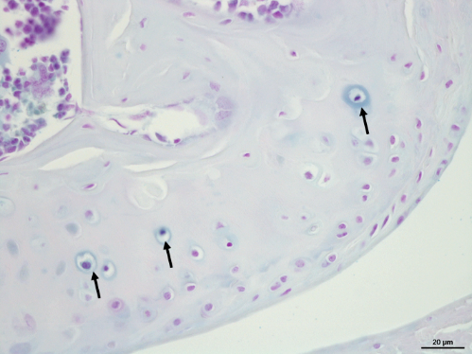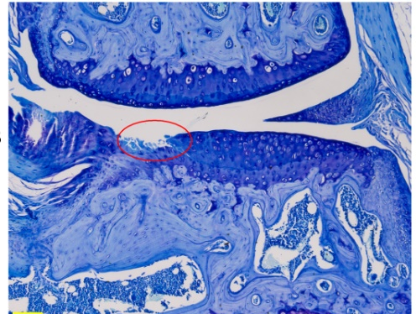
Ochronotic pigmentation of chondrons (arrows) within a femoral condyle in an alkaptonuria mouse (Hgd^{-/-}), identified with Schmorl’s stain (left). Osteoarthritic lesion (circle) in the tibial plateau of a STR/Ort mouse, stained with toluidine blue (right).

Copyright: If you submit images you must either own the copyright to the image or have gained the explicit permission of the copyright holder for the image to be submitted as part of the report for upload to the Society’s website, Newsletter, social media and so forth. A copyright statement must accompany each report if relevant. Answer N/A not applicable, YES or NO in the box below
Yes
SIGNATURE | Dr Juliette Hughes | DATE | 2/4/24

