
_______________________________________________________________________________________
AWARDEE REPORT FORM
_______________________________________________________________________________________

NAME |  | Joseph Gough
TWITTER HANDLE* optional
UNIVERSITY |  | Newcastle University
NAME OF AWARD |  | Barclay Smith Travelling Fund
PURPOSE OF AWARD conference/event attended/organised (full name) with city and dates.
Funding to attend winter meeting to present a poster developed from my research during the undergraduate summer vacation research studentship.
Anatomical Society Winter Meeting, Anglia Ruskin University, Chelmsford, 17th to 19th December 2025.

REPORT: What were your anticipated benefits?
Minimum number of words between 200-400. Please write in coherent paragraphs.
I was greatly looking forward to presenting the poster that I developed following my research as part of the Undergraduate Summer Vacation Studentship programme. I anticipated that sharing my results with likeminded individuals from the wide range of professions represented within the society would lead to engaging and insightful discussions. These conversations would not only allow me to receive valuable feedback on my work but also help me to refine my ideas and develop further plans for continuing research in this area.

In addition to presenting my own work, I was eager to attend the diverse programme of talks and to view the other posters on display. Listening to a wide array of speakers would expose me to different research approaches, methodologies, and perspectives, helping me to broaden my understanding of the field. Engaging with the work of others would also support the development of thoughtful questions, which would benefit not only my own future research but also encourage others to reflect on their work from a fresh and critical perspective.

Furthermore, attending my first academic conference was expected to significantly increase my confidence in presenting and discussing my research in a professional setting. The experience of communicating my findings to both peers and senior researchers would help me to improve my academic communication skills. Ultimately, this opportunity would make the progression to delivering oral presentations in the future feel more achievable and would represent an important milestone in my academic and professional development.

COMMENTS: Describe your experience at the conference / lab visit / course / seminar/ event.
Minimum number of words between 200-400. Please write in coherent paragraphs.
I had an amazing time at the Anatomical Society Winter Meeting 2025. I had the opportunity to get some refreshments before setting up my poster, and then the first session of talks commenced. Listening to the young investigator flash talks was eye opening. It was inspiring to be able to hear from people like me at the start of their careers, who have been conducting such interesting and valuable research.

The keynote talks were similarly fascinating to watch. To be able to learn from leaders in their fields about the cutting-edge research and technological developments taking place was a privilege. This is especially true, for speakers in areas that I was initially less familiar with. I have been able to take away from these talks, new ways of thinking about my own research, and ideas that I can share with others.

There was also an array of great booths from the sponsors of the event, giving me the ability to appreciate the commercial uses for anatomical research, and an understanding of how new technologies can be incorporated into teaching.

Finally, the Gala Dinner was a lovely way to round off the conference. A lovely evening of good food and company, allowing bridges to be built that I hope stand into the future.
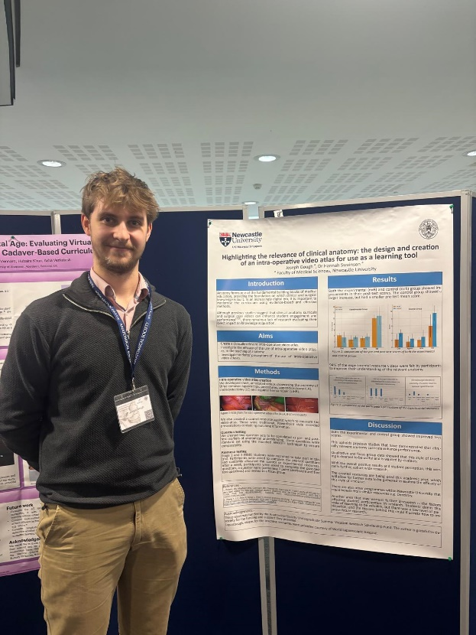
This is me stood with my poster in the conference foyer.

REPORT: In relation to skills, what were the most important things you gained? (does not apply to equipment grant. For public engagement/outreach awards what did your audience gain and how did you evaluate success?
Minimum number of words between 200-400. Please write in coherent paragraphs.
I have gained a new appreciation of how academic conferences are structured and how they function as spaces for professional discussion and knowledge exchange. The experience of being able to talk to a wide range of people about my own research has been invaluable, as it allowed me to explain my work clearly, respond to questions, and consider alternative perspectives. As a result of this experience, I now feel far more confident in my ability to participate in an oral presentation and to discuss my research in a formal academic setting.

In addition, I have developed a greater understanding of different methods used to undertake qualitative research. Several of the talks focused on research within education, and these sessions generated particularly interesting discussions about how researchers can gain meaningful insights not only from quantitative data, but also from the opinions, thoughts, and feelings of participants. This highlighted the importance of using qualitative approaches to capture the richness and complexity of human experience.

Finally, attending the conference has helped me to further develop my skills in critically reading, interpreting, and evaluating research. Being able to discuss findings directly with the researchers themselves strengthened my critical thinking and analytical skills and enhanced my ability to understand the wider implications of academic research.

REPORT: How do you think you will put this learning experience into practice in the future? For public engagement/outreach awards how with the materials/knowledge generated by this activity be used in the future?
Minimum number of words between 200-400. Please write in coherent paragraphs.
I am going to apply the knowledge and skills that I gained at this conference when further developing my current research projects, as well as when undertaking any new research in the future. In particular, I plan to take a more detailed and reflective approach when analysing qualitative data. By employing novel and engaging techniques that were discussed during the Winter Meeting, I will be better equipped to capture the depth and complexity of participants’ responses and to interpret their experiences in a more meaningful and rigorous way. This will strengthen the quality and impact of my research findings.

Furthermore, as a medical student, I was exposed to a range of new techniques and emerging technologies that have direct relevance to clinical practice. Learning about these advances has encouraged me to consider how research and innovation can be translated into improved patient care. When I qualify, I hope to incorporate these approaches into my own clinical practice in order to enhance decision-making, improve efficiency, and ultimately achieve better patient outcomes.

Finally, attending the conference allowed me to meet likeminded individuals with shared research interests. Building these professional relationships provides valuable opportunities to exchange ideas, seek feedback, and develop collaborative research projects. These connections will support the production of more well-rounded, robust, and innovative research in the future, while also contributing positively to my ongoing academic and professional development.

Data Protection/GDPR: I consent to the data included in this submission being collected, processed and stored by the Anatomical Society. Answer YES or NO in the Box below
YES
Graphical Images: If you include graphical images you must obtain consent from people appearing in any photos and confirm that you have consent. A consent statement from you must accompany each report if relevant. A short narrative should accompany the image. Answer N/A not applicable, YES or NO in the box below
YES
Copyright: If you submit images you must either own the copyright to the image or have gained the explicit permission of the copyright holder for the image to be submitted as part of the report for upload to the Society’s website, Newsletter, social media and so forth. A copyright statement must accompany each report if relevant. Answer N/A not applicable, YES or NO in the box below
Yes
SIGNATURE | J.Gough |  | DATE | 29/12/2025

