
_______________________________________________________________________________________
AWARDEE REPORT FORM
_______________________________________________________________________________________

NAME |  | Dr Phil Cox
TWITTER HANDLE* optional |  | I don’t use Twitter/X any more, but my bluesky handle is: @drphilcox.bsky.social
UNIVERSITY |  | UCL
NAME OF AWARD |  | Departmental seminar award
PURPOSE OF AWARD conference/event attended/organised (full name) with city and dates.
To cover the travel and accommodation of a keynote speaker, Dr Brandon Kilbourne at a one-day seminar on Functional Morphology, hosted by the Centre for Integrative Anatomy at University College London on 20 February 2025.

REPORT: What were your anticipated benefits?
Minimum number of words between 200-400. Please write in coherent paragraphs.
The benefit of inviting Dr Kilbourne to speak at our symposium was to enable us to round off the day with a presentation of high impact research from an established expert in the field of functional morphology. As most of our other speakers were early career researchers, we felt Dr Kilbourne’s keynote talk would be inspirational to them and provide a model for how their own careers could progress. In particular, many of the talks at our symposium were focused on the relationship between anatomy and locomotion, and Dr Kilbourne’s research relates directly to this field of study. Furthermore, we felt that including Dr Kilbourne in our list of presenters would provide an additional draw to encourage people to attend the symposium as it would give the opportunity not only to hear him speak, but also to interact with him during the breaks.

More broadly, we anticipated that the symposium would have the benefit of bringing together researchers in functional morphology, in particular facilitating cross-disciplinary networking between anatomists and engineers, thus stimulating new collaborations and research ideas. Additionally, we anticipated that the event would serve as an opportunity for early career researchers to gain presenting experience and to make themselves known to the academic community.

COMMENTS: Describe your experience at the conference / lab visit / course / seminar/ event.
Minimum number of words between 200-400. Please write in coherent paragraphs.
The UCL Centre for Integrative Anatomy Annual Symposium 2025 on interdisciplinary aspects of functional morphology was held in London on Thursday, 20 February. This full-day conference delved into the fascinating world of anatomy and morphology, particularly focusing on the inter-relationship between form and function. This in-person gathering provided ample opportunity to engage in discussions, attend insightful lectures, and participate in informal socialising and networking. It brought together 73 PIs, students and other researchers, and people simply curious about anatomy and its inter-relation with other fields including palaeontology, biomechanics, imaging, development and many others.

Speakers were predominantly in the early stages of their research career and gave 15-minute talks about their recent research. Our keynote speaker, funded by the Anatomical Society, was Dr Brandon Kilbourne from the Berlin Museum of Natural History who presented a summary of research over his career so far. Dr Kilbourne addresses questions relating to morphological diversity through major groups of terrestrial vertebrates, with a major focus on limb anatomy and locomotion in mammals.

Other speakers hailed from Cambridge, York, Liverpool, Manchester and London (including UCL, King’s College London, London South Bank University, the Royal Veterinary College and the Natural History Museum), and from further afield in Antwerp (Belgium) and Naturalis (Netherlands). They covered subjects concerning the masticatory apparatus, limbs, genitalia, brains, wings and bones, across a wide range of species including birds, lizards, snakes, humans and other primates, dogs, horses, and more.

The day was rounded off by many participants continuing their discussions in a local hostelry and a few remained chatting over dinner, later. With old contacts reinforced and new ones made, we are now all looking forward to next year’s symposium, which will be part of UCL’s 200-year anniversary celebrations.

REPORT: In relation to skills, what were the most important things you gained? (does not apply to equipment grant. For public engagement/outreach awards what did your audience gain and how did you evaluate success?
Minimum number of words between 200-400. Please write in coherent paragraphs.
The audience gained two major benefits from the symposium. Firstly, there was the direct transmission of knowledge and novel research findings imparted by the talks themselves. From discussions during and after the symposium, the general opinion amongst attendees was that the talks were of a high standard across the board, and that the breadth of topics and taxa covered made for a very interesting and engaging day that broadened perspectives. Secondly, the symposium also facilitated networking opportunities between researchers, including across disciplines: our delegates included researchers working in the fields of anatomy, palaeontology, anthropology, biomechanics, materials science, mechanical engineering and robotics. In the planning of the event, we were keen to include relatively long breaks to allow attendees to meet and talk to one another, and to provide lunch so that delegates would remain on-site rather than dispersing to nearby restaurants. This strategy worked well and post-symposium feedback has indicated that attendees very much appreciated the opportunity to meet and interact with their peers and forge new connections.

The event’s success was evaluated on direct comments to the organisers during the event and at the social afterwards which were very positive indeed. In the longer term, we will also evaluate success based on how many delegates return in future years. We had many returners from previous symposia this year, suggesting it is an enjoyable and valuable meeting.
REPORT: How do you think you will put this learning experience into practice in the future? For public engagement/outreach awards how with the materials/knowledge generated by this activity be used in the future?
Minimum number of words between 200-400. Please write in coherent paragraphs.
The Symposium on Functional Morphology, part funded by this Departmental Seminar Award, has enabled us to create a network of comparative anatomists with interests in function based in the UK and northwest Europe. It is our sincere hope that connections created at our symposium will lead to scientific collaborations and the generation of novel research findings. There is not a regular conference on functional morphology in the UK, so we have been aiming to fill that vacancy with our annual symposium. However, we are running it on an incredibly limited budget, so receiving funds from the Anatomical Society to enable us to invite an overseas keynote speaker has been transformative. As well as being a forum for sharing new research, the symposium also acts a networking event, particularly for early career researchers, and we hope that it helps them to progress their careers in the highly competitive academic job market. We very much intend to run this event again next year – indeed this was our fifth annual symposium. We have increased attendee numbers year on year, and aim to continue this trend. Next year is UCL’s 200th anniversary and so we are aiming to incorporate this in some way into the symposium, perhaps with a talk about the history of anatomy at UCL.

Data Protection/GDPR: I consent to the data included in this submission being collected, processed and stored by the Anatomical Society. Answer YES or NO in the Box below
YES

Graphical Images: If you include graphical images you must obtain consent from people appearing in any photos and confirm that you have consent. A consent statement from you must accompany each report if relevant. A short narrative should accompany the image. Answer N/A not applicable, YES or NO in the box below
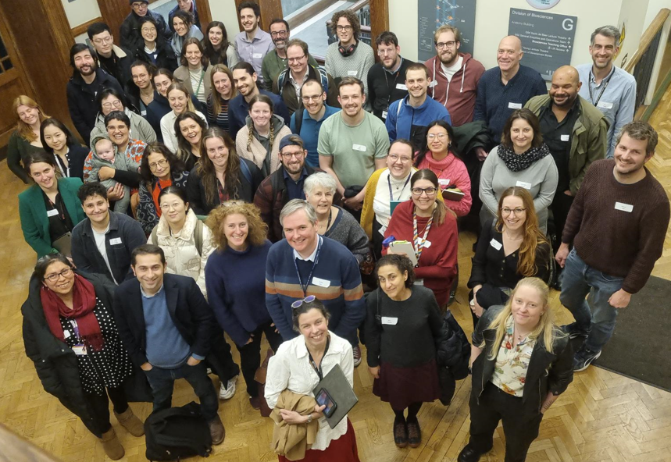
The attendees of the UCL Centre for Integrative Anatomy Symposium on Functional Morphology 2025. Keynote speaker Dr Brandon Kilbourne is at the back right in the green jacket.

Consent
YES, all delegates gave consent for their image to be used when they registered to attend the meeting.
Copyright: If you submit images you must either own the copyright to the image or have gained the explicit permission of the copyright holder for the image to be submitted as part of the report for upload to the Society’s website, Newsletter, social media and so forth. A copyright statement must accompany each report if relevant. Answer N/A not applicable, YES or NO in the box below
YES, I own the copyright to this image.

SIGNATURE | Philip Cox |  | DATE | 26.03.2025
If submitted electronically, a type-written name is acceptable in place of a hand-written signature
File: AS-Award-Report-Form-171023 – International Conference

