YEAR 2014/15
SUPERVISOR: PROFESSOR ANTHONY GRAHAM
STUDENT: MR TOBY ANDREWS
INSTITUTION: KING’S COLLEGE, LONDON
PROJECT TITLE: THE DEVELOPMENTAL BASIS OF BRANCHIAL ANOMALIES

Brief Resume of your Project’s outcomes for the Society’s Website: (no more than 200-250 words).
The title of your project and a brief 200-250 word description of the proposed/completed project. The description should include sufficient detail to be of general interest to a broad readership including scientists and non-specialists. Please also try to include 1-2 graphical images (minimum 75dpi). NB: Authors should NOT include sensitive material or data that they do not want disclosed at this time.

The Developmental Basis of Branchial Anomalies
A major event in early embryonic development is the posterior expansion of the second pharyngeal arch. In fish this results in formation of the operculum, which overlies the gills and acts as a valve. The operculum has been lost in terrestrial species, but in amniotes it persists as an embryonic structure that fuses posteriorly and defines the smooth contour of the adult neck. It is known that failure of this expansion can result in formation of pharyngeal cysts and persistent openings called branchial fistulae, both of which are found in human abnormalities including branchio-oto-renal and DiGeorge/22q11.2 deletion syndromes. This project has contributed to a more detailed understanding of the molecular mechanisms at play in second arch expansion, with consequent implications both for health and evolutionary biology.

We succeeded in further characterising the expression patterns of FGF8 and Sonic Hedgehog (SHH), two important developmental signalling molecules, and markers of pathway activation in the arch. This means we have located which cells are secreting these signals and which are responsive. In addition, we have established a robust protocol through which cross-talk between the pathways can be tested, where feedback between FGF8 and SHH contributes to important developmental networks elsewhere in the embryo – in the limb, the lungs and the external genitalia. Finally, we have also identified in the pharynx high levels of expression of genes known to be responsive to SHH in the limb. This research lays the ground for future work in which the action of each signal can be further defined, as can the clusters of cells secreting them.

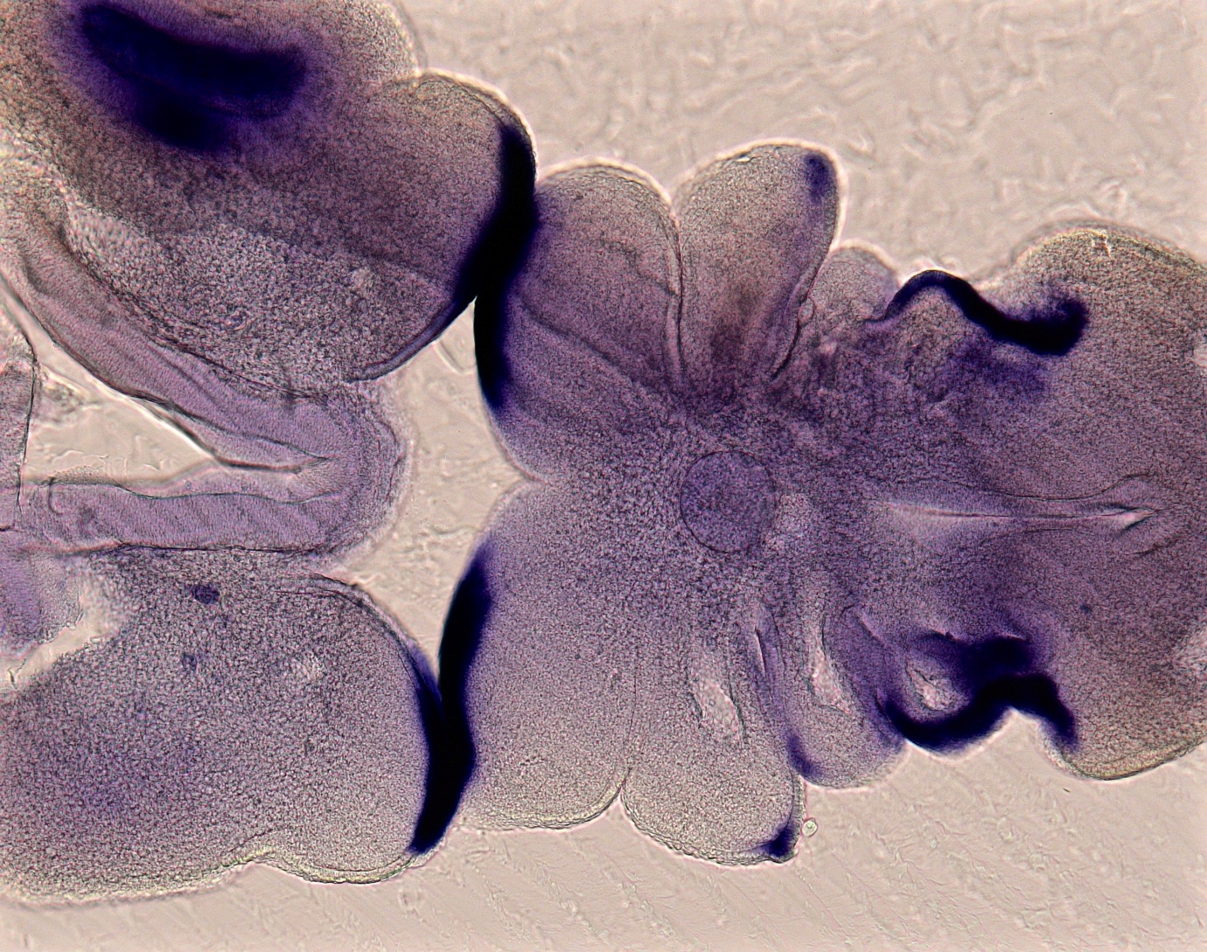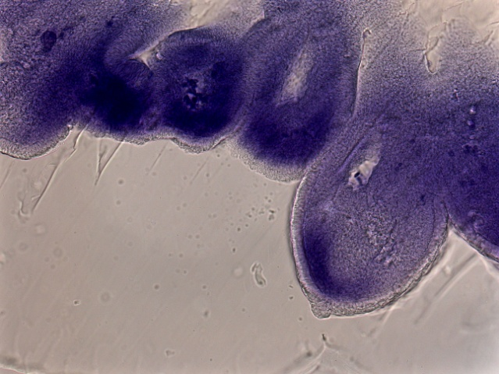

Expression of FGF8 (left) and Spr2 (right), a marker of FGF8 signalling, in the second pharyngeal arch. This shows that while FGF8 is expressed from cells in the ectodermal leading edge of the arch, the cells responding to the signal are located in the underlying mesenchymal core.

File: UGProjectOutcomes201415GrahamAndrews

