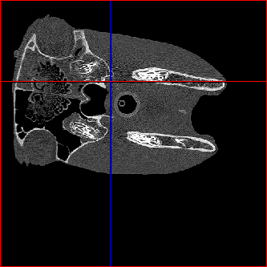
Ethmoid labyrinth
Left Mandible
Left guttural pouch
Right guttural pouch
Right Mandible
Larynx

After Cropping
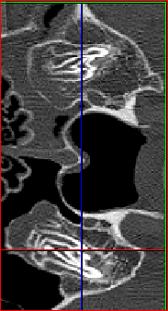
Rectus capitis ventralis
Stylohyoid
Right guttural pouch
Left guttural pouch

