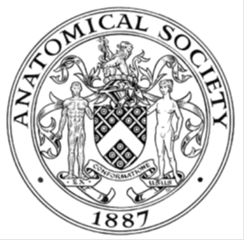
_______________________________________________________________________________________
AWARDEE REPORT FORM
_______________________________________________________________________________________

NAME |  | Dr. Alannah J Mortimer
TWITTER HANDLE* optional |  | @_AlannahM
UNIVERSITY |  | University of Edinburgh
NAME OF AWARD |  | Barclay Smith Award
PURPOSE OF AWARD conference/event attended/organised (full name) with city and dates.
Summer conference of the Anatomical Society in Bristol, 15th – 17th July 2026

REPORT: What were your anticipated benefits?
Minimum number of words between 200-400. Please write in coherent paragraphs.
Attending this conference was anticipated to provide an important opportunity to present my latest research to an international audience of experts in neuromuscular biology and musculoskeletal research. As I prepare this work for publication and develop upcoming fellowship applications, receiving critical feedback was expected to be invaluable. Constructive discussion around my findings would help refine my interpretation of the data, identify potential limitations, and ultimately strengthen the quality, rigour and impact of future manuscripts and grant proposals.

Presenting my work would provide an opportunity to increase the visibility of my research and my developing independent research profile. Sharing these findings with researchers working across complementary disciplines was anticipated to stimulate discussion, generate new ideas, and facilitate collaborations that could enhance future projects. Exposure to diverse perspectives and methodologies would also broaden my understanding of current advances and help identify opportunities to incorporate new approaches into my own work.

In addition, the conference was expected to support my professional development by strengthening my presentation and communication skills through the delivery of a poster presentation and engagement in scientific discussion. Building relationships with established and early-career researchers is particularly important at this stage of my career as I transition towards research independence. Developing these professional networks may lead to future collaborations, mentoring opportunities and partnerships that support my independent progression.

Overall, attendance was expected to support both my immediate research objectives and my longer-term career development as an independent investigator, while strengthening the competitiveness of future publications and fellowship applications.

COMMENTS: Describe your experience at the conference / lab visit / course / seminar/ event.
Minimum number of words between 200-400. Please write in coherent paragraphs.
The conference provided an excellent opportunity to engage with a diverse programme of presentations covering a broad range of topics in musculoskeletal anatomy. Exposure to research outside my immediate area of expertise provided insight into evolving concepts in musculoskeletal biology and highlighted how researchers from other specialities are applying innovative techniques that could be adapted to my own work. Attending these sessions broadened my perspective and identified methodological approaches that may be useful in future studies investigating neuromuscular junction function and repair.

Presenting my research generated considerable interest and led to constructive discussions with researchers at different career stages and from a range of complementary disciplines. These conversations provided valuable opportunities to explain my work to both specialists and non-specialists, helping me refine how I communicate complex scientific concepts to a broader audience. The questions and feedback I received encouraged me to consider alternative interpretations, identify areas where additional clarification would strengthen my delivery, and improve the overall presentation of my data.

The discussions also provided practical suggestions for future experiments and highlighted potential opportunities for collaboration with researchers working in related fields. Importantly, the experience increased my confidence in presenting my research, responding to scientific questions, and engaging in critical discussion. The feedback I received will directly inform the preparation of my manuscript and strengthen future fellowship applications. I was also able to ask other scientists and clinicians my own questions, improving my confidence in this aspect.

REPORT: In relation to skills, what were the most important things you gained? (does not apply to equipment grant. For public engagement/outreach awards what did your audience gain and how did you evaluate success?
Minimum number of words between 200-400. Please write in coherent paragraphs.
The conference enhanced several important skills that will directly benefit my future research and career development. Presenting my work to an international audience strengthened my scientific communication skills, particularly my ability to explain complex concepts clearly, tailor my message to researchers from different disciplines, and respond to challenging scientific questions. Discussing my work with both specialists and non-specialists also improved my ability to communicate the broader significance and translational potential of my research. The feedback I received encouraged me to critically evaluate my findings from different perspectives, refine my interpretation, and identify ways to strengthen both my manuscript and future fellowship applications.

Attending presentations across a broad range of topics exposed me to new methodologies, technologies and analytical approaches that could be incorporated into my own work. Learning how investigators from other areas of musculoskeletal research address similar biological questions broadened my understanding of this field and highlighted innovative strategies that may be applicable to studies of neuromuscular junction function and regeneration. These sessions also enhanced my ability to critically assess different experimental approaches; listening to the questions rasied by others helped me in formulating my own thoughts and questions.

The conference further strengthened my networking skills by providing opportunities to engage in scientific discussions with researchers at different career stages and from diverse disciplines. These interactions increased my confidence and helped me build and maintain professional relationships that could support future research. Overall, the conference strengthened my scientific communication, critical thinking, networking and broader understanding of musculoskeletal anatomy. These experiences have increased my confidence as I prepare manuscripts for publication, develop competitive fellowship applications, and continue progressing towards research independence.

REPORT: How do you think you will put this learning experience into practice in the future? For public engagement/outreach awards how with the materials/knowledge generated by this activity be used in the future?
Minimum number of words between 200-400. Please write in coherent paragraphs.
The feedback I received during the conference has already informed the refinement of my manuscript and will strengthen future fellowship applications by helping me present my findings more clearly and critically. Discussions generated new perspectives on data interpretation and highlighted opportunities for additional analyses and future work.

Importantly, presenting my research at this meeting increased my confidence in communicating my work to a broad and non-specialist audience. I intend to build on this experience by actively seeking further opportunities to deliver oral presentations at leading international conferences within the field of motor neuron disease research. These opportunities will allow me to disseminate my findings more widely, gain further constructive feedback from experts, and continue developing my scientific communication skills. Increasing the visibility of my research in this way will also support my transition towards research independence and help establish my profile within the neuromuscular research community.

The professional relationships established and strengthened during the conference will provide a valuable foundation for future collaborative research and knowledge exchange. I intend to maintain these connections and continue engaging with members of the Anatomical Society community and future conferences, exploring opportunities for collaboration and sharing expertise. Overall, this has equipped me with new knowledge, practical skills and increased confidence that will directly influence my future career and support my long-term goal of becoming an independent academic researcher.

Data Protection/GDPR: I consent to the data included in this submission being collected, processed and stored by the Anatomical Society. Answer YES or NO in the Box below
YES
Graphical Images: If you include graphical images you must obtain consent from people appearing in any photos and confirm that you have consent. A consent statement from you must accompany each report if relevant. A short narrative should accompany the image. Answer N/A not applicable, YES or NO in the box below
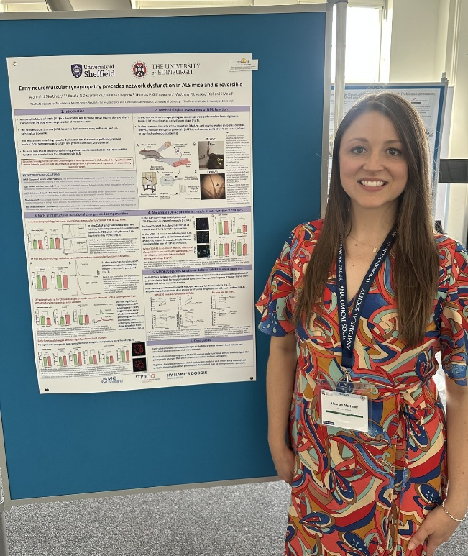

Copyright: If you submit images you must either own the copyright to the image or have gained the explicit permission of the copyright holder for the image to be submitted as part of the report for upload to the Society’s website, Newsletter, social media and so forth. A copyright statement must accompany each report if relevant. Answer N/A not applicable, YES or NO in the box below
N/A

SIGNATURE | Alannah Mortimer |  | DATE | 13/08/2026
If submitted electronically, a type-written name is acceptable in place of a hand-written signature
File: AS-Award-Report-Form-171023 – International Conference

File: Mortimer BS2526 R4 Report Approved Website version

