UNDERGRADUATE SUMMER VACATION SCHOLARSHIP AWARDS – FINAL SUMMARY REPORT FORM 2020/21
NB: This whole report will be posted on the Society’s website therefore authors should NOT include sensitive material or data that they do not want disclosed at this time.

Name of student:
Clara Deady

Name of supervisor(s):
Professor Gerard O’Keeffe

Project Title: (no more than 220 characters)
The investigation into the anatomical, neuronal, and histochemical changes in the brain and the gastrointestinal tract induced by early life stress.

Project aims: (no more than 700 words)

Early life stress (ELS) has been shown to have a harmful impact on both the development and the physiology of the nervous system and the gastrointestinal tract. Studies have linked stress during the early postnatal period with numerous stress-related psychiatric disorders and gastrointestinal tract disorders. The connection between the two, known as the microbiota-gut-brain axis, plays a vital role in the formation of such disorders. The model of maternal separation is known to induce ELS in animals and to contribute to dysfunction of the microbiome-gut-brain axis. Despite this, the impact that maternal separation has on the anatomy and histology of certain brain regions and the gastrointestinal tract and if these are impacted by the microbiome has not been studied in great detail.

Knowing this, the main aim for this project was to investigate pain behaviours and the anatomical and histological changes of the gut-brain axis in the offspring of an ELS model and determine the impact of altering the microbiome using antibiotics in early life.

We hypothesised that ELS is associated with both anatomical and histochemical changes in the brain and the gastrointestinal tract and that these changes may be related to behavioural and influenced by the microbiome..

The specific objectives of the project are listed below:
- Carry out immunohistochemical analysis of specific brain regions that may be altered by early life stress
-Carry out neuronal cell culture to determine the impact of stress (corticosterone) on developing brain cells.
- Identify any anatomical and neuronal changes in the gastrointestinal tract that may be altered by early life stress.
- Determine if this early life stress increased visceral pain behaviours.
- Determine if any changes noted were impacted on by antibiotic administration in early life.

Project Outcomes and Experience Gained by the Student (no more than 700 words)

In Vitro-Primary Cell Culture
As part of this studentship, I learned the methods to carry out primary cell culture to examine the effects of stress on the brain in an in vitro setting.
I learned how to remove a rat embryonic brain. Underneath the microscope, the ventral mesencephalon was dissected out and trimmed down to the correct size. This allowed me to observe the developing rat brain specifically at embryonic day 14. This built on theoretical knowledge of embryology I’d learned throughout my undergraduate degree. Following the dissection, a cell culture was set up and maintained using cells from the neural tube. To mimic an ELS paradigm, corticosterone was applied to the cultures in varying concentrations. We were particularly interested on what effect this would have on the dopaminergic system in this area, as it’s known that this system is impacted by neurodevelopmental disorders, such as autism spectrum disorder and schizophrenia.
Due to time constraints, I don’t have results to add here but I’m very confident that I’ve learned these methods in sufficient detail to now carry them out independently.

In vivo-Maternal Separation Stress
Separately, data and samples from offspring from a maternal separation study were analysed. Maternal separation was carried out previously by a PhD student in the lab. Maternal separation involves removing the pups from the mother for 3 hrs/day from postnatal day 2-12. There were 6 experimental groups: maternally separated, non-separated, maternally separated+antibiotics, non-separated+antibiotics, maternally separated+vehicle, non-separated+vehicle. The average pup weight in early life was collected and body weight was collected before sample collection in adulthood. No changes were noted in either of these assessments (Figure 1A and 1B). Despite not being involved in the live aspect of this study, I received a good insight into the planning and running of an in vivo study. I analysed the data and generated all graphs included in this report.
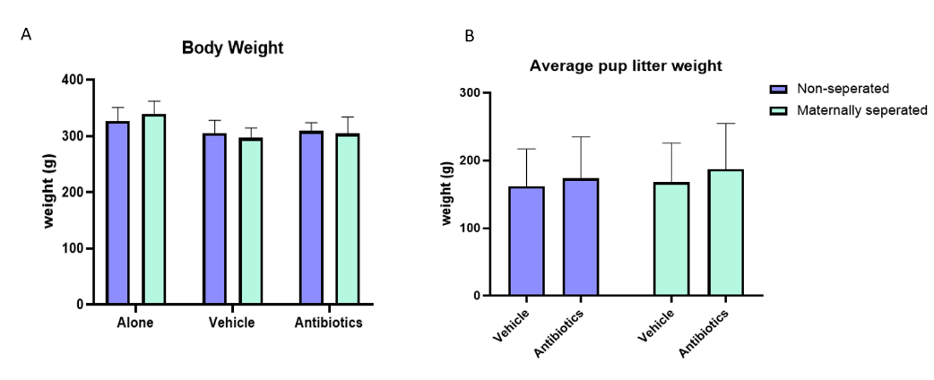

Figure 1: No changes in A. Average pup weight. Or B. Body weight in adulthood were noted. Data expressed as Mean±SEM; (n=6-9/group).

Brain:
I received the frozen, whole brains from the offspring. I learned how to orientate the brain stereotaxicly and how to achieve uniform brain slices using a rat brain matrix. I learned how to use a hole punch kit and collected samples from the medial prefrontal cortex, amygdala, and periaqueductal grey. All these areas are known to be altered in ELS and has direct implications on behaviour. The tissue samples I collected will be used in a polymerase chain reaction assay.

Gastrointestinal tract Anatomy:
To look at the effects of ELS and the microbiome on the gastrointestinal tract anatomy the length of the small intestine, colon and weight of the caecum were collected. I analysed the data and graphed the data using GraphPad Prism. The general anatomy of the gastrointestinal tract was not altered by ELS or the early life antibiotic treatment (Figure 2A and 2B). Caecum weight was increased in maternally separated animals treated with vehicle only (Figure 2C).

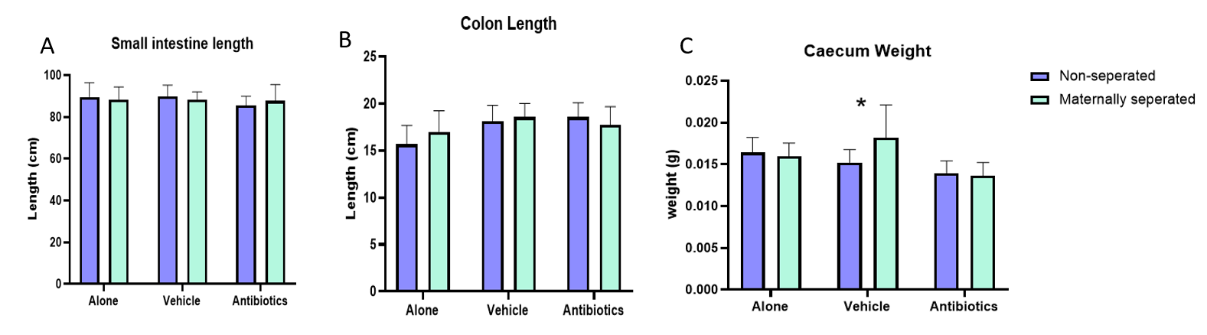
Figure 2: A. Small intestine length. B. Colon length. C. Caecum weight in maternally separated and non-separated groups and the antibiotic treated counterparts. Data expressed as Mean±SEM; (n=6-9/group).

Gastrointestinal tract immunohistochemistry:
I learned immunohistochemical techniques on gastrointestinal samples. HUC/D and streptavidin label Alexa Fluor 488 antibodies were used to stain neuronal cell bodies. β-III-Tubulin and Alexa Fluor 568 (goat anti-chicken) antibodies were used to stain the microtubule network (Figure 3). The samples were viewed on a confocal microscope and the image were later analysed. While I was involved in the staining of the samples a substantial amount of analysis is still required.
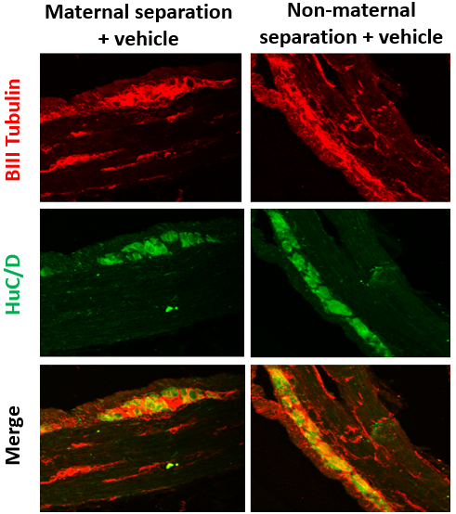

Figure 3: Immunohistochemical staining of gastrointestinal tract.

Behaviour:
The effect that ELS has on behaviour was examined with a particular focus on visceral pain-like behaviour. The behavioural tests were carried out by a PhD student, I analysed the data and graphed the results (Figure 4). The threshold to the noxious stimulus (colorectal distension) was higher in the antibiotic treated rats which was unexpected. The number per group was lower than previous studies so perhaps this is the reason for this result. Further analysis is required.

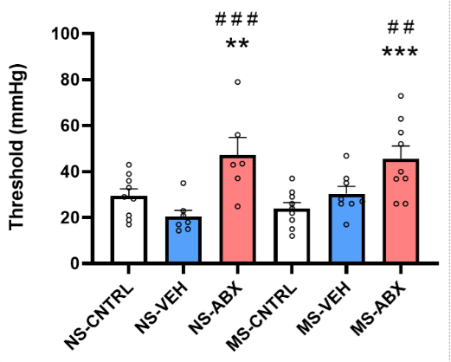

Figure 4: The threshold to the noxious stimulus was higher in the antibiotic treated animals. Data expressed as Mean±SEM; (n=6-9/group).

Please state which Society Winter or Summer Meeting the student is intending to present his/her poster at:
Winter

Proposed Poster Submission Details (within 12 months of the completion of the project) for an AS Winter/ Summer Meeting – (no more than 300 words)
Subject to change based on data analysis

Introduction: The microbiota has been shown to play a key role in the modulation of the visceral pain response. Maternal separation, a well-established rodent model of ELS, results in a persistent increase in visceral sensitivity into adulthood. However, the specific role the gut microbiota plays in ELS-induced visceral hypersensitivity is not known. The objective of this study was to evaluate the causal or correlative role of the microbiota in ELS-induced visceral hypersensitivity.

Methods: Maternal separation was used as an ELS paradigm which involved separating Sprague Dawley pups (whole litters) from their dams for 3 hours per day from postnatal day 2 until 12 inclusively. An antibiotic cocktail (Ampicillin, Imipenem, and Vancomycin) was administered daily via the oral route to pups in early life during the same period (postnatal day 2-12) to deplete the microbiota in early life. These animals then underwent colorectal distension in adulthood to assess their response to a noxious visceral stimulus.

Results: Antibiotic depletion of the microbiota in this early life timeframe reduced sensitivity to the noxious stimulus of colorectal distension in adulthood in both maternally separated and non-separated controls.

Conclusions: The present study reinforces the major role of the microbiota in modulation of the visceral pain response and suggests that there is a critical window in early life whereby the microbiota may affect the development and later life functioning of pain pathways.

Brief Resume of your Project’s outcomes: (no more than 200-250 words).
The title of your project and a brief 200-250 word description of the proposed/completed project. The description should include sufficient detail to be of general interest to a broad readership including scientists and non-specialists. Please also try to include 1-2 graphical images (minimum 75dpi). NB: Authors should NOT include sensitive material or data that they do not want disclosed at this time.

‘The investigation into the anatomical, neuronal, and histochemical changes in the brain and the gastrointestinal tract induced by ELS’.

This experiment aimed to examine the impact that ELS may have on the brain, behaviour, and the gastrointestinal tract of the offspring.

Whilst this study is on-going I learned a lot of techniques that I can apply to my further studies. I intend to continue with a research MSc with Professor O’Keeffe.

While we saw no overt changes in the anatomy of the gastrointestinal tract we noted that the antibiotic treatment reduced pain as in an increase in threshold to colorectal distention.

The threshold to the noxious stimulus was higher in the antibiotic treated animals. Data expressed as Mean±SEM; (n=6-9/group).

Other comments: (no more than 300 words)

I thoroughly enjoyed my studentship and want to thank Professor O’Keeffe and the Anatomical Society for providing me with this invaluable experience.

Data Protection/GDPR: I consent to the data included in this submission being collected, processed and stored by the Anatomical Society. Answer YES or NO in the Box below
Yes
Graphical Images: If you include graphical images you must obtain consent from people appearing in any photos and confirm that you have consent. A consent statement from you must accompany each report if relevant. A short narrative should accompany the image. Answer N/A not applicable, YES or NO in the box below
N/A
Copyright: If you submit images you must either own the copyright to the image or have gained the explicit permission of the copyright holder for the image to be submitted as part of the report for upload to the Society’s website, Newsletter, social media and so forth. A copyright statement must accompany each report if relevant. Answer N/A not applicable, YES or NO in the box below
N/A

Signature of student Date 27.09.2021

Signature of supervisor Date 27.09.2021

File: USVRS – 2021 Report Website No sigs – O’Keeffe and Deady

