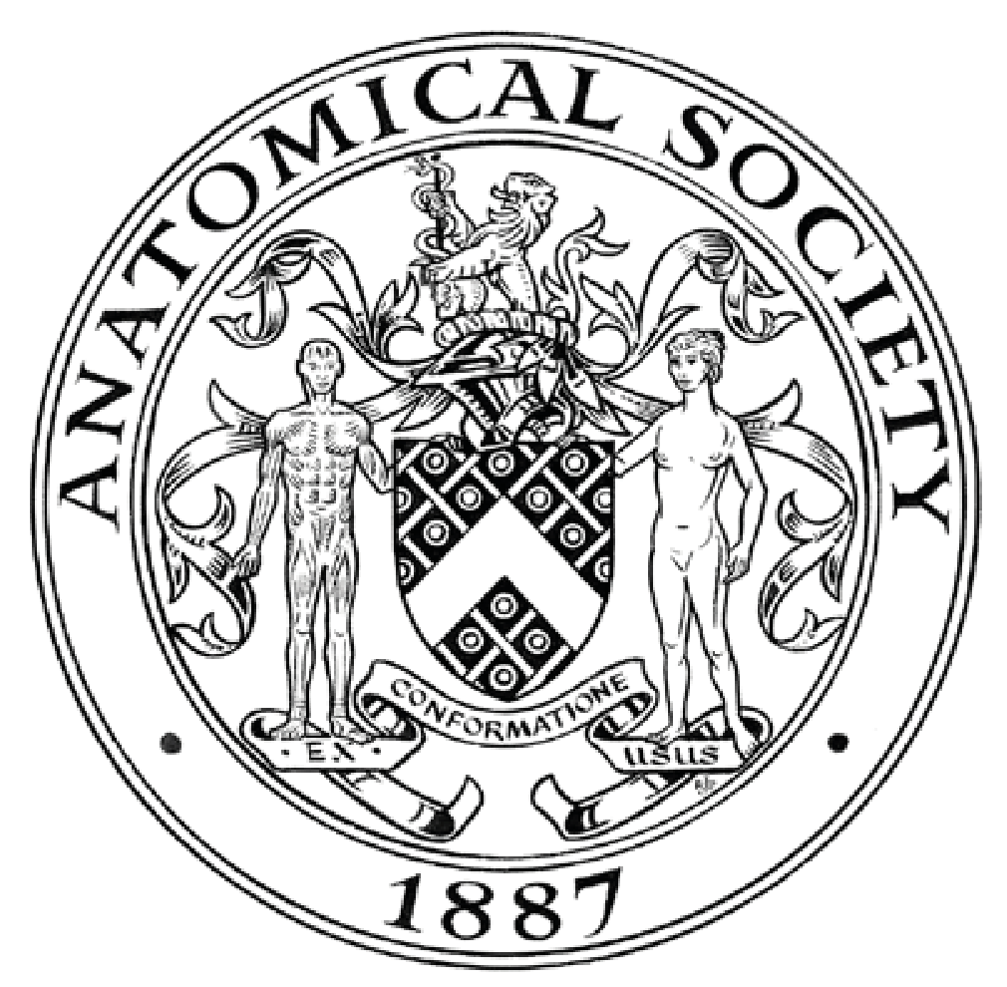
UNDERGRADUATE SUMMER VACATION SCHOLARSHIP AWARDS – FINAL SUMMARY REPORT FORM 2024/25
NB: This whole report will be posted on the Society’s website therefore authors should NOT include sensitive material or data that they do not want disclosed at this time.

Name of student:
Anas Al Kharusi

Name of supervisor(s):
Dr Adrian Dervan

Project Title: (no more than 220 characters)
Development of an AI-based deep learning analytical method for the accurate and precise detection of blood vessels in the human spinal cord.

Project aims: (no more than 700 words)
Anatomical donors represent a precious resource for microscopical investigation. In a recent publication (Trucas et al. (2025). J. Anat, 00: 1. doi: 10.1111/joa.14188.) we showed that routine embalming of donors for anatomical examination is capable of sufficiently preserving medulla and spinal cord (cervical, thoracic and lumbar) for detailed histological investigation. Building on this work, this study aimed to advance the knowledge that could be gained from donors by harnessing recent advancements in artificial intelligence (AI)-based analytical approaches to yield further important histological information from stained tissue sections. AI based algorithms have the ability to recognize complex histological patterns and provide standardized, quantitative metrics allowing for accurate and consistent objective assessments. Of particular interest to our team is the number and location of blood vessels in the spinal cord. This project therefore assessed the ability of AI to accurately detect the number and location of different sized blood vessels in the grey and white matter and the meninges of the spinal cord.
The proposed work consisted of the following five short work packages (WP):
WP1: The first objective of this study was to generate a library of serially cut sections from existing paraffin embedded blocks containing spinal cord tissue. The blocks consisted of the whole spinal cord from cervical, thoracic and lumbar levels from three different anatomical donors (9 blocks in total).

WP2 & 3: Determine the optimal histological staining method for the identification of blood vessels in cut tissue sections and generation of high-resolution whole section images of stained spinal cord sections using high resolution light microscopy (Weeks 3-5). Using several staining protocols, the student will be trained in different staining methods (H&E, PAS and Alcian blue stains). The optimal staining method for blood vessel identification in sections will be assessed using light microscopy. Next, all optimally stained tissue sections will be imaged and manually analysed using NIH-Image software to create a reference data set of identified blood vessels to serve as a comparator for AI-generated data sets.

WP4: A convolutional neural network (CNN) was developed in Python using PyTorch, employing a backbone, neck, and head architecture. Features in the backbone were extracted through convolution and pooling layers, where low-level patterns such as edges and textures are identified, and progressively deeper layers capture detailed features of the blood vessels. These hierarchical features were then aggregated and passed to the detection head, where bounding boxes for vessel identification were generated. Images were annotated using Label Studio, and the model was trained for approximately 250 epochs with early stopping applied to prevent overfitting. This approach enabled precise localization and quantification of vessels in meningeal, grey, and white matter regions.

WP5: Evaluation the accuracy, sensitivity, and specificity of the developed model on a separate image dataset (Weeks 8-10). To fully evaluate the ability of the trained AI-based deep learning model to accurately identify blood vessels a new set of histological sections will be acquired from stained sections from all three cord levels. It is expected the trained model will accurately identify all blood vessels and their associated parameters in all presented stained sections.

Project Outcomes and Experience Gained by the Student (no more than 700 words)
The proposed work packages of the first 3 weeks of the study involved the generation of histologically stained sections of the cervical, thoracic and lumbar human spinal cord. On review of the existing and extensive library of spinal cord tissue sections stained with H&E, Toluidine Blue, PAS and Alcian Blue, Dr Dervan and I ascertained that they were of sufficiently high quality to warrant their use in the project. Further, initial calculations for the accurate training of the algorithm determined that at least 1000 images would be required for each stain. Therefore, to accelerate the project to the collection of the necessary number of images it rapidly moved to implementing WP3. This WP consisted of generating an extensive library of images (N > 3000) using a Nikon eclipse 90i optical microscope. Next, we used Label Studio software to annotate the blood vessels in our images. The dataset (N = 3000 images) was then divided into training, validation, and test sets using a 70:15:15 ratio. We next structured our tool as shown below in Figure 1A. It consisted of two layers: a stain classification layer and a blood vessel detection layer. When trained the classifier achieved 100% accuracy distinguishing between H&E, PAS, and Alcian Blue stained sections. The second part of the workflow then directed the identified stained sections to their corresponding detection model, which identifies and localizes the blood vessels. For blood vessel detection, the PAS and Alcian Blue models performed best, reaching accuracies of 92% and 94% respectively, while the H&E model performed slightly lower (< 80%).
During this project, I developed proficiency in a diverse range of laboratory techniques under the supervision of Dr Dervan and other members of the tissue engineering group (TERG) at RCSI including Prof Fabio Quondamatteo (expert in spinal cord anatomy and histology) who trained me in blood vessel identification in histological sections. In addition, Dr Brenton Kavanagh trained me in image acquisition using light microscopy.
As a prerequisite to working in TERG I received instruction in laboratory health and safety. In order to complete the microscopy component of the work for the project I completed a short online microscopy course and received training in all aspects of light microscopy from the in-house imaging specialist Dr Brenton Kavanagh. He also trained me in the use of image analysis software, and together we selected Label Studio as the most suitable tool for the annotation of acquired images to prepare them for model training. This project also allowed me to apply my passion for machine learning and deep learning in a meaningful way. As a medical student, it helped me appreciate the role of AI in histology and encouraged me to think about other potential applications of AI in clinical practice. In addition, I improved my Python programming skills not only in building models but also in developing tools to speed up image acquisition, leaving more time to focus on refining and training the models effectively. As the project progressed, I was able to move from supervised training to working independently, preparing large datasets, annotating images, and running model evaluations. This growth gave me confidence in both my technical skills and my capacity to contribute meaningfully to the groups research goals.
Beyond the research, I have gained invaluable experience in data analysis, assembly of data in several software packages including MS PowerPoint and Word. As the work has proven highly successful, we have decided to assemble a manuscript for publication and this has allowed me to gain invaluable experience in scientific writing, data assembly and presentation. I will shortly present my work to the TERG community at one of their weekly meetings and this will add greatly to my skill set and provide me invaluable experience. Throughout my project I actively engaged daily with colleagues in TERG and met regularly with Dr Dervan and Prof Quondamatteo who provided guidance throughout the project. This experience added great depth to my research journey.

Please state which Society Winter or Summer Meeting the student is intending to present his/her poster at:
The Anatomical Society Summer Meeting 2026 (University of Bristol, 15th-17th July)

Proposed Poster Submission Details (within 12 months of the completion of the project) for an AS Winter/ Summer Meeting – (no more than 300 words)
Title: Development of an AI-based deep learning analytical method for the accurate and precise detection of blood vessels in the human spinal cord.

The proposed poster will highlight the key findings of this project which is currently being assembled as a manuscript for publication. It will demonstrate the feasibility of applying AI-based deep learning algorithms to the identification and analysis of blood vessel distribution in the cervical, thoracic and lumbar spinal cord. This work paves the way for more in-depth analyses of blood vessel structure and organisation in the aging human spinal cord. Moreover, it demonstrates the potential of the approach for the identification and analysis of other anatomical features in embalmed human spinal cord tissues.

Brief Resume of your Project’s outcomes: (no more than 200-250 words).
The title of your project and a brief 200-250 word description of the proposed/completed project. The description should include sufficient detail to be of general interest to a broad readership including scientists and non-specialists. Please also try to include 1-2 graphical images (minimum 75dpi). NB: Authors should NOT include sensitive material or data that they do not want disclosed at this time.

Development of an AI-based deep learning analytical method for the accurate and precise detection of blood vessels in the human spinal cord.

Anatomical donors represent a precious resource for microscopical investigation. Recently, Trucas and colleagues (2025; J. Anat, doi: 10.1111/joa.14188.) showed that routine embalming of donors for anatomical examination sufficiently preserves the spinal cord for histological investigation. Artificial intelligence (AI)-based analytical techniques have begun to revolutionise biological investigation by enabling rapid, automated analysis of tissues. This project aimed to assess the feasibility of employing this approach for the accurate detection of the different sized blood vessels in histologically prepared tissue sections of the cervical, thoracic and lumbar spinal cord.
To do so, a library of 3000 images were first acquired from Haematoxylin & Eosin (H&E), Periodic Acid Schiff (PAS) and Alcian blue stained sections that were first divided into training, validation, and test sets in a 70:15:15 ratio. We next structured our tool (Figure 1A) to consist of two layers: a stain classification layer and a blood vessel detection layer. When trained the classifier achieved 100% accuracy distinguishing between H&E, PAS, and Alcian Blue stained sections. The second part of the workflow then directed the identified stained sections to their corresponding detection model, which identifies and localizes the blood vessels. For blood vessel detection, the PAS and Alcian Blue models performed best, reaching accuracies of 92% and 94% respectively, while the H&E model performed slightly lower (< 80%).
In conclusion, the findings of this project demonstrate the feasibility of employing AI-based analytical methods for the accurate detection of blood vessels in histologically stained tissue sections from embalmed spinal cord.
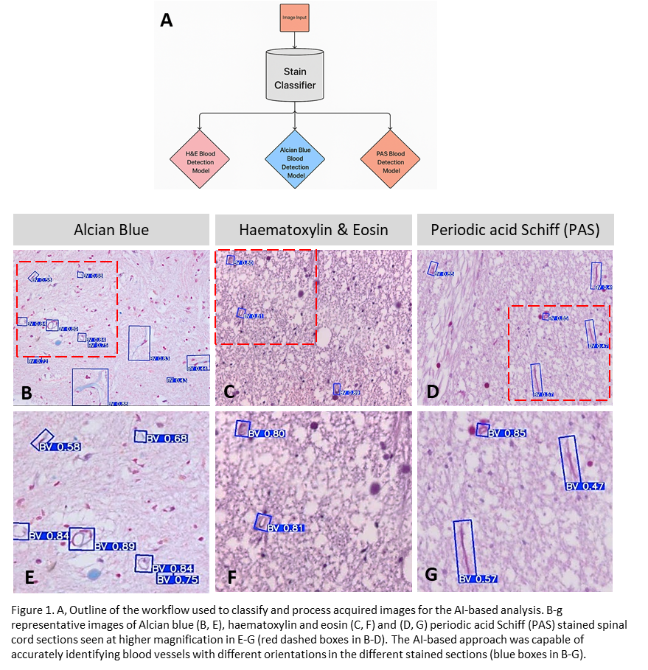

Other comments: (no more than 300 words)

As a medical student, I feel very fortunate the Society gave me the chance to get involved in research in the Department of Anatomy & Regenerative Medicine at RCSI. Joining the Tissue Engineering Research Group has been a great experience, as it gave me the chance to work in a really active and supportive research environment. Under the supervision of Dr Dervan and the guidance of Prof Fabio Quondamatteo and Dr Brenton Kavanagh, I worked on histologically stained spinal cord sections and learned a lot of practical skills in microscopy, image analysis, and annotation. I also had the chance to apply my interest in programming, using Python and machine learning tools on histological images, which showed me how important AI can be in medicine. On top of the technical side, I also learned about data presentation, writing, and working closely with colleagues. This experience has really helped me grow and made me more excited about research in the future. This fellowship has inspired me to continue my work applying machine learning to the identification of cellular (and other) features in histologically processed tissue sections, which I hope once published will be of benefit to the wider anatomical research community.

Data Protection/GDPR: I consent to the data included in this submission being collected, processed and stored by the Anatomical Society. Answer YES or NO in the Box below
YES

Graphical Images: If you include graphical images you must obtain consent from people appearing in any photos and confirm that you have consent. A consent statement from you must accompany each report if relevant. A short narrative should accompany the image. Answer N/A not applicable, YES or NO in the box below
YES
Copyright: If you submit images you must either own the copyright to the image or have gained the explicit permission of the copyright holder for the image to be submitted as part of the report for upload to the Society’s website, Newsletter, social media and so forth. A copyright statement must accompany each report if relevant. Answer N/A not applicable, YES or NO in the box below
YES

Signature of student Date 19/5/2025

Signature of supervisor……. Date 19/05/2025

END OF FORM
----------------------------------------------------------------------------------------------------------------------------------------
File: USVRS Award Letter 2025 TEMPLATE v2 APP CB 160525_Dr Adrian Dervan

