
_______________________________________________________________________________________
AWARDEE REPORT FORM
_______________________________________________________________________________________

NAME |  | Ruaraidh McCulloch
TWITTER HANDLE* optional
UNIVERSITY |  | University of Glasgow
NAME OF AWARD |  | Barclay Smith Award
PURPOSE OF AWARD conference/event attended/organised (full name) with city and dates.
Provide funding for attendance of the Preston (UCLan) winter meeting on the 6th of January 2025.
REPORT: What were your anticipated benefits?
Minimum number of words between 200-400. Please write in coherent paragraphs.
This funding would allow me to present my summer research project as a poster to the society. This would allow me to showcase the skills I have developed during the project alongside the research results and demonstrate the value of the Anatomical Society Undergraduate Summer Vacation Research Scholarship. Besides showcasing my results, this opportunity would allow practice of science communication and presentation skills which are essential skills for student to learn and become a confident presenter. The winter conference also allowed networking within an established society of researchers. This was beneficial as I was able to learn about potential career paths and engage with researchers that could potentially support the growth of my career. The AS winter conference was the first academic conference I had attended which meant I was nervous and didn’t know what to expect. However, after attending I feel confident and prepared for future events. The whole experience has allowed me to grow as a researcher and look forward to future events. Ultimately, I feel the studentship and conference have helped prepare me for a career in research by fostering difficult skills like scientific communication and personal confidence by providing the opportunity to gain these skills independently through experience.
COMMENTS: Describe your experience at the conference / lab visit / course / seminar/ event.
Minimum number of words between 200-400. Please write in coherent paragraphs.
I arrived in Preston the day before the conference to mitigate any travel disruptions due to the adverse weather and stayed in an amazing local hotel before the conference. I arrived early to the first day of the conference to set up my research poster in the Foster building and explored the campus before meeting my supervisor and other professors who had attended from my university. I enjoyed the social aspect of the conference and felt included within the society. During lunch, I engaged with the other students who had completed the Undergraduate Summer Vacation Research Scholarship and were also presenting a poster. I particularly enjoyed this because we were able to discuss our experiences and practice presenting our poster before the dedicated session. After lunch, the seminar began and we listened to a wide range of presentation styles and topics. I feel this session allowed me to engage with the work of Anatomical Society members and learn about a diverse area of topics outside my own research area. The presenters were skilled and confident communicators who I was able to learn from; by taking the positive aspects for their presentations I was able to define my own areas of weakness and improvement. Ultimately, the seminar was a learning experience that I thoroughly enjoyed. I spent at my time during the poster presentation explaining my research and answering questions. This session tested my knowledge of the field and my understanding of the project such as the methodology choices and the logic of the conclusions. Mostly, the questions focused on asking to explain the images on the poster for a greater understanding of what they were seeing due to the complicated immunohistochemistry. These images were: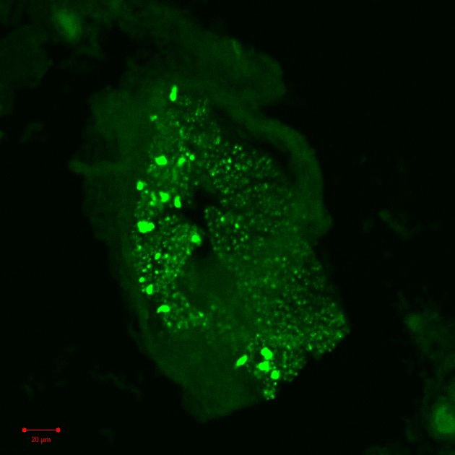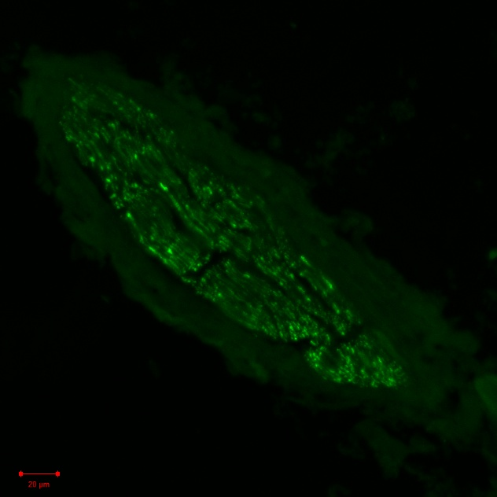
Ultimately, this experience allowed the practice of presenting and defending research – essential skills for a student who aims to complete a PhD. At the end of the day, I joined the early career social to relax before going back to Glasgow as I could not stay for the whole conference.
REPORT: In relation to skills, what were the most important things you gained? (does not apply to equipment grant. For public engagement/outreach awards what did your audience gain and how did you evaluate success?
Minimum number of words between 200-400. Please write in coherent paragraphs.
Whilst the Undergraduate Summer Vacation Research Scholarship allowed me to develop practical skills such as dissection and histology. The conference (and the Barclay Smith award) allowed the development of communication, presentation and networking skills. My communication skills improved as I attended the conference seminars and critically evaluated the presentations to identify personal areas of improvement. For example, I felt the best presentations were clear, concise and engaged with the audience visually. As I was able to attend so many presentations, the event allowed me to identify these attributes as essential to an engaging presentation and improved my own presenting skills as such. During my own presentation, I was able to practice demonstrating my knowledge of the field and understanding of the project. I felt I was able to accurately and effectively confer the information and evaluated the success by the questions my audience asked in response. For example, if I was able to explain the background and the research effectively, they were able to ask more complex questions. The conference also provided an opportunity to network within an established group of researchers. I believe networking is an essential skill for career growth and due to the experience I have gained from the conference, I will be able to apply these skills throughout my research career.
REPORT: How do you think you will put this learning experience into practice in the future? For public engagement/outreach awards how with the materials/knowledge generated by this activity be used in the future?
Minimum number of words between 200-400. Please write in coherent paragraphs.
Presenting my poster at the winter Anatomical Society meeting provided me with valuable insights into current trends, challenges, and innovations in the field. Moving forward, I plan to integrate this knowledge into my learning, research collaborations, and public engagement. Specifically, networking with other researchers at the conference opened doors for potential collaborations such as PhD opportunities. These relationships could lead to a further engagement within the anatomical community. For example, whilst my degree is in neuroscience, I am intrigued to pursue neuroanatomy as a career because of the experience the AS has provided. The knowledge I have gained from this activity will serve as a foundation for future public outreach events. For example, I will adapt my current presentation skills to include the core ideas from other researcher presentations I have attended during this event.

After engaging with the Elsevier representative, I learned the potential their material has to benefit my learning as a student. This experience has led me to pursue a wider range of studying material and consider a number of new learning techniques. As the seminars had a theme of anatomical teaching, I was able to take away new ideas of using current technology such as augmented reality to benefit my learning.
Data Protection/GDPR: I consent to the data included in this submission being collected, processed and stored by the Anatomical Society. Answer YES or NO in the Box below
YES

Graphical Images: If you include graphical images you must obtain consent from people appearing in any photos and confirm that you have consent. A consent statement from you must accompany each report if relevant. A short narrative should accompany the image. Answer N/A not applicable, YES or NO in the box below
N/A
Copyright: If you submit images you must either own the copyright to the image or have gained the explicit permission of the copyright holder for the image to be submitted as part of the report for upload to the Society’s website, Newsletter, social media and so forth. A copyright statement must accompany each report if relevant. Answer N/A not applicable, YES or NO in the box below
YES
SIGNATURE | Ruaraidh McCulloch |  | DATE | 12/01/2025
If submitted electronically, a type-written name is acceptable in place of a hand-written signature
File: AS-Award-Report-Form-171023 – International Conference

