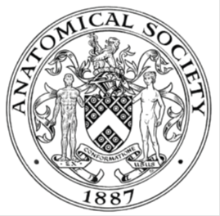
_______________________________________________________________________________________
AWARDEE REPORT FORM
_______________________________________________________________________________________

NAME |  | Dr Zubeyde Bayram Weston, FAS, FLSW, SFHEA
TWITTER HANDLE* optional |  | @ZBW23
UNIVERSITY |  | Swansea University
NAME OF AWARD |  | Public Engagement and Outreach Awards 2024/25 – Round 6
PURPOSE OF AWARD conference/event attended/organised (full name) with city and dates.
To purchase materials to perform “Jelly Brain Surgery” activity for at Swansea Science Festival on 26th of October 2025, Swansea Museum.

REPORT: What were your anticipated benefits?
Minimum number of words between 200-400. Please write in coherent paragraphs.
Presenting the “Jelly Brain Surgery” activity, my anticipated benefits were:

This activity offered a unique opportunity to connect the public (especially children) with the brain anatomy through an engaging, hands-on approach. One of the key anticipated benefits was to increase knowledge and understanding of brain anatomy and function in young children. By using interactive jelly brains, models, puzzles, brain hats participants were able to visualise and explore the structures of the brain in an accessible and enjoyable way. This tactile experience helped to transform abstract scientific concepts into something tangible, reinforcing learning and curiosity.

A further aim was to spark interest in science (particularly in anatomy) and inspire the next generation of learners. By creating a playful and inclusive environment, the activity encouraged children and families to see science as approachable, relevant, and fun. This aligns with wider educational goals to nurture curiosity, creativity, and confidence in exploring scientific ideas from an early age.

Another anticipated benefit was to raise public awareness of current research and promote informed discussion about brain health and neurological disorders. Through informal conversations, participants learn about the importance of brain research and its real-world applications. Ultimately, the activity aimed to build bridges between the scientific community and the public, promoting lifelong engagement with anatomy and health sciences.

COMMENTS: Describe your experience at the conference / lab visit / course / seminar/ event.
Minimum number of words between 200-400. Please write in coherent paragraphs.
Participating in the Swansea Science Festival 2025 was an engaging and rewarding experience. The event took place at the National Swansea Museum in partnership with Swansea University. Our activity was located on the ground floor alongside a range of other interactive exhibits, shows and presentations. The festival attracted over with 5000 + happy visitors to the museum.

The “Jelly Brain Surgery” activity drew particular attention from children (age 5 to 13), who were excited by the idea of operating on a jelly brain. This hand of activity encouraged active participation and curiosity. Before the surgery, we explained the different brain regions using purchased brain models, puzzles and brain hats. The activity also involved a giant brain cell display and soft brain toy illustrating the glial cells and their role in the brain.

Children were then invited to perform the “surgery” by using MRI brain scan sheet to guide them as they carefully removed the fruit pieces from the jelly brains. Many children were very enthusiastic and asked interesting questions about how brain works and how scientists study it. The between surgeries, participant also involved in brain puzzles to enforce their undertaking of brain regions and their functions.

Each participant also received a paper brain hat showing brain anatomy to take home, helping to extend their learning beyond the event. Most of adults also loved these brain hats and asked questions about brain anatomy. Overall, the activity successfully promoted curiosity, engagement and public understanding of neuroscience in a fun and memorable way.

Jelly Brain Recipe

Ingredients
1 pack of strawberry jelly
Aprox120 ml hot water
1 tin/can evaporated milk (410 ml can)
Mixed fruit (e.g. strawberry, raspberry and blueberry)
strawberry laces sweet
Cling film
Spray oil
One brain mould

Instructions:
- Dissolve one pack jelly 120 ml of hot water, stirring until fully melted.
- Slowly add 1 tin evaporated milk to fill up until the total volume reaches 1 pint (approx. 560ml) mixing well.
- Prepare the brain mould by lining it with cling film and lightly spraying with oil (this will be our meninges)
- Pour the jelly mixture until the mould is about 1/3 full
- Add the fruit and strawberry laces
- Fill up a tiny bit so it all sets in the correct position then chill until set
- Once set, Fill the mould to the top with remaining jelly mixture and refrigerate until completely set

For one full jelly brain, you will need 3 times the ingredients:
3 packs of jelly
360 ml hot water
3 tins of can evaporated milk (to make 3pints/~1.60 L total liquid).

Note: Condensed milk or and any other types of milk are not suitable, as they will prevent the jelly form setting properly.

Blancmange Brain Recipe (Gelatine-Free Alternative)

Occasionally, the jelly may not set properly, so we can make a spare “brain” using this blancmange recipe instead. This version is fully edible and does not contain gelatine.

Ingredients
125 gr corn flour
100 gr granulated sugar
Pinch of salt
1250 milk
Pink food colouring
1 teaspoon vanilla essence
Mixed fruit (e.g. strawberry, raspberry and blueberry)
strawberry laces sweet
Spray oil
One silicone brain mould

Instructions
- In a large bowl, combine the cornflour, sugar and salt.
- Add a little milk to form a smooth paste.
- Heat the remaining milk until hot (but not boiling), then pour it into cornflour mixture, stirring continuously with wooden spoon.
- Return the mixture to the saucepan and place it over medium heat. Bring it to the boil, stirring constantly for 5-10 minutes until the mixture thickens.
- Add the vanilla essence and a few drops of pink food colouring to achieve the desired shade. Mix well.
- Pour the mixture until the mould is about 1/3 full
- Add the fruit and strawberry laces
- Fill the mould with the remaining mixture and Place the mould in the fridge and allow it to set for at least an hour (it may take a few hours to fully firm up).
REPORT: In relation to skills, what were the most important things you gained? (does not apply to equipment grant. For public engagement/outreach awards what did your audience gain and how did you evaluate success?
Minimum number of words between 200-400. Please write in coherent paragraphs.
During the activity, it was evident that participants gained a greater understanding of brain anatomy and function through hands on learning. As an enthusiastic neuroanatomist, it was a real pleasure to share my knowledge and passion for anatomy with the public. It is important to me to communicate with people to create a spark to generate an interest in anatomical science. Participants (especially children) learned about new anatomical structures and had an opportunity to discuss them directly with experts.
The Jelly Brain Surgery activity allowed participant children to explore scientific ideas in a fun and accessible way, helping to demystify neuroscience and spark curiosity about how the brain works. We also received very interesting questions from adults, such as, “Can you show us which part of the brain is affected in Alzheimer’s disease? “a question that opened a meaningful discussion and deepened public understanding of neurological conditions.
Participants were invited to evaluate the activity using an ethics- approved questionnaire and verbal feedback. Many described the experience as “really cool” and rated it five stars. One participant commented that the most memorable thing they learned was that “the brain has membranes around it to stop its moving.”, while others were surprised by how soft brain was like jelly. Most participant indicated that they learned something new about during the activity.
Verbal feedback form parents and children highlighted how enjoyable and memorable the experience was, and many expressed to a desire to learn more about the brain and science more broadly.
REPORT: How do you think you will put this learning experience into practice in the future? For public engagement/outreach awards how with the materials/knowledge generated by this activity be used in the future?
Minimum number of words between 200-400. Please write in coherent paragraphs.
The material and knowledge generated through the Jelly Brain Surgery activity will continue to be used to promote public engagement with neuroscience and anatomy in a range of educational and outreach settings. The interactive resources such as brain models, brain puzzles, MRI scan templates and paper brain hats will be used in schools, community science events and various public engagement events to inspire curiosity about brain science among learners.

Insights gained form participants feedback will inform improvements to the activity’s design and delivery ensuring it remains inclusive, accessible, and aligned with current public engagement best practices. The evaluation data highlighting increased confidence and curiosity about brain anatomy will be also shared with colleagues through presentations, workshops and outreach networks to encourage wider adoption of hands-on learning in anatomy education.

In addition, the Brain Jelly recipes will be shared with the Anatomical Society, enabling other members to replicate the activity at their own institutions or public engagement events. This will support wider dissemination of hands-on neuroscience education, promote engagement with anatomy across diverse audiences, and encourage the adoption of evidence-based, interactive approaches to teaching and outreach within the anatomical community.

In the longer term, these materials will contribute to a toolkit of evidence-based outreach resources supporting science communication, public awareness and lifelong learning. This sustained use will help strengthen community connections with research inspire the next generation of scientist and enhance public understanding of the human brain and neurological health.

Data Protection/GDPR: I consent to the data included in this submission being collected, processed and stored by the Anatomical Society. Answer YES or NO in the Box below
YES
Graphical Images: If you include graphical images you must obtain consent from people appearing in any photos and confirm that you have consent. A consent statement from you must accompany each report if relevant. A short narrative should accompany the image. Answer N/A not applicable, YES or NO in the box below
Yes, I confirm that consent from filled by their guardians. No identifiable personal data or images of participants have been included in this report.

The Jelly Brain Surgery activity exhibition table and its content, engaged children in a hands-on exploration of brain anatomy

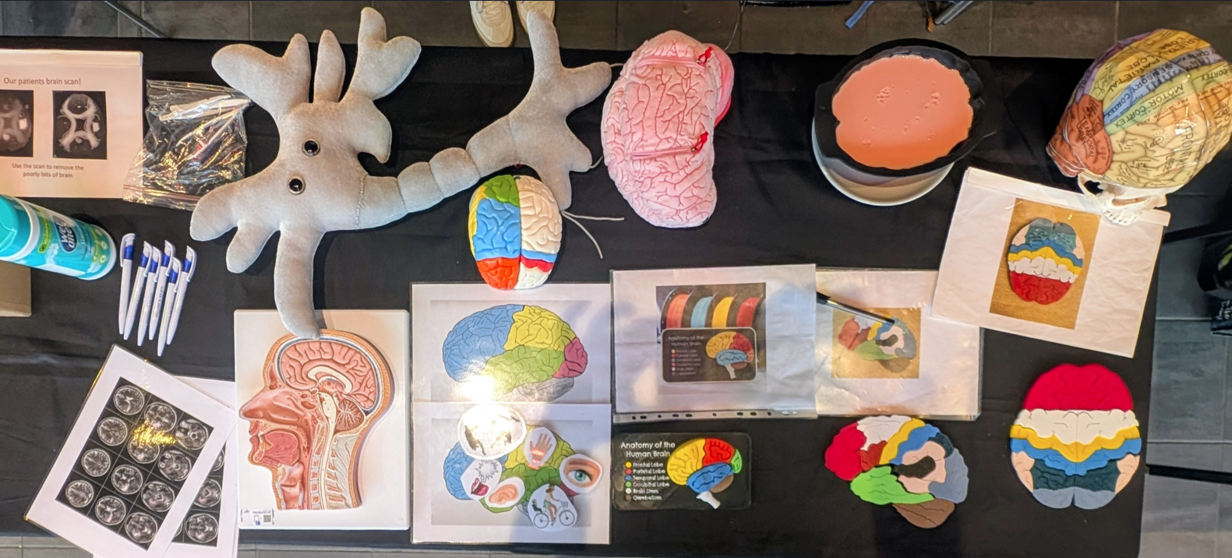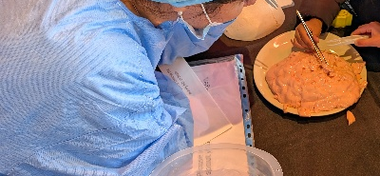
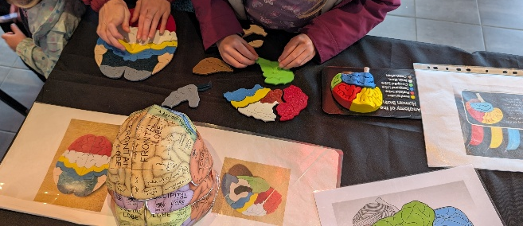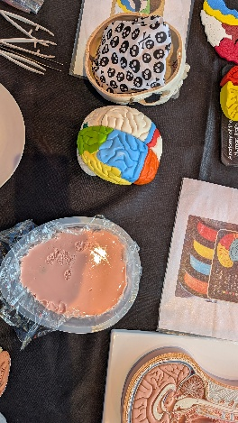

Copyright: If you submit images you must either own the copyright to the image or have gained the explicit permission of the copyright holder for the image to be submitted as part of the report for upload to the Society’s website, Newsletter, social media and so forth. A copyright statement must accompany each report if relevant. Answer N/A not applicable, YES or NO in the box below
I own the copyright to all images included in this report.

SIGNATURE | Zubeyde Bayram-Weston |  | DATE | 28/10/2025
If submitted electronically, a type-written name is acceptable in place of a hand-written signature
File: AS-Award-Report-Form-171023 – International Conference

