UNDERGRADUATE SUMMER VACATION SCHOLARSHIP AWARDS – FINAL SUMMARY REPORT FORM 2024/25
NB: This whole report will be posted on the Society’s website therefore authors should NOT include sensitive material or data that they do not want disclosed at this time.

Name of student:

Avanthika Sivakumar

Twitter Handle*:
(*optional)
Name of supervisor(s):
Professor Stephanie Cragg
Project Title: (no more than 220 characters)
Exploring short-term plasticity in dopamine release between anatomical compartments of nigrostriatal dopamine neurons
Project aims: (no more than 700 words)

Dopamine (DA) neurons of the nigrostriatal system project from the substantia nigra pars compacta (SNc) to the dorsal striatum and are critically implicated in motor control and in the pathogenesis of Parkinson’s disease. Anatomically, SNc neurons give rise to the most branched axonal arbours seen in the CNS, forming dense arbours in the striatum (Matsuda et al., 2009), while conversely having remarkably unbranched but long dendrites in the SNc. Intriguingly, DA can be released from both axonal and somatodendritic compartments, and while this is thought to be sourced from small synaptic vesicles in striatum, the anatomical storage units in somatodendrites in SNc are less well defined. Differences in the corresponding mechanisms that regulate dopamine release from these different anatomical compartments remain incompletely understood.

In the striatum, the release of DA from vesicles is dynamic, showing moment-by-moment variation, of ‘short-term plasticity’ (Cragg, 2003). Condon et al. (2019) showed that, in mice, this short-term plasticity is strongly governed by a non-canonical role of the dopamine transporter (DAT), that is thought to regulate vesicle availability and also axon excitability. Specifically, inhibition of DAT abolishes short-term facilitation and relieves depression implicating DAT as a key gatekeeper of dynamic DA release probability (Condon et al., 2019).

In contrast, the somatodendritic compartment of nigrostriatal dopaminergic neurons remains under-characterised in terms of short-term release plasticity. Somatodendritic release of DA has been confirmed in the SNc and ventral tegmental area, and while it shares some characteristics of exocytosis, its Ca²⁺-dependence, release machinery composition and transporter regulation differ from those of axons (Rice & Patel, 2015; Lebowitz et al., 2022). Whether somatodendritic DA exhibits short-term plasticity, and whether DAT plays a regulatory role has not been tested. Understanding compartment-specific dopamine release dynamics may provide insight into signalling dysregulation or selective vulnerability of nigrostriatal neurons in Parkinson’s disease.

In this project, I compare short-term plasticity of DA release in somatodendritic versus axonal compartments of nigrostriatal neurons and test the role of DAT in governing this plasticity. In order to undertake this work, I also first needed to establish and validate the use of a powerful new genetically encoded sensor for DA, the GRAB-DA sensor (Zhuo et al., 2023), that allows imaging of DA release in real-time.

Aims
1. Validate the functionality of new DA sensor GRAB_{DA3M} sensor in the SNc.
2. Determine whether somatodendritic DA release exhibits short-term plasticity.
3. Explore the influence of DATs on somatodendritic DA release

Project Outcomes and Experience Gained by the Student (no more than 700 words)
The GRAB_{DA3M} sensor was intracranially injected in wild type mice into the bilateral SNc. Following 3-4 weeks, the mice were culled by cervical dislocation to extract the brains, from which 300μm coronal slices containing the dorsolateral striatum (DLS) and SNc were prepared using a vibratome. A platinum/iridium electrode was used to provide electrical stimulation, and fluorescent GRAB_{DA3M} signals were captured on an sCMOS camera.

Aim 1:
Transient evoked increases in fluorescence were obtained reliably from both single and multiple pulse electrical stimulation in the SNc and DLS. This confirmed successful injection of viral vectors encoding the sensor in the SNc, and showed that the vector had been trafficked from the initial injection site to the axonal compartment of the nigrostriatal neurons. Evoked signals were abolished in SNc and DLS upon application of tetrodotoxin (TTX), a voltage-gated Na⁺ channel blocker. This confirmed that the fluorescent signal observed was action-potential dependent.

The GRAB_{DA3M} sensor utilised for this project is constructed based on a human D₁ receptor (Zhuo et al., 2023). The D₁R antagonist SCH 39166 was applied to verify that the fluorescent signal generated is due to binding of dopamine to the sensor, and this resulted in almost complete attenuation of the signal. Together, these experiments illustrated that the GRAB_{DA3M} sensor is able to detect DA release by somatodendritic and axonal compartments of nigrostriatal DA neurons with good specificity.

Aims 2 and 3:
To investigate whether dopamine release in the SNc exhibits short-term plasticity, paired-pulse stimulation experiments were conducted. Following the first stimulus pulse, the second pulse was administered at inter-pulse intervals (IPIs) of 25ms, 40ms, 100ms, or 200ms. Paired pulse stimulations were flanked by single pulse stimulations to allow for calculation of second pulse peaks through subtraction. Stimulations were repeated following the application of 5μM cocaine, a DAT inhibitor, to assess the contribution of DATs to DA re-release.
Paired-pulse experiments were also conducted in the DLS at IPIs of 100ms and 200ms.
The ratio of release at the second stimulation (P2) to that of the first stimulation (P1) formed the paired pulse ratio (PPR), serving as a measure of short-term plasticity.

As expected, DAT inhibition by cocaine slowed signals observed both in the DLS and SNc. Short term depression (PPR <1) was observed at all IPIs. DAT inhibition appeared to increase PPR in the SNc (Figure 1A), indicating that DATs limit DA re-release with subsequent stimulation. PPRs appear higher in the SNc relative to the DLS both before and after the administration of cocaine (Figure 1B). This greater re-release of dopamine in the somatodendritic compartment of nigrostriatal neurons compared to the axonal compartments reveals less short-term depression of release, which could potentially be explained by differences in morphology, storage compartment, or structure excitability. Statistical analysis of these results are currently ongoing.

Further experiments were conducted to compare the characteristics of signals observed in the medial and lateral SNc and the influence DAT inhibition on these signals—analysis of these results is currently ongoing.

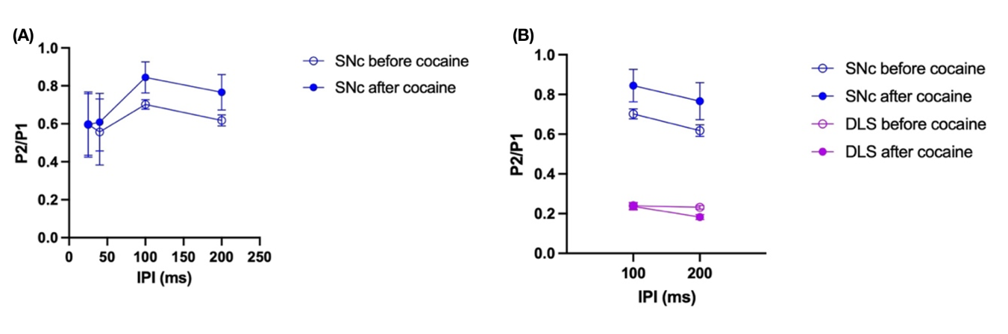
Figure 1. (A) PPR of DA release in medial SNc at IPIs of 25 ms and 40ms (n=3), and 100ms and 200ms (n=6) in the absence and presence of 5µM cocaine. (B) PPR of DA release in medial SNc (n=6) and DLS (n=7) in the absence and presence of 5µM cocaine.

Experience gained:
Through this project, I have developed a broad range of experimental and analytical skills. I learned to use a vibratome to prepare acute mouse brain sections, gained more detailed knowledge about the anatomical organization of the mouse brain, and gained hands-on experience with pharmacological manipulations in ex vivo slice preparations. I have also become familiar with fluorescent DA imaging using GRAB sensors to monitor neuronal activity, and with data analysis tools including ImageJ for anatomical image analysis and MATLAB for data analysis. The project also strengthened my ability to plan and execute experiments independently, troubleshoot technical challenges such as adjustment of electrode placement, and critically interpret data. More broadly, it has allowed me to delve into the incredibly complex world of neuroanatomical and physiological research, and fostered an appreciation for the diverse and innovative methods driving current research in the anatomy and physiology of dopamine neurobiology.

Please state which Society Winter or Summer Meeting the student is intending to present his/her poster at:
Winter Meeting 2025

Proposed Poster Submission Details (within 12 months of the completion of the project) for an AS Winter/ Summer Meeting – (no more than 300 words)
The poster will describe the work detailed above, and will also include details of the methods used to prepare and conduct ex vivo brain slice imaging, including various pharmacological agents and stimulation protocols that were used to investigate characteristics of dopamine release in different anatomical compartments of nigrostriatal DA neurons. Images of key brain regions will be shown, quantitative results illustrating the fluorescence signals obtained will be included, and signal characteristics such as paired pulse ratios, peak percentages, and areas under the curve will be comparatively analysed to evaluate somatodendritic and axonal dopamine release. A discussion of these results will also demonstrate how they relate to our current understanding of the morphology and physiology regulating DA release.

Brief Resume of your Project’s outcomes: (no more than 200-250 words).
The title of your project and a brief 200-250 word description of the proposed/completed project. The description should include sufficient detail to be of general interest to a broad readership including scientists and non-specialists. Please also try to include 1-2 graphical images (minimum 75dpi). NB: Authors should NOT include sensitive material or data that they do not want disclosed at this time.

The nigrostriatal dopamine (DA) pathway plays a key role in motor control and is particularly vulnerable to degeneration in Parkinson’s disease. A better understanding of the mechanisms that regulate the release of DA from these neurons could shed light on their vulnerability and new strategies to treat disease. Intriguingly, these neurons release DA from both their axonal arbours in the striatum, and also their dendrites in the substantia nigra (SN). The mechanisms that regulate DA release seem to differ between these anatomical compartments but are incompletely resolved. We explored the moment-by-moment variability, or ‘short-term plasticity’ of DA release, and a non-canonical role for the DA uptake transporter (DAT). The DAT is well known to take DA back up into releasing structures, but the Cragg lab and others have previously found that in DA axons, the DAT also shapes the short-term plasticity in release itself. DATs might shape vesicular availability and axonal excitability. In this project, I assessed the short-term plasticity of DA release from the somatodendritic compartment of substantia nigra pars compacta (SNc) neurons, and tested for involvement of the DAT. To monitor DA release in real-time, we used a recently developed genetically-encoded fluorescent DA sensor (Zhuo et al., 2023). I found much less short-term depression of release for somatodendritic than axonal DA release, but evidence from application of the monoamine uptake inhibitor cocaine to suggest a potential role for the DAT in shaping this plasticity. Future work could test whether these differences are due to the different morphology or electrical excitability of these compartments.

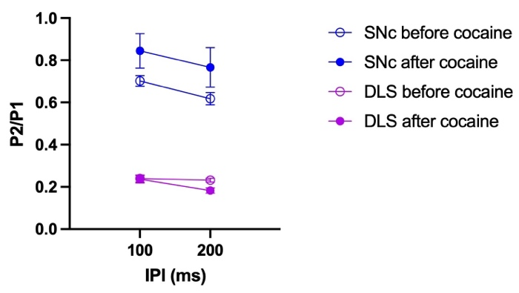
Figure 1. Paired pulse ratios of stimulations done in medial SNc in the absence and presence of 5µM cocaine.

Other comments: (no more than 300 words)
I would like to thank Professor Stephanie Cragg for giving me the opportunity to pursue my interest in dopaminergic neuron research within her lab. I am also deeply grateful to Cragg Lab members for their welcoming atmosphere and generosity in sharing their expertise. I owe particular thanks to my day-to-day supervisor, Dr Bethan O’Connor, for her consistent support, insightful advice, and patience in guiding me through the experimental and analytical aspects of this project. Finally, I would like to thank the Anatomical Society for their generous funding of this studentship.

References:

Matsuda, W., Furuta, T., Nakamura, K. C., Hioki, H., Fujiyama, F., Arai, R., & Kaneko, T. (2009). Single Nigrostriatal Dopaminergic Neurons Form Widely Spread and Highly Dense Axonal Arborizations in the Neostriatum. Journal of Neuroscience, 29(2), 444–453. https://doi.org/10.1523/JNEUROSCI.4029-08.2009

Cragg, S. J. (2003). Variable Dopamine Release Probability and Short-Term Plasticity between Functional Domains of the Primate Striatum. Journal of Neuroscience, 23(10), 4378–4385. https://doi.org/10.1523/jneurosci.23-10-04378.2003

Condon, M. D., Platt, N. J., Zhang, Y.-F., Roberts, B. M., Clements, M. A., Vietti-Michelina, S., Tseu, M.-Y., Brimblecombe, K. R., Threlfell, S., Mann, E. O., & Cragg, S. J. (2019). Plasticity in striatal dopamine release is governed by release-independent depression and the dopamine transporter. Nature Communications, 10(1), 4263. https://doi.org/10.1038/s41467-019-12264-9

Rice, M. E., & Patel, J. C. (2015). Somatodendritic dopamine release: Recent mechanistic insights. Philosophical Transactions of the Royal Society B: Biological Sciences, 370(1672), 20140185. https://doi.org/10.1098/rstb.2014.0185

Lebowitz, J. J., Banerjee, A., Qiao, C., Bunzow, J. R., Williams, J. T., & Kaeser, P. S. (2023). Synaptotagmin-1 is a Ca2+ sensor for somatodendritic dopamine release. Cell reports, 42(1), 111915. https://doi.org/10.1016/j.celrep.2022.111915
Zhuo, Y., Luo, B., Yi, X., Dong, H., Miao, X., Wan, J., Williams, J. T., Campbell, M. G., Cai, R., Qian, T., Li, F., Weber, S. J., Wang, L., Li, B., Wei, Y., Li, G., Wang, H., Zheng, Y., Zhao, Y., … Li, Y. (2024). [Sensor]- Improved green and red GRAB sensors for monitoring dopaminergic activity in vivo. Nature Methods, 21(4), 680–691. https://doi.org/10.1038/s41592-023-02100-w

Data Protection/GDPR: I consent to the data included in this submission being collected, processed and stored by the Anatomical Society. Answer YES or NO in the Box below
YES
Graphical Images: If you include graphical images you must obtain consent from people appearing in any photos and confirm that you have consent. A consent statement from you must accompany each report if relevant. A short narrative should accompany the image. Answer N/A not applicable, YES or NO in the box below
YES
Copyright: If you submit images you must either own the copyright to the image or have gained the explicit permission of the copyright holder for the image to be submitted as part of the report for upload to the Society’s website, Newsletter, social media and so forth. A copyright statement must accompany each report if relevant. Answer N/A not applicable, YES or NO in the box below
N/A

Signature of student..................... ...................Date……24/10/25……..

Signature of supervisor…… ....... Date……24/10/2025.…

END OF FORM
--------------------------------------------------------------------------------------------------------------------------------------

