
_______________________________________________________________________________________
AWARDEE REPORT FORM
_______________________________________________________________________________________

NAME |  | Elena Patera
TWITTER HANDLE* optional |  | @ArtedelCuerpoH1
UNIVERSITY |  | University of Liverpool
NAME OF AWARD |  | Barclay Smith Travelling Fund
PURPOSE OF AWARD conference/event attended/organised (full name) with city and dates.
Anatomical Society Winter Meeting
Dates: 6th-8th January 2025
Location: University of Central Lancashire, Preston, UK
REPORT: What were your anticipated benefits?
Minimum number of words between 200-400. Please write in coherent paragraphs.
Since I had the opportunity to organise the Anatomical Society-ECA pre-conference workshop on behalf of the Early Career Anatomists (ECA) group, I was looking forward to running the workshop I organised with Maryam Rajid, a local anatomist from UCLan, titled ‘Visualising Anatomy: Exploring the Use of 2D and 3D Imaging Modalities Across Different Anatomy Teaching Settings & Imaging Analysis Software for Research Purposes’. I was looking forward to interacting with attendees and discussing the different types of 2D and 3D imaging modalities, how each imaging modality can be better suited to teach a specific anatomical concept as well which other resources can be used as adjuncts to support student learning. I was also keen to find out which 2D and 3D imaging modalities are being used at different higher education institutions, as well as how students perceive the use of these imaging modalities. For the second hour of the workshop, I ran a discussion on the use of an imaging analysis software (3DSlicer) and how I use it for my PhD; therefore, I was keen to find out if attendees have heard of this software before. My aim was to inform them on how they can use it for neuroanatomy teaching purposes and research purposes as well. I also anticipated to learn more about the use of micro-CT and MRI in research, in education and current advances in 3D modelling. I anticipated that the conference would be a place where I could network with fellow anatomists and thankfully that was the case.

COMMENTS: Describe your experience at the conference / lab visit / course / seminar/ event.
Minimum number of words between 200-400. Please write in coherent paragraphs.
Attending the Anatomical Society’s meetings are always a pleasure as they are so enlightening. I feel privileged to have had the opportunity to organise and run the AnatSoc-ECA pre-conference workshop with the local anatomist from UCLan, Maryam Rajid. Our pre-conference workshop was titled ‘Visualising Anatomy: Exploring the Use of 2D and 3D Imaging Modalities Across Different Anatomy Teaching Settings & Imaging Analysis Software for Research Purposes’.

During the first hour of our workshop, attendees performed two activities. The first activity required attendees to match a picture of a 2D or 3D imaging modality with its definition & the equipment it requires. For the second activity, the attendees were randomly assigned an imaging modality (i.e., Virtual Reality) and a body region (i.e., Thorax) and they needed to discuss the suitability of their assigned imaging modality for their assigned body region. The attendees were encouraged to discuss the advantages and disadvantages of their imaging modality, which anatomical concepts could be taught using that imaging modality as a resource, if specific anatomical structures were more likely to be visualized with that modality, challenges associated with using this modality (i.e., equipment, cost, number of students) & which other imaging modality/resource they could use as an adjunct. In the remaining 40 minutes of the workshop attendees had 20 minutes to explore specific resources such as the AR version of Complete Anatomy and the Anatomage Inc. table with Maryam Rajid. For the remaining 20 minutes, I had the opportunity to discuss my PhD project with the attendees and how I use 3DSlicer, a free open-source software to visualize T1w MRI scans from the OASIS dataset and specific automated segmentation tools (FreeSurfer, FastSurfer) to obtain volumetric data for the segmented regions of interest.

Attending the conference was enlightening for me as I currently use T1w MRI scans to research the variation in brain morphology as part of my PhD research, hence, learning how individuals use MRI and Micro CT to research different parts of the human body is always thought-provoking and interesting. Also learning how different imaging modalities are used for educational purposes was really nice, as different imaging modalities can allow us to teach anatomy in a clinically applied manner.

As one of the Anatomical Society Young Ambassadors, it was great to be able to keep all those who could not attend in-person up to date with what was going on during the meeting and inform them on the wide range of presentations from the keynote speakers, oral, flash-talk and pecha kucha presenters, sponsors and poster presenters as well. It was also great to inform people on the anatomical artwork showcase that was available throughout the meeting,

I thoroughly enjoyed all the in-conference workshops as well.

REPORT: In relation to skills, what were the most important things you gained? (does not apply to equipment grant. For public engagement/outreach awards what did your audience gain and how did you evaluate success?
Minimum number of words between 200-400. Please write in coherent paragraphs.
I can certainly say that attending Anatomical Society conferences and presenting my work and running a workshop has helped me improve my oral presentation and communication skills, gain more experience with answering questions related to my presented work. From the workshop, I know now that I will need to take into consideration further my audience and their background as well when designing activities. I learnt that it is very important to allocate some time before a group starts going through an activity, just to use that time as an icebreaker and for individuals to introduce themselves. I also know that it is important to ensure that there is enough time for each group to discuss their opinions with the rest of the groups. In the future, I will definitely try and incorporate different elements in my talk that will make it more engaging for my audience and to ensure that there is enough time for the attendees to have a more hands-on experience with the software I was talking about and demonstrated to them via pre-recorded videos. I have also networked further which was great and after having a look at the different oral and poster presentations, I feel that I have new ideas that I will work on in the near future.
REPORT: How do you think you will put this learning experience into practice in the future? For public engagement/outreach awards how with the materials/knowledge generated by this activity be used in the future?
Minimum number of words between 200-400. Please write in coherent paragraphs.
In the future, if I am running a workshop again, I will try to make sure that the time I have available for activities is sufficient, and perhaps to restrict the number of activities as having too many might overload the attendees or not allow them to fully interact and engage with each activity and their peers due to time restrictions. In terms of the presentation, I gave as part of the workshop, I will ensure to make it more engaging for the attendees and more hands-on as well as such opportunities are not often available to attendees even though they might be extremely beneficial for them. From the in-conference workshops I have attended, a major take-away message I took was little tricks that can catch the audience’s attendance. For instance, in the ‘Trauma Resuscitation: Tips on Using Anatomy When Interpreting Plain Radiographs’ in-conference workshop, Prof Peter Driscoll he gave us 10 seconds to identify any abnormalities in the radiograph that was displayed. He has done that activity three times, and even though it can be quite stressful, it definitely caught our attention and is something that I might consider doing in the future. In the in-conference workshop on EDI, I really liked the wide range of resources that were created and the various ways they can be incorporated into our teaching practice.

Data Protection/GDPR: I consent to the data included in this submission being collected, processed and stored by the Anatomical Society. Answer YES or NO in the Box below
YES

Graphical Images: If you include graphical images you must obtain consent from people appearing in any photos and confirm that you have consent. A consent statement from you must accompany each report if relevant. A short narrative should accompany the image. Answer N/A not applicable, YES or NO in the box below
N/A *All individuals shown in the pictures have consented to be photographed during the AnatSoc Winter Meeting 6th-8th of January 2025.

Elena’s Poster Presentations
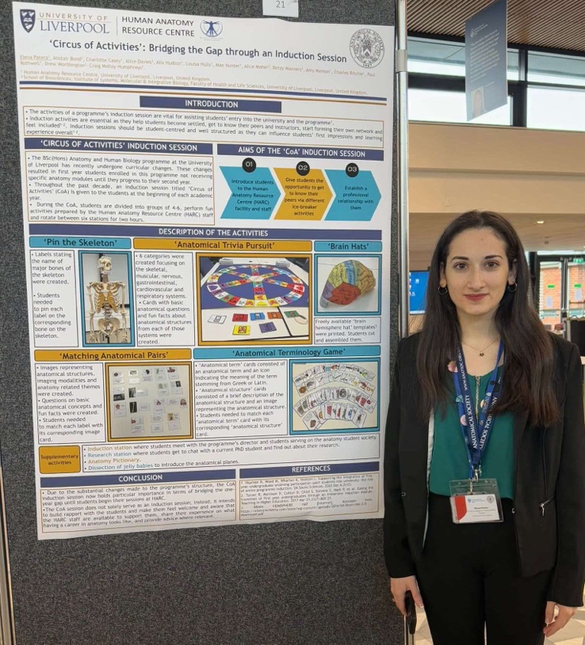
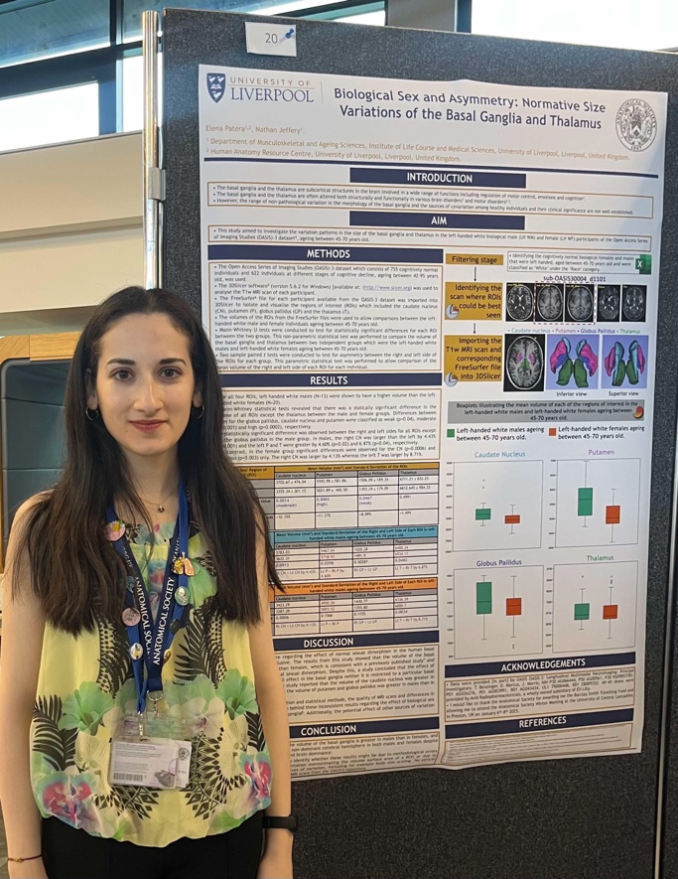

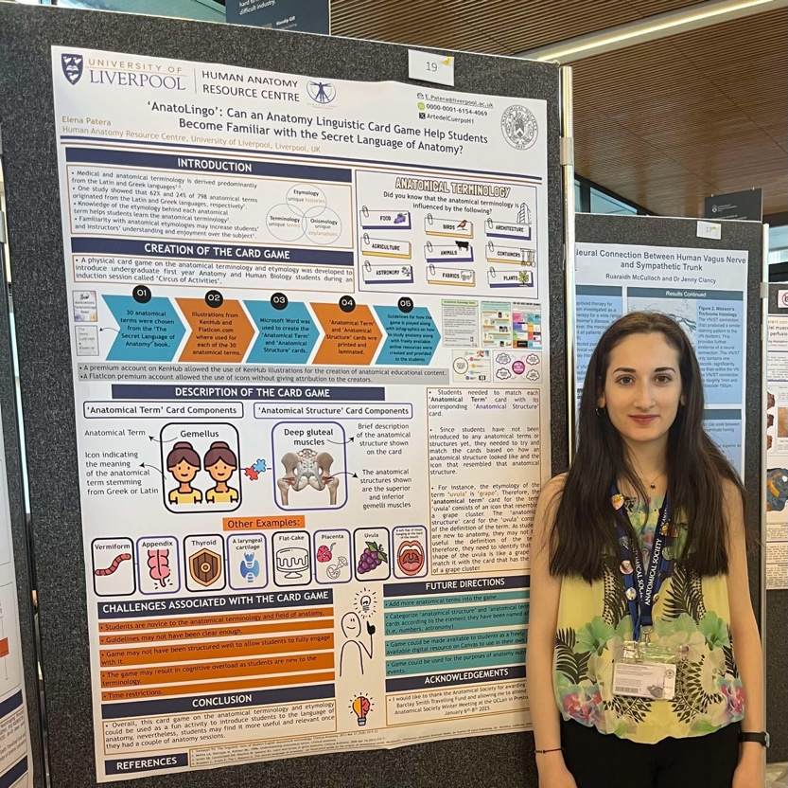

Pictures from the Anatomical Society-ECA pre-conference workshop second hour where Elena discussed with the attendees her PhD research and how she uses the 3DSlicer imaging analysis software to visualise T1w MRI scans of healthy adult individuals and obtain volumetric data.
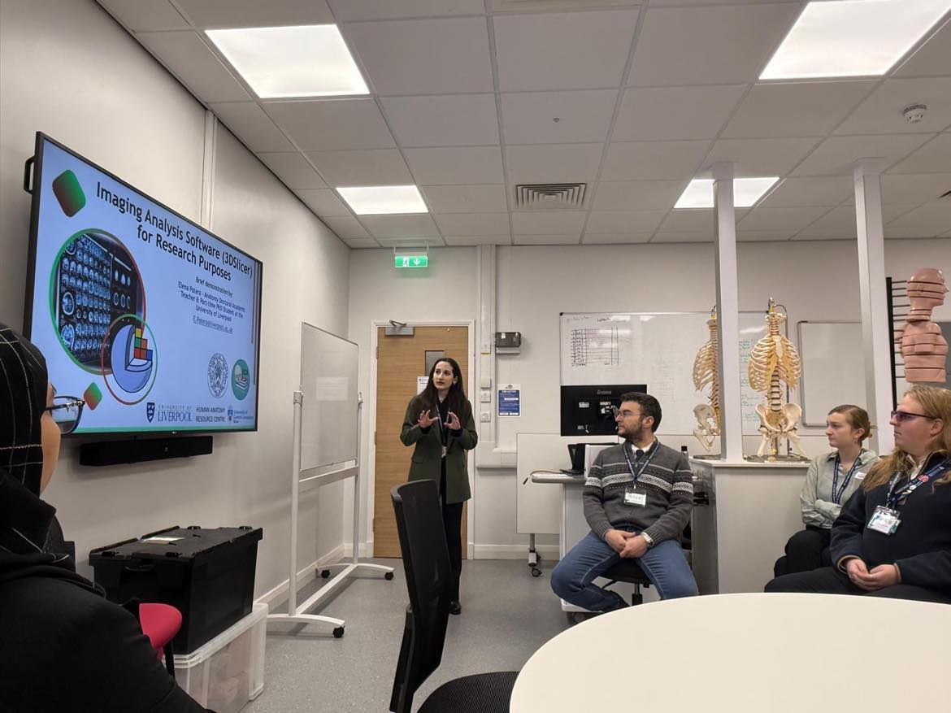

Copyright: If you submit images you must either own the copyright to the image or have gained the explicit permission of the copyright holder for the image to be submitted as part of the report for upload to the Society’s website, Newsletter, social media and so forth. A copyright statement must accompany each report if relevant. Answer N/A not applicable, YES or NO in the box below
YES
SIGNATURE | Elena Patera |  | DATE | 14.01.2025
If submitted electronically, a type-written name is acceptable in place of a hand-written signature
File: AS-Award-Report-Form-171023 – International Conference

File: BSF 202425 R1 EP Report website uploaded 160125

