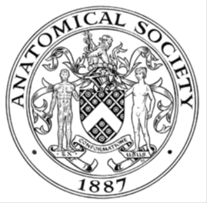
_______________________________________________________________________________________
AWARDEE REPORT FORM
_______________________________________________________________________________________

NAME |  | Munesh Khamuani
TWITTER HANDLE* optional |  | KhamuaniMunesh
UNIVERSITY |  | University of Nottingham
NAME OF AWARD |  | Symington Bequest
PURPOSE OF AWARD conference/event attended/organised (full name) with city and dates.
Attend/Present at IFAA 2026 in Melbourne, Australia
13-16 August in Melbourne

REPORT: What were your anticipated benefits?
Minimum number of words between 200-400. Please write in coherent paragraphs.
One of the most valuable aspects of attending IFAA 2026 was the opportunity to meet and connect with so many anatomists and anatomy educators from around the world, particularly those from outside the UK. It was amazing to see just how vast and diverse the field of anatomy education is, and how many different approaches, perspectives, and experiences exist across different countries and institutions.

Despite being separated by geographical borders, cultures, and educational systems, I found that many of the experiences shared by educators and students were surprisingly similar. We often face comparable challenges in teaching and learning anatomy and histology, whether that involves making complex anatomical concepts easier to understand, engaging students with the subject, or finding innovative ways to improve the learning experience. It was reassuring and inspiring to realise that, although our educational environments may be different, there is a shared passion for anatomy and a common goal of helping students develop a deeper understanding of the human body.

I also really appreciated being able to connect with people who have similar interests to me, particularly around anatomy and histology education. These conversations allowed me to exchange ideas, learn from other educators, and gain new perspectives that I can take forward in my own practice. More broadly, the experience reminded me that education is not confined by borders. There is a strong international community of educators and learners who are continually sharing knowledge, experiences, and ideas.

Overall, I found the experience incredibly enriching, both professionally and personally. It broadened my understanding of anatomy education and allowed me to build meaningful connections with people who share the same enthusiasm for the subject.
COMMENTS: Describe your experience at the conference / lab visit / course / seminar/ event.
Minimum number of words between 200-400. Please write in coherent paragraphs.
This was my first IFAA conference and, in fact, my first international anatomy conference outside the UK, so the experience was both exciting and quite overwhelming at the beginning. The scale of the conference was much larger than anything I had previously experienced, with over 800 delegates attending across four days. The programme was incredibly varied, with workshops taking place on the first day, followed by multiple sessions, symposia, presentations, and social events throughout the conference.

Initially, I found the sheer amount of activity slightly overwhelming, as there was always something happening and so many opportunities to learn and engage. There were several parallel sessions and symposia taking place at the same time, which meant that I often had to make difficult decisions about which sessions to attend. The conference/event app was particularly helpful in navigating the programme and planning my schedule, but even with this, there were many sessions and presentations that I would have loved to attend but simply could not because they were running simultaneously. In some ways, this was a positive challenge, as it reflected how much high-quality content was available.

One of the highlights of the conference was undoubtedly the quality of the speakers and presenters. The calibre of the presentations was exceptional, and I was able to learn about a wide range of topics and approaches within anatomy and histology education. I found it particularly valuable to hear from experts from different countries, such as the USA and Australia, as this exposed me to perspectives and ideas that I may not otherwise have encountered.

I also really enjoyed the social aspects of the conference, as these provided opportunities to meet and speak with other delegates in a more informal setting. If anything, my only wish would have been to have more time. With such a large number of attendees and so many interesting people to meet, I would have liked more opportunities to have longer conversations and build further connections. Overall, however, the experience was incredibly enriching and gave me a much greater appreciation of the scale and diversity of the international anatomy community.

REPORT: In relation to skills, what were the most important things you gained? (does not apply to equipment grant. For public engagement/outreach awards what did your audience gain and how did you evaluate success?
Minimum number of words between 200-400. Please write in coherent paragraphs.
In terms of skills, one of the most important things I gained from the conference was a better understanding of qualitative research methodology. I found the session on qualitative research particularly helpful, especially as it included speakers from the USA and Australia who discussed important considerations when conducting and evaluating qualitative research. In particular, the session explored how to ensure trustworthiness, rigour, and quality within qualitative research, which gave me a clearer understanding of how to strengthen the research process and improve the credibility of qualitative findings. These are skills that I feel will be particularly useful in developing my own research and critically evaluating qualitative studies in the future.

I also found the “Training the Trainer” session particularly valuable because of its interactive nature. Rather than simply listening to presentations, we were encouraged to actively participate, discuss ideas, and engage with other educators. What I found especially useful was the opportunity to work and communicate with participants from different countries and educational backgrounds. This allowed me to hear different perspectives on anatomy teaching and consider how approaches to education can vary depending on the context in which teaching takes place.

Overall, the conference strengthened both my research and teaching-related skills. More importantly, it encouraged me to think more critically about my own practice, learn from others, and consider how I can incorporate new approaches into my future work in anatomy and histology education.

REPORT: How do you think you will put this learning experience into practice in the future? For public engagement/outreach awards how with the materials/knowledge generated by this activity be used in the future?
Minimum number of words between 200-400. Please write in coherent paragraphs.
I think this learning experience will have a positive impact on both my teaching and research practice in the future. One of the main things I would like to do is explore the topics that I found particularly interesting in greater depth by reading more of the relevant literature and published research. The conference introduced me to several areas and approaches that I had not previously considered in detail.

I also hope to continue building the professional connections I made during the conference. In particular, I would like to stay connected with anatomists and educators who have similar interests and backgrounds, including through professional platforms such as LinkedIn. I think maintaining these connections will provide opportunities to continue sharing ideas, discussing challenges in anatomy and histology education, and learning from each other beyond the conference itself.

In the longer term, I would also be very interested in developing potential collaborations with some of the people I met. This could include working together on educational research, sharing teaching resources or approaches, or contributing to future projects. Having the opportunity to meet researchers and educators from different countries has shown me the value of bringing together different perspectives and experiences, and I would like to explore how this could contribute to future collaborative work.

Overall, I hope to use what I have learned not only by applying new ideas to my own teaching and research, but also by continuing to learn from the wider international anatomy education community. I see the conference as a starting point for further learning, networking, and potential collaboration rather than a one-off experience.
Data Protection/GDPR: I consent to the data included in this submission being collected, processed and stored by the Anatomical Society. Answer YES or NO in the Box below
YES
Graphical Images: If you include graphical images you must obtain consent from people appearing in any photos and confirm that you have consent. A consent statement from you must accompany each report if relevant. A short narrative should accompany the image. Answer N/A not applicable, YES or NO in the box below
YES
Copyright: If you submit images you must either own the copyright to the image or have gained the explicit permission of the copyright holder for the image to be submitted as part of the report for upload to the Society’s website, Newsletter, social media and so forth. A copyright statement must accompany each report if relevant. Answer N/A not applicable, YES or NO in the box below
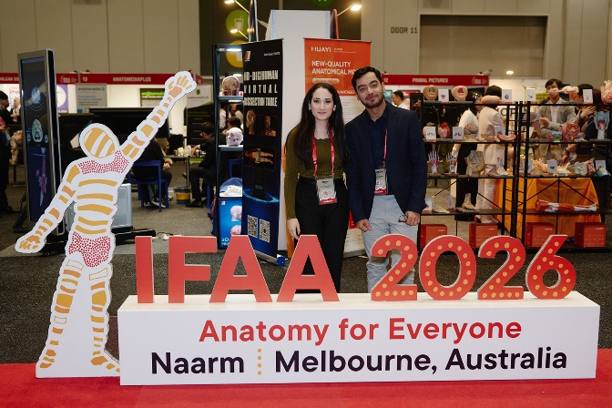
SIGNATURE | Munesh Pal Khamuani |  | DATE | 31.08.2026
If submitted electronically, a type-written name is acceptable in place of a hand-written signature
File: AS-Award-Report-Form-171023 – International Conference

