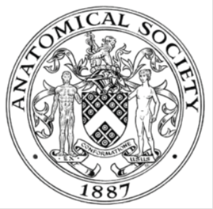
_______________________________________________________________________________________
AWARDEE REPORT FORM
_______________________________________________________________________________________

NAME |  | Elias Kassapis
UNIVERSITY |  | The University of Edinburgh
NAME OF AWARD |  | The Barclay-Smith Travelling Fund
PURPOSE OF AWARD conference attended (full name) with city and dates
To attend the Anatomists on the Edge 2017 conference, Galway, Ireland. 27th - 29th June

REPORT: What were your anticipated benefits?
To gain experience in attending and presenting in a scientific conference, expanding my networking and oral communication skills, as well as enriching my knowledge on anatomy, and to get informed of the latest advances in the field.
COMMENTS: Describe your experience at the conference / lab visit / course / seminar.
Being my first time in a scientific conference, I was surprised by how relaxed and friendly the atmosphere was, making it easy to approach and converse with people across disciplines and academic positions. This allowed me to get a better grasp of the many different aspects of anatomy, and of the value of such research and its application in clinical settings. It also improved my understanding of the life of a scientist and increased my awareness of the different opportunities offered in such a career setting. Overall it was a very enjoyable learning experience.

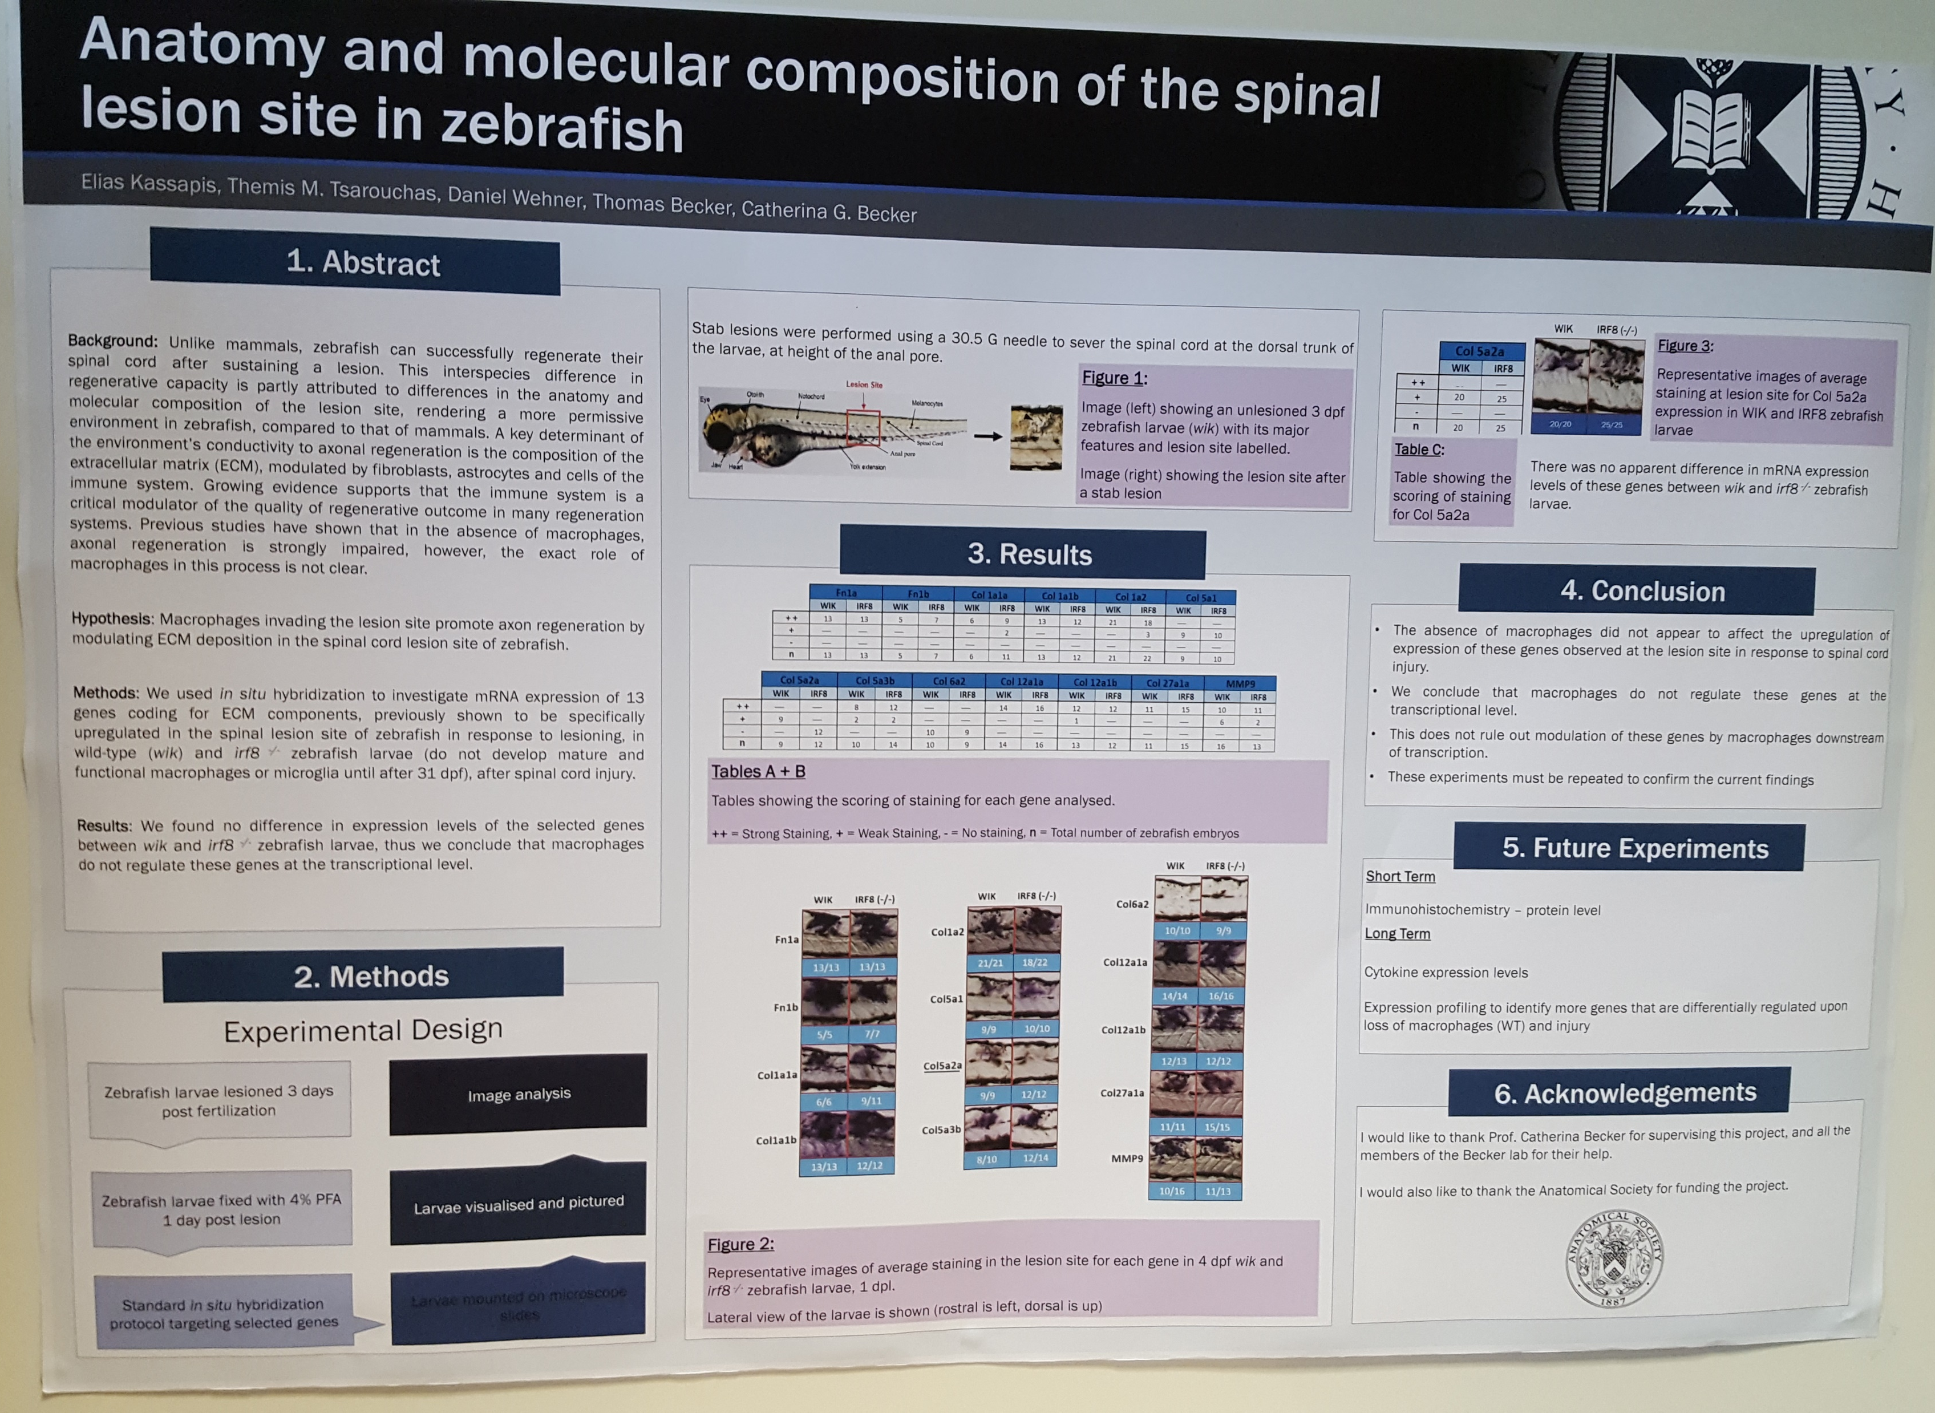

Figure 1. An image of the poster I presented in the conference

REPORT: In relation to skills, what were the most important things you gained? (does not apply to equipment grant)
This experience has enhanced my oral communication and poster presentation skills. I learned to be flexible in presenting my work, tailoring my presentation to meet the background, and relevant knowledge of each of my peers. This is a very important transferable skill, which will allow me to communicate information to the audience more effectively.

REPORT: How do you think you will put this learning experience into practice in the future?
Through this experience I have gained new insights that will increase the efficacy of my oral communication and presentation skills. For example, I have learned that differentiated instruction among peers of different background knowledge is more effective than using an identical approach for everyone. Also, I am now more familiar with the nature of the audience in such conferences, and thus, I will be better prepared for future conferences, ensuring effective and concise communication to all my spectators. Finally, in the conference I have seen a lot of very good posters, which have given me ideas to better design my own posters in the future.

SIGNATURE | Elias Kassapis |  | DATE | 18/07/2017
If submitted electronically, a type-written name is acceptable in place of a hand-written signature

File: AS-Award-Report-Form-BLANKCO-SEAL-date110216

