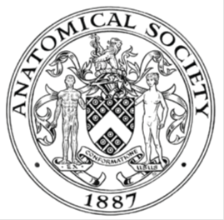
_______________________________________________________________________________________

AWARDEE REPORT FORM
_______________________________________________________________________________________

NAME |  | Matthew Myers
UNIVERSITY |  | University of Southampton
NAME OF AWARD |  | Barclay Smith Travel Bursary
PURPOSE OF AWARD conference attended (full name) with city and dates
To participate in the Anatomical Society Summer Meeting, Oxford, 23rd-25th July 2018.

REPORT: What were your anticipated benefits?
To deliver an oral presentation on research undertaken during my intercalated degree on the association between subarachnoid haemorrhage and amyloid-beta pathology in the human brain. Also to meet new professionals in the field and to keep up-to-date with current advances in anatomy.
COMMENTS: Describe your experience at the conference / lab visit / course / seminar.
St. John’s College, Oxford was an exceptional venue for this enjoyable summer AS meeting. The work presented was engaging and of a high standard. The conference ran smoothly and was clearly well organised. I enjoyed the opportunity to present my research to the audience and it was exciting to see talks from presenters with a range of experience from those at the cutting-edge of their field to a number of undergraduate students. I look forward to returning for the next AS meeting.

REPORT: In relation to skills, what were the most important things you gained? (does not apply to equipment grant)
It was useful to be able to practice delivering an oral presentation to an audience of experienced professionals. It was interesting to see the talks on how radiology should/can be applied to medical education. Discussion during the poster sessions was useful for sharing ideas and appraising research.

REPORT: How do you think you will put this learning experience into practice in the future?
I have received feedback on my oral presentation which I look forward to implementing in my next talk. As a group we have received interesting and insightful feedback on our work in the field of medical education which has given us ideas for future work.

SIGNATURE | Matthew Myers |  | DATE | 27/7/18
If submitted electronically, a type-written name is acceptable in place of a hand-written signature

File: AS-Award-Report-Form-BLANKCO-SEAL-date110216

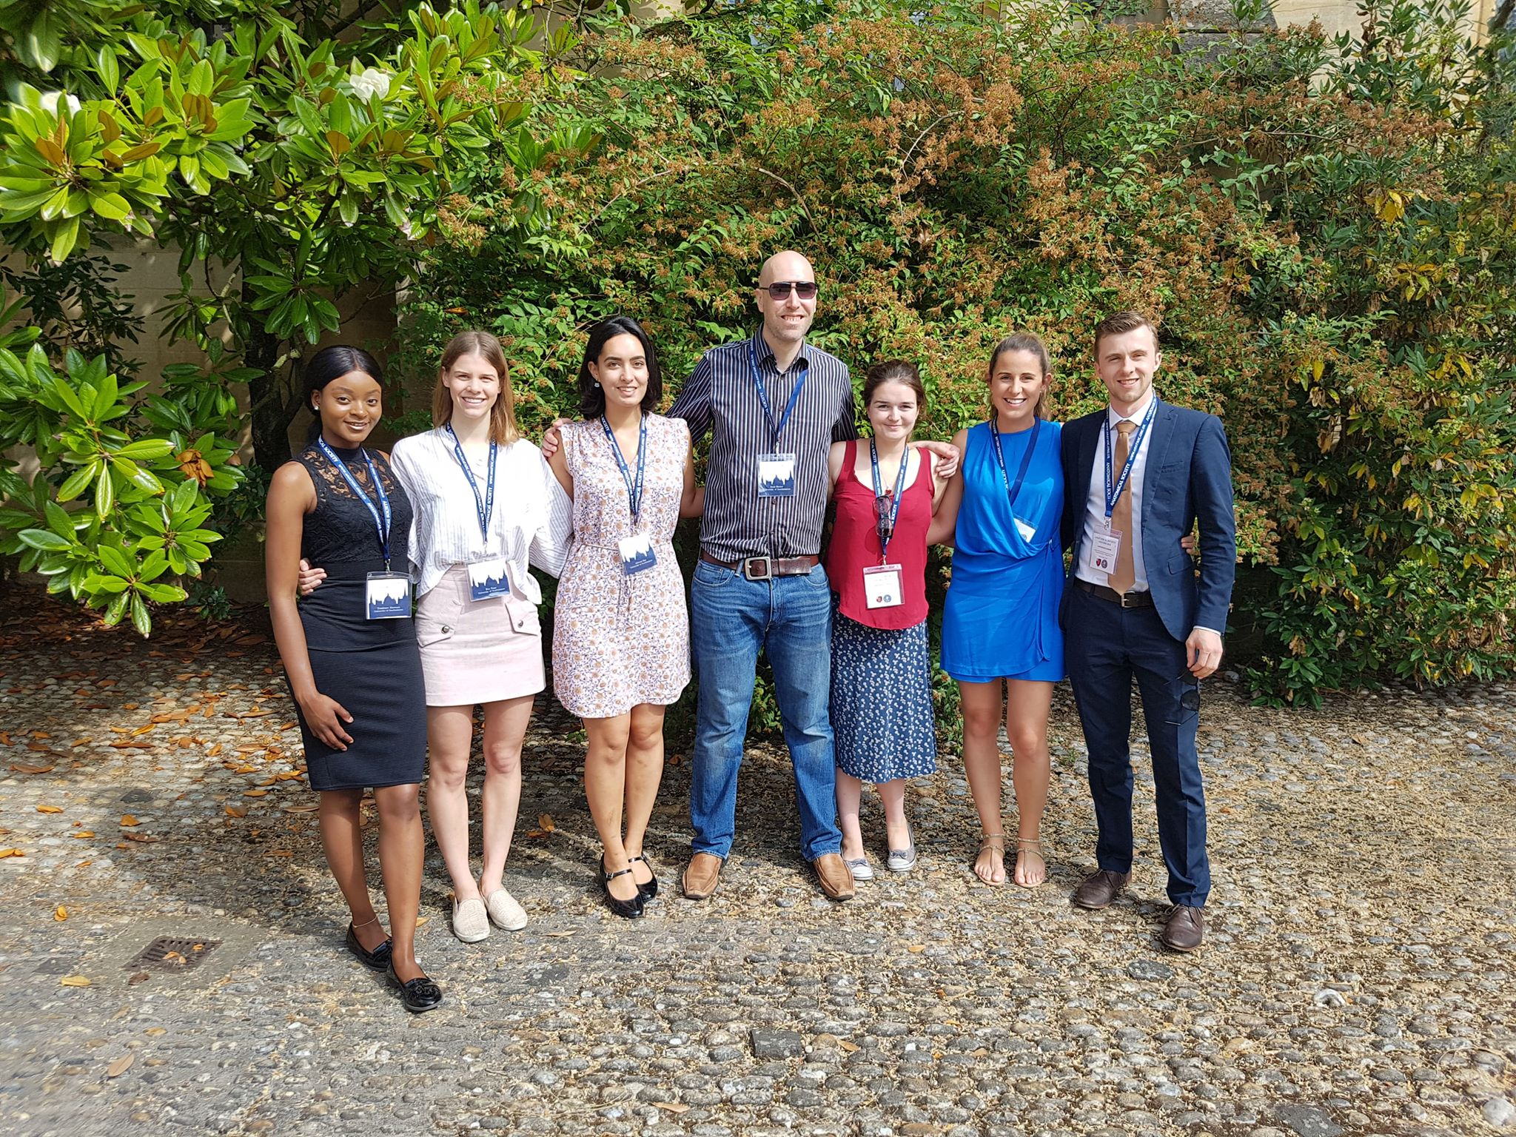

(permissions granted)
