PROJECT RESUME UPDATED SEPTEMBER 2019
First Supervisor: Lyndsay Murray, Centre For integrative Physiology, University of Edinburgh
Second Supervisor: Kosala Dissanayake, Centre for Cognitive and Neural Systems, University of Edinburgh
Investigating degeneration in morphologically distinct forms of axonal degeneration

The axons of motor neurons degenerate during development, following injury and across a range of neurodegenerative conditions, including motor neurone diseases. Degeneration can proceed as a retraction (die-back) away from the muscle, or as a fragmentation of the axon, in a process known as Wallerian degeneration. Despite morphological differences in degeneration under different physiological conditions, the extent of mechanistic overlap is unclear. We aim to investigate the molecular mechanisms of morphologically distinct types of axon degeneration, and determine whether there are common or distinct pathways.

We have expanded and optimised an ex vivo model previously developed to examine axon degeneration in tibial nerve/lumbrical muscle preparations, to introduce abdominal and cranial nerve/muscle preparations from the mouse. Using this model, we have demonstrated that the rate of Wallerian degeneration in all muscles examined is age-dependent, with neonatal muscles showing significant delays in Wallerian degeneration following transection when compared to adults (Fig. 1). Interestingly, there in intermuscular variability in the rate of degeneration, with some muscles displaying a greater rate of axon degeneration than others. We further show that the rate of Wallerian degeneration is increased in a mouse model of motor neuron disease. This implies there is likely to be a common mechanism of axon degeneration following injury and during disease. We have also investigated the effect of P53 knockout on morphologically distinct types of degeneration, and show that reduced levels of P53 do not affect the rate of synaptic and axonal degeneration which occurs during normal development or during Wallerian Degeneration.
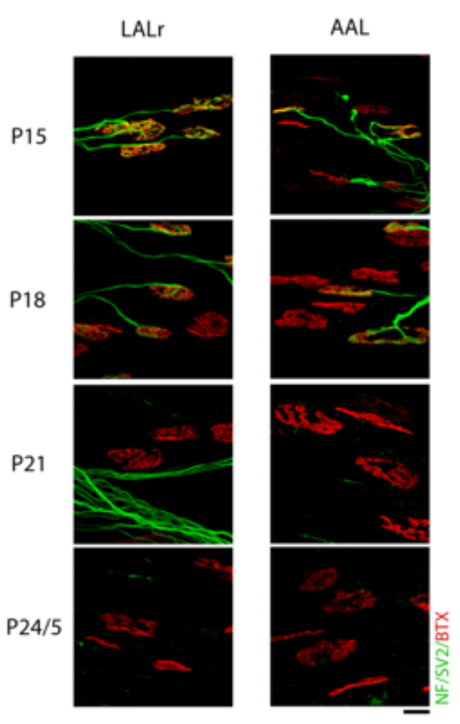

Fig. 1: The Rate of Wallerian Degeneration accelerates during postnatal development, and is different in different muscles. Representative confocal micrographs showing neuromuscular junctions labelled with antibodies against neurofilament (NF, green) and synaptic vesicle protein 2 (SV2, green), and α-bungarotoxin (BTX, red) from cranial muscles (levator auris longus rostral (LALr) and abductor auris longus (AAL)) which have been maintained ex vivo at 30°C for 24 hours. Note that levels of innervation remaining following injury decline as age increases, supporting the finding that rates of degeneration are developmentally regulated. Also note that levels of denervation are also non-uniform across these muscle bands, with the AAL being noticeably more denervated at younger time points. Scale bar = 20μM.

File: Project Resume Updated Sept 2019 Murray -v1 - 071019

