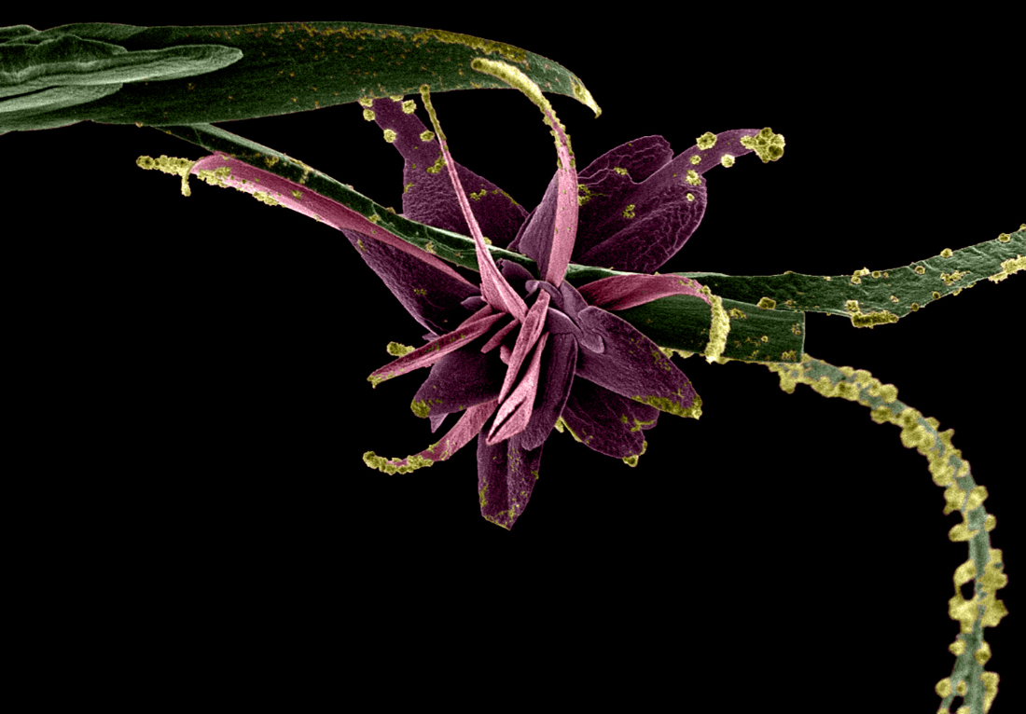

File: Medesan Science in Bloom

