
_______________________________________________________________________________________
AWARDEE REPORT FORM
_______________________________________________________________________________________

NAME |  | Fiona Cronin
UNIVERSITY |  | University of Limerick
NAME OF AWARD |  | Barclay Smith Travelling Award
PURPOSE OF AWARD conference/event attended/organised (full name) with city and dates.
Attendance at the IFAA conference, London, 9-11 August 2019.

REPORT: What were your anticipated benefits?
This was the first major conference I have attended and although I had no well-defined expectations, I thought I would at least be exposed to novel research in areas I am both familiar and unfamiliar with. I hoped to be inspired by speakers of all career stages at the conference, in particular those at the early stage. As I was presenting a poster, I also expected that I would get some advice or thought-provoking questions from others during the poster session.
COMMENTS: Describe your experience at the conference / lab visit / course / seminar/ event.
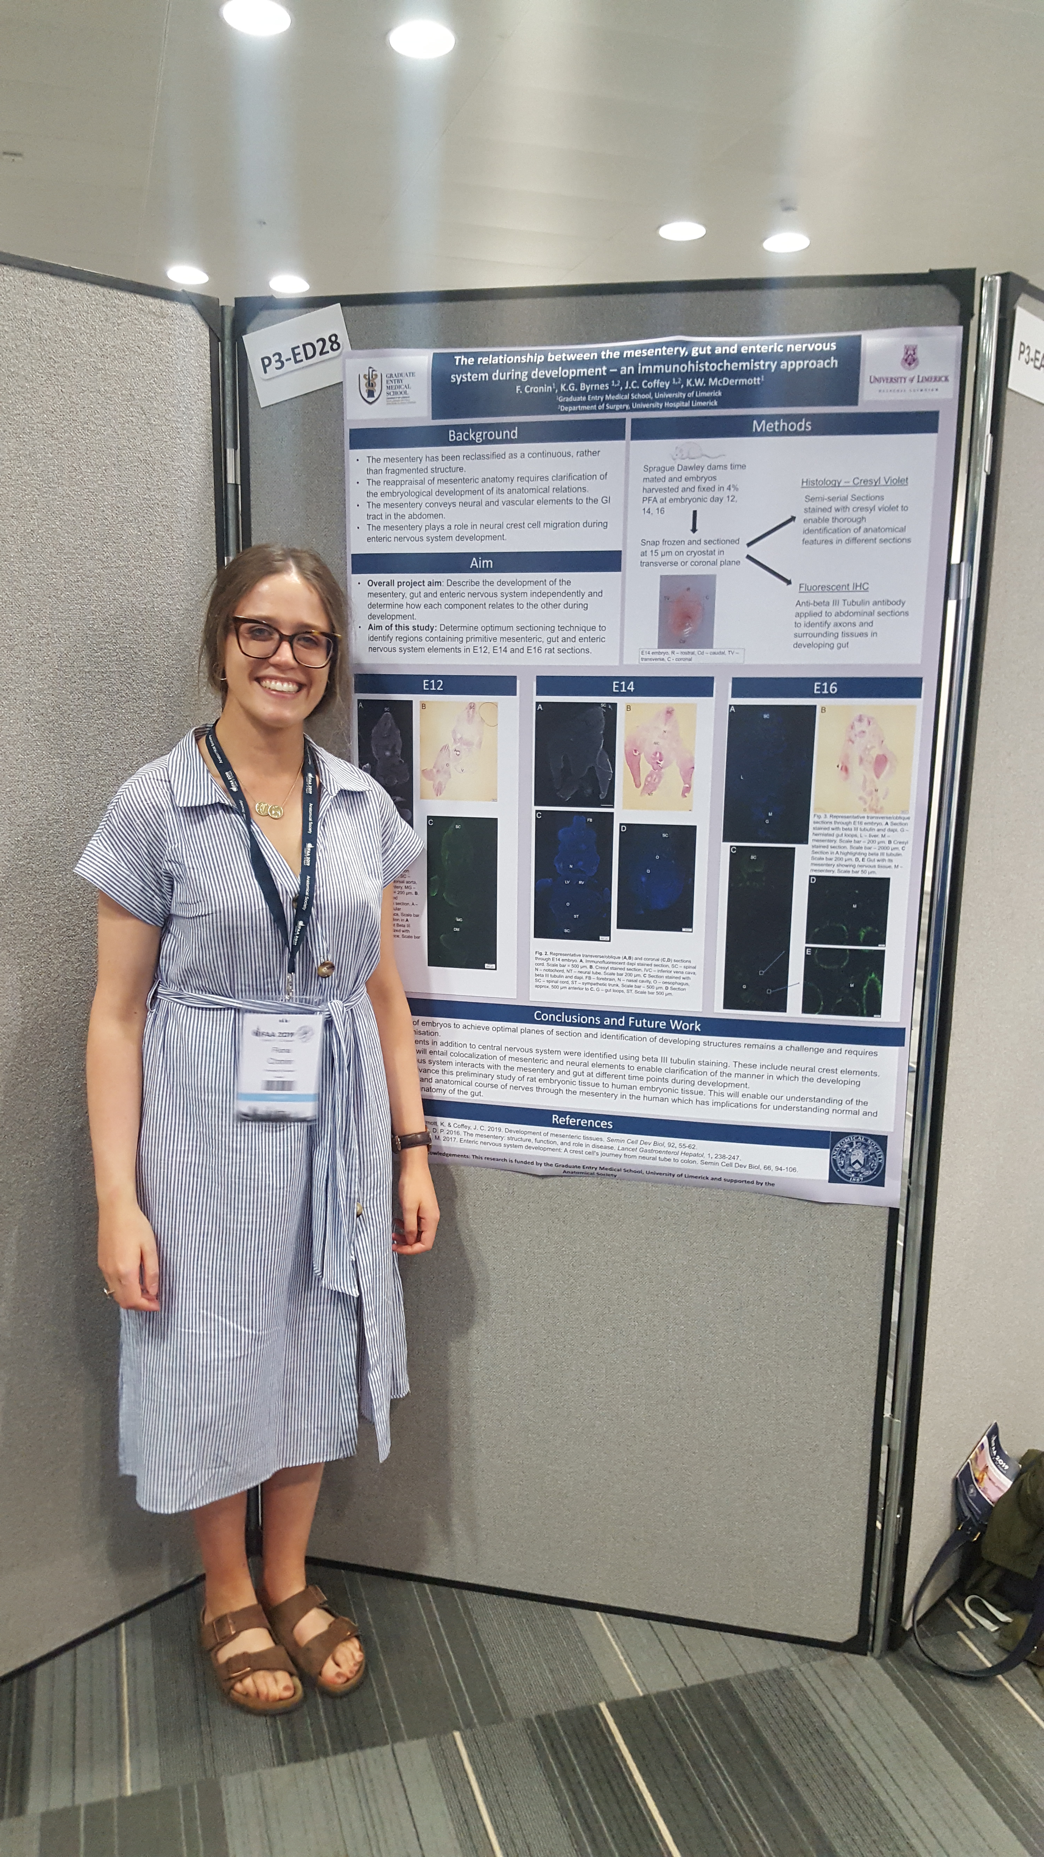
My experience at the conference was positive. I travelled to the conference alone and although it was a little daunting on the first day, the choice of speakers and talks each day meant I was always engrossed in a topic that was of interest to me. At times I had to forego one interesting talk to attend another which was unfortunate but understandable. I did engage with neighbours during the poster session which was a great way to get to know other researchers. I also attended a number of sessions that I had limited knowledge of but now feel I have learned something about.

REPORT: In relation to skills, what were the most important things you gained? (does not apply to equipment grant. For public engagement/outreach awards what did your audience gain and how did you evaluate success?
Although I did not have an oral presentation, I definitely picked up on some examples of how to make a short presentation more captivating and after the second day I noticed common structures that made presentations more informative and easier to follow. I also took note of imaging software and analysis tools that I intend to make use of in my research.

REPORT: How do you think you will put this learning experience into practice in the future? For public engagement/outreach awards how with the materials/knowledge generated by this activity be used in the future?
I hope to present at a conference in the near future and I will certainly use my experience at IFAA as a guide when making and delivering that presentation. Although the poster session was not as busy as I thought it would be, I did get the contact details of a late-stage PhD student who I hope to remain in contact with as she is developing an imaging programme that may be useful in my research.

Data Protection/GDPR: I consent to the data included in this submission being collected, processed and stored by the Anatomical Society.
YES/NO Yes
Graphical Images: If you include graphical images you must obtain consent from people appearing in any photos and confirm that you have consent. A consent statement from you must accompany each report if relevant. A short narrative should accompany the image.
YES/NO YES

Copyright: If you submit images you must either own the copyright to the image or have gained the explicit permission of the copyright holder for the image to be submitted as part of the report for upload to the Society’s website, Newsletter, social media and so forth. A copyright statement must accompany each report if relevant.
YES/NO YES

SIGNATURE | Fiona Cronin |  | DATE | 15/08/19
If submitted electronically, a type-written name is acceptable in place of a hand-written signature
File: BS Report 201819 edited no signature – Ms Fiona Cronin

