YEAR: 2014/15
SUPERVISOR: DR SARAH CHANNON
STUDENT: MR ALAN JOHNSON
INSTITUTION: RVC, LONDON
PROJECT TITLE: DO THEY SNOOZE AND LOSE? DEVELOPMENT OF A VALID AND RELIABLE ASSESSMENT FOR EVALUATION OF ANATOMICAL KNOWLEDGE LOSS/GAIN DURING A 5 YEAR CLINICAL UNDERGRADUATE DEGREE PROGRAMME

Brief Resume of your Project's outcomes for the Society's Website: (no more than 200-250 words).
The title of your project and a brief 200-250 word description of the proposed/completed project. The description should include sufficient detail to be of general interest to a broad readership including scientists and non-specialists. Please also try to include 1-2 graphical images (minimum 75dpi). NB: Authors should NOT include sensitive material or data that they do not want disclosed at this time.
The aim of this project was to create a test to evaluate anatomical knowledge and application of students on the Veterinary Medicine course at the Royal Veterinary College. Clinicians have felt for a number of years that students in the later (clinical) years forgot much of their 'pre-clinical' anatomical knowledge from the first 2 years. The test was designed to cover the broad number of species veterinarians work with and identify if there was indeed a loss of knowledge and potentially identify a suitable time for an anatomy knowledge 'booster'. Figure 1 shows a screenshot from part of the online test:
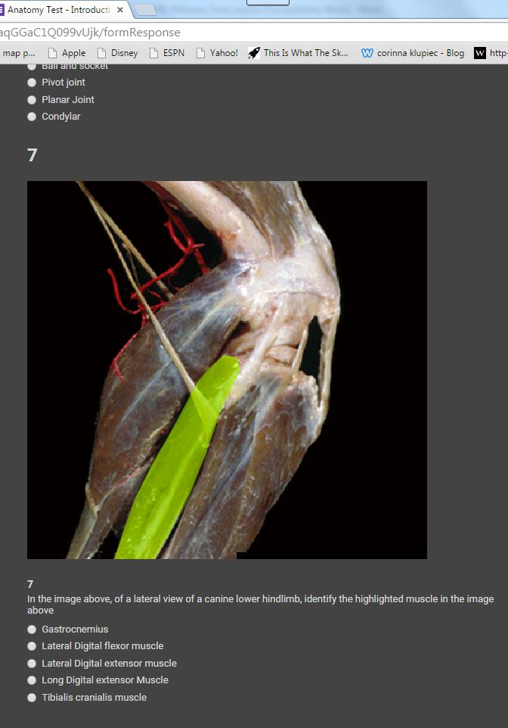

Figure 1 - screenshot from online test
Reliability and difficulty of the test were statistically determined, and the test was adapted to ensure that it was of a suitable level and reliability. Two independent year groups of students with differing levels of knowledge scored 64.8 v 35.7 % on the test respectively indicating that the test was able to discriminate between differing abilities of students. The test will now be rolled out to the student cohort at the Royal Veterinary College at the start of the 2015-16 academic year. We will be able to report the full results of the project at the upcoming Winter Meeting of the Anatomical Society (December 2015).
File: UGProjectOUtcome201415ChannonJohnson

