UNDERGRADUATE SUMMER VACATION SCHOLARSHIP AWARDS – FINAL SUMMARY REPORT FORM 2023/24
NB: This whole report will be posted on the Society’s website therefore authors should NOT include sensitive material or data that they do not want disclosed at this time.

Name of student:
NURUL FIRZANAH BINTI OMAR

Twitter Handle*:
(*optional)
Name of supervisor(s):
PROFESSOR LAURA ANDREAE
Project Title: (no more than 220 characters)
MAPPING RNA REGULATORY MECHANISMS UNDERLYING AUTISM SPECTRUM DISORDER
Project aims: (no more than 700 words)
Autism spectrum disorder (ASD) is a neurodevelopmental disorder that is characterised by impairments in social communication and behaviour of the affected individuals. Approximately it is affecting over 1% of the population and its prevalence has been increasing over the years. It has a strong genetic basis but is highly heterogeneous, with hundreds of genes associated with ASD risk identified to date. Given the heterogeneity of the disorder, identifying common underlying mechanisms is crucial for the development of effective treatments.

A common molecular mechanism in ASD is the misregulation of brain-specific microexons, 3-27 nucleotide exons that are frequently skipped in the brains of individuals with ASD because of disrupted splicing (Irimia et al., 2014). The splicing regulator SF Serine/Arginine Repetitive Matrix 4 (SRRM4) is a key regulator of neuronal microexons and has also been linked to ASD as its expression is reduced in the brains of individuals with the disorder (Irimia et al., 2014).

Preliminary data suggests that Srrm4 expression is downregulated in mouse models of haploinsufficiency of ASD risk genes. This could therefore represent a potential molecular pathway linking genotype to downstream effects. However, it remains unclear whether changes in Srrm4 expression are specific to cell types, brain regions or under specific activity conditions. We are particularly interested in determining whether Srrm4 expression is specifically altered in areas of the brain that are implicated in ASD, such as the prefrontal cortex and hippocampus. Neuroanatomical mapping of Srrm4 expression across the entire mouse brain could help answer these questions. For this summer studentship, we will begin by focusing on the prefrontal cortex, and hippocampus.

The aim of this project is to determine whether there are region-specific changes in Srrm4 expression in mouse models of haploinsufficiency of ASD-associated genes. To address this question, we intend to use RNA fluorescence in situ hybridization (RNA-FISH) to measure Srrm4 mRNA levels in different areas of mouse brain sections.

Project Outcomes and Experience Gained by the Student (no more than 700 words)
During my 10-week summer studentship, we focused on detecting whether there are region-specific changes in Srrm4 expression in a mouse model of haploinsufficiency of the ASD-associated gene Chd8. We used RNA fluorescence in situ hybridization (RNA-FISH) to measure Srrm4 mRNA levels in different brain areas, focusing on the hippocampus and prefrontal cortex. As a control, we also measured Camk2a mRNA levels.
We started by carrying out a series of experiments to optimise the signal to noise ratio by trying different concentrations of Srrm4 and Camk2a probes for RNA-FISH. After a few trials, we decided to go with 5pmol in 100µl for Camk2a and 2pmol in 100µl for Srrm4, which showed a good signal to noise ratio.
4 mice were used for the experiments – 2 Chd8+/- and 2 wildtype littermate controls. The brain sections were prepared by sectioning the brain coronally using a cryostat and mounting the sections onto glass slides. For this project, we used a Hybridization Chain Reaction RNA fluorescence in situ hybridization (HCR-FISH) protocol to measure Srrm4 and Camk2a mRNA levels. The protocol involved a detection stage where the probes bind to their target sequences and an amplification stage. The brain sections were then imaged using a confocal microscope to aquire images of the signals for DAPI, Srrm4 and Camk2a focusing on the CA1 region of the hippocampus and prefrontal cortex layer 5 (Fig. 1).

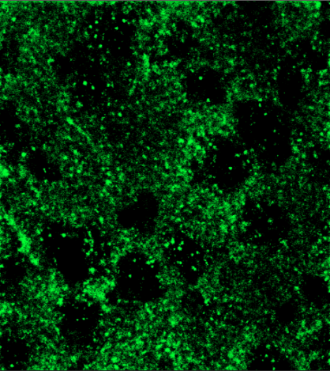
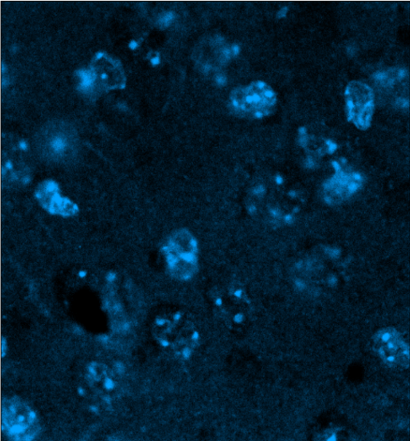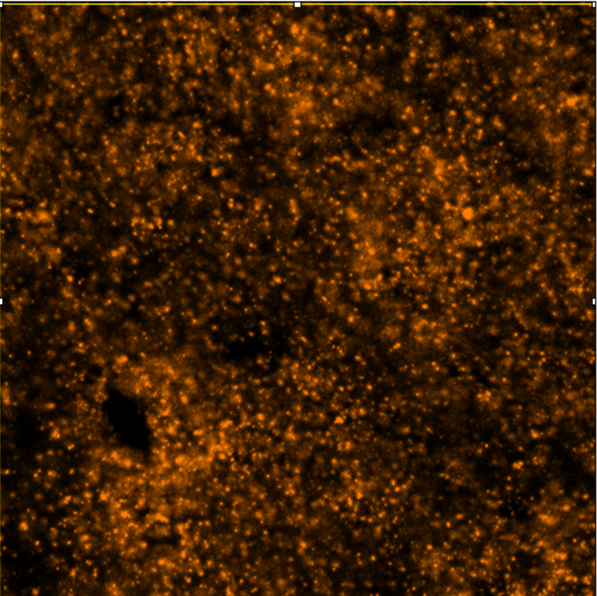

Figure 1: DAPI, Srrm4 and Camk2a signals in prefrontal cortex layer 5 detected using 63x confocal microscopy.

I used MATLAB to analyse the images and to calculate the puncta density per 100 µm ²(Fig.2). The images were first masked based on the DAPI signals to identify the cell nuclei and only measure the signals within the nuclei. The analysis was done blinded to genotype to avoid bias. The puncta density per 100µm² was calculated for both Srrm4 and Camk2a for each region.

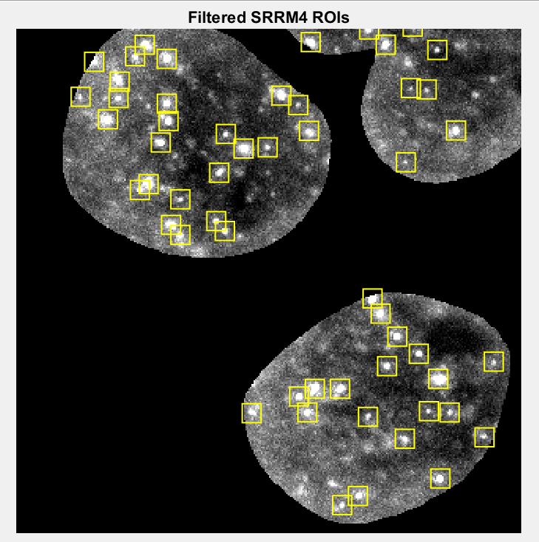
Figure 2: Srrm4 signals detected and puncta density per 100µm² calculated using MATLAB.

The data were plotted into bar charts using GraphPad Prism 10 (Fig. 3).

Figure 3: Puncta density per 100 µm² of Camk2a and Srrm4 in wildtype and CHD8+/- mice in the CA1 region of the hippocampus and prefrontal cortex layer 5. 4-5 slices were analysed from n=2 animals per genotype.

Based on this data, there is a trend for a decrease in Srrm4 expression in prefrontal cortex layer 5 in the Chd8+/- mouse brain. However, this does not seem to be the case for Srrm4 in the CA1 region as the values were similar for the wildtype and Chd8+/- mice. However, a larger sample size is needed to confirm these results. Future research can also be done on mapping Srrm4 expression in other brain regions of Chd8 haploinsufficient mice.

Experience Gained: This project has been a fun and fantastic journey for me discovering neuroscience and surrounding myself with academic and experimental environment. I have learned various experimental techniques in a variety of fields, including a combination of molecular and imaging techniques. I learned how to prepare frozen brain sections using a cryostat, perform in situ hybridisation, gel electrophoresis to detect gender of the mice and whether they were heterozygous or not, and received training on how to obtain images using a confocal microscope. Other than that, I also learned how to analyse images using ImageJ and MATLAB, which I used it for quantitative analysis. This project deepens my understanding in neuroanatomy as I can connect and relate what I learned during lecture with this project. I also managed to learn more about the structure and cellular composition of different brain areas, which in this project I focused on pre-frontal cortex and hippocampus. In addition, I really enjoyed the lab meetings and attending the journal clubs as I was exposed to the exciting research that currently being conducted or related with the team’s research. I managed to reflect that there are many more exciting and amazing questions can be asked and yet to be explored.

Please state which Society Winter or Summer Meeting the student is intending to present his/her poster at:
Summer Meeting University of Oxford, Oxford, 14th to 16th July 2025

Proposed Poster Submission Details (within 12 months of the completion of the project) for an AS Winter/ Summer Meeting – (no more than 300 words)
Investigating Region-Specific Changes in Srrm4 Expression in Mouse Models of Autism Spectrum Disorder

Brief Resume of your Project’s outcomes: (no more than 200-250 words).
The title of your project and a brief 200-250 word description of the proposed/completed project. The description should include sufficient detail to be of general interest to a broad readership including scientists and non-specialists. Please also try to include 1-2 graphical images (minimum 75dpi). NB: Authors should NOT include sensitive material or data that they do not want disclosed at this time.

MAPPING RNA REGULATORY MECHANISMS UNDERLYING AUTISM SPECTRUM DISORDER

Autism spectrum disorder (ASD) is a neurodevelopmental disorder affecting social communication and behaviour of the affected individuals. A potential common mechanism is the misregulation of brain-specific microexons that are frequently skipped in individuals with ASD (Quesnel-Vallières et al., 2016). The splicing factor SRRM4 is a key regulator of neuronal microexons and has also been linked to ASD as its expression is reduced in individuals with the disorder (Irimia et al., 2014). Preliminary evidence suggests the expression of Srrm4 may also be altered in mouse models of haploinsufficiency of ASD-associated genes. We used fluorescent in situ hybridisation (FISH) to determine Srrm4 expression in specific brain regions in those mouse models focusing on prefrontal cortex layer 5 and hippocampal CA1 region. Synaptic transmission is disrupted in prefrontal cortex of a haploinsufficient Chd8 mouse model (Ellingford et al., 2021). We hypothesised that if there are changes in Srrm4 expression, they would be found in the same areas where synaptic transmission is also affected. From the data, there is a trend for a decrease in Srrm4 expression in prefrontal cortex layer 5 in the Chd8+/- mouse brain, while Srrm4 expression in the hippocampus does not seem to be altered. This project suggests that there may be region-specific changes in Srrm4 expression in mouse models of haploinsufficiency of ASD-associated genes.

Bar charts comparing puncta density per 100 µm² of Camk2a and Srrm4 between wildtype and Chd8+/- mutant mouse in the CA1 region of the hippocampus and prefrontal cortex layer 5.

Other comments: (no more than 300 words)

All procedures were done in accordance with the Animals (Scientific Procedures) 1986 Act and in
accordance with the relevant project and personal licenses.

References

Ellingford, R. A., Panasiuk, M. J., de Meritens, E. R., Shaunak, R., Naybour, L., Browne, L., Basson, M. A., & Andreae, L. C. (2021). Cell-type-specific synaptic imbalance and disrupted homeostatic plasticity in cortical circuits of ASD-associated Chd8 haploinsufficient mice. Molecular Psychiatry, 26(7), 3614–3624. https://doi.org/10.1038/s41380-021-01070-9

Irimia, M., Weatheritt, R. J., Ellis, J. D., Parikshak, N. N., Gonatopoulos-Pournatzis, T., Babor, M., Quesnel-Vallières, M., Tapial, J., Raj, B., O’Hanlon, D., Barrios-Rodiles, M., Sternberg, M. J. E., Cordes, S. P., Roth, F. P., Wrana, J. L., Geschwind, D. H., & Blencowe, B. J. (2014). A highly conserved program of neuronal microexons is misregulated in autistic brains. Cell, 159(7), 1511–1523. https://doi.org/10.1016/j.cell.2014.11.035

Quesnel-Vallières, M., Dargaei, Z., Irimia, M., Gonatopoulos-Pournatzis, T., Ip, J. Y., Wu, M., Sterne-Weiler, T., Nakagawa, S., Woodin, M. A., Blencowe, B. J., & Cordes, S. P. (2016). Misregulation of an Activity-Dependent Splicing Network as a Common Mechanism Underlying Autism Spectrum Disorders. Molecular Cell, 64(6), 1023–1034. https://doi.org/10.1016/j.molcel.2016.11.033

I would like to express my heartfelt gratitude to my supervisor, Professor Laura Andreae for providing me the opportunity to participate in this project and her invaluable guidance, support, and encouragement throughout this project. A special thanks to Miss Preslava Todorova for her mentorship, full support and insightful advice, which greatly contributed to my learning experience. I am also deeply grateful to all the members of the lab and Centre for Developmental Neurobiology, for their warm welcome and constant support. Finally, I extend my sincere thanks to the Anatomical Society for providing the studentship that made this research possible.

Data Protection/GDPR: I consent to the data included in this submission being collected, processed and stored by the Anatomical Society. Answer YES or NO in the Box below
YES
Graphical Images: If you include graphical images you must obtain consent from people appearing in any photos and confirm that you have consent. A consent statement from you must accompany each report if relevant. A short narrative should accompany the image. Answer N/A not applicable, YES or NO in the box below
N/A
Copyright: If you submit images you must either own the copyright to the image or have gained the explicit permission of the copyright holder for the image to be submitted as part of the report for upload to the Society’s website, Newsletter, social media and so forth. A copyright statement must accompany each report if relevant. Answer N/A not applicable, YES or NO in the box below
N/A

Signature of student....FIRZANAH OMAR.........Date…8/10/24………..

Signature of supervisor LAURA ANDREAE Date…15/10/2024.…

END OF FORM
---------------------------------------------------------------------------------------
File: USVRS-Award Letter 2024_ v1-170524_Template_ Dr Laura Andreae-200524
File: USVRS 2324 Report FO LA – website – uploaded 241024

