UNDERGRADUATE SUMMER VACATION SCHOLARSHIP AWARDS – FINAL SUMMARY REPORT FORM 2024/25
NB: This whole report will be posted on the Society’s website therefore authors should NOT include sensitive material or data that they do not want disclosed at this time.

Name of student:
Ms Katherine Kurth

Twitter Handle*:
(*optional)

Name of supervisor(s):
Dr Caroline Allen

Project Title: (no more than 220 characters)
Comparison of Fixation Techniques for Immunohistochemistry and Basic staining of Human Post-Menopausal Ovarian Tissue.

Project aims: (no more than 700 words)
Background
Fixation of tissue samples/biopsies is the first step in the preparation of tissue for histological
analysis. It is required to prevent autolysis and/or putrification of tissues, preserving the normal
architecture of the sample to allow for subsequent analysis in histopathology investigations in
clinical and research settings. Common fixatives include the use of aldehydes which fix tissues by
forming cross links between proteins. Commercially available fixatives include Bouins, formalin
and paraformaldehyde which all contain a mixture of formaldehyde [1]. Neutral buffered formalin (NBF) is a common fixative in histology laboratories and is used for samples which undergo immunohistochemistry to detect specific antigens. This is due to superior preservation of tissue microarchitecture whilst maintaining antigenicity to allow for antigen detection. The solution of NBF is composed of a 4% formaldehyde solution that is buffered to a neutral pH using PBS, however, this fixative has been shown to produce significant tissue shrinkage which can disrupt the normal architecture and overall size of tissue samples, hindering histological analysis [2].

Current fixation methods can cause significant issues when performing histological analysis of ovarian tissue [3]. The most common fixatives used today for ovarian tissue fixation include NBF which can cause shrinkage, and Bouin’s solution which interferes with immunohistochemical analysis [3][4]. Ovarian tissue is unique in its composition as it contains hyaluronic acid, which is sensitive to different types of fixatives, and plays an important role in gauging ovarian health [4]. Previous investigations have shown the potential of utilizing a solution of formalin with 5% acetic acid as a fixative for ovarian tissue from humans, feline, sheep, and mice of reproductive age [3,4,5]. They have shown that this fixation protocol was superior in comparison to NBF or Bouin’s fixatives with multiple histological techniques including basic stains and IHC. At the University of Glasgow, we have a body donation programme and therefore access to human tissue samples for histological investigations. We currently embalm cadavers with formaldehyde or preserve the body through freezing to be used as fresh-frozen cadavers. However, previous attempts within our facility to use either formaldehyde fixed ovaries or NBF fixed ovaries from fresh-frozen cadavers from postmenopausal women have not been successful and has therefore hindered our ability to conduct further research into ovarian biology.

Aims
Evaluate the effectiveness of formalin-acetic acid versus formalin fixation in preserving ovarian tissue from postmenopausal women for histological investigations including basic staining and IHC.

1. Collect ovarian tissue from postmenopausal fresh-frozen cadavers and fix ovaries in neutral buffered formalin or Form-Acetic
2. Process ovarian tissue for histological analysis including processing, wax embedding and sectioning
3. Perform basic histological staining with H&E and analyse the % of shrinkage in the tissue fixed with NBF and Form-Acetic
4. Perform immunohistochemistry to determine whether post-menopausal ovarian health markers could be visualized in tissue fixed with NBF and Form-Acetic

References
1. Suvarna, S.K., Layton, C. and Bancroft, J.D., 2019. Bancroft’s theory and practice of histological techniques. 8th ed. Oxford: Elsevier.

2. Buesa, R.J., 2008. Histology without formalin? Annals of Diagnostic Pathology, [online] 12(6), pp.387–396. Available at: https://doi.org/10.1016/j.anndiagpath.2008.07.004.

3. Adeniran, B.V., Bjarkadottir, B.D., Appeltant, R., Lane, S. and Williams, S.A., 2021. Improved preservation of ovarian tissue morphology that is compatible with antigen detection using a fixative mixture of formalin and acetic acid. Human Reproduction, [online] 36(7), pp.1871–1890. Available at: https://academic.oup.com/humrep/article/36/7/1871/6270965.

4. Appeltant, R., Adeniran, B.V. and Williams, S.A., 2021. Fixation in Form-Acetic allows hyaluronic acid detection in mouse ovaries. Reproduction and Fertility, 2(4), pp.L10–L12. Available at: https://www.ncbi.nlm.nih.gov/pmc/articles/PMC8788581/.

5. Alkali, I.M., Colombo, M., Rodak, O., Nizanski, W. and Luvoni, G.C., 2024. Effect of fixatives and fixation period on morphology and immunohistochemistry of feline ovarian tissue. Animals, [online] 14(6), p.825. Available at: https://www.ncbi.nlm.nih.gov/pmc/articles/PMC10967444/.

Project Outcomes and Experience Gained by the Student (no more than 700 words)
Project Outcomes

Aims 1 and 2
Four pairs of postmenopausal ovaries were collected from fresh frozen cadavers at the University of Glasgow. One of the ovaries from each pair was fixed in the buffered formalin, while the other was fixed in Form-Acetic for 24 hours. The ovaries were embedded in paraffin wax and serially sectioned at 7µm to provide an overview of the ovary. Donors who had provided imaging permission were included within this study which was conducted under the Anatomy Act (1984) and Human Tissue (Scotland) Act (2006), therefore ethical approval was not required by UoG Ethics Committee. Permission for this project involving the use of human material was provided by the Head of Anatomy prior to start date.

Aim 3
Basic H&E staining was performed on the NBF and form-acetic fixed ovaries from five donors. Quantitative analysis was used to measure the percentage of shrinkage. Images were taken with a Zeiss Axioscope 2 microscope and assessor analysed images blinded to fixative. Percentage area of shrinkage was calculated using ImageJ where area of white space from shrinkage due to fixation was circled and area measured (excluding the tears from the microtome and the white spaces around the edges of the sections) (Figure 1). The total area of shrinkage was then divided by area of tissue to provide a percentage. Statistical analysis is ongoing using RStudio.

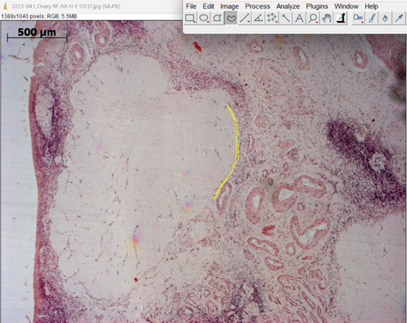

Figure 1: ImageJ screenshot of analysis, white space was circled and area measured, seen in yellow. The total area of white spaces divided by the overall area of the ovary to provide percentage of shrinkage.
Aim 4
Immunohistochemistry was performed with FOXL2 (ab246511) and vimentin (ab92547) primary antibodies purchased from Abcam. Antibodies were optimized using mouse ovarian tissue sections testing three dilutions based on ranges provided in datasheets. Following the results of optimization, 1/500 dilution was used for vimentin, and 1/1000 dilution was used for FOXL2. Immunohistochemistry was performed using standard protocols. Antigen retrieval was carried out using citrate buffer. Endogenous peroxidase activity was blocked with hydrogen peroxide, and non-specific binding was minimized using goat serum. Biotinylated secondary antibodies were applied, followed by signal amplification using the avidin-biotin complex (ABC) method. Visualization was achieved with 3,3'-diaminobenzidine (DAB), developed for 6 minutes. Comparative qualitative analysis was used to compare expression of markers between different fixatives. For both the Vimentin and FOXL2, the antibody showed up darker on the Form-Acetic fixative (Figure 2) despite both fixatives developing for the same amount of time. This suggests better preservation of antigenicity with Form-Acetic fixative. This may be due to the addition of the acetic acid, which allows the fixative to balance between morphological preservation and antigen accessibility. By itself, formalin creates intense cross links that can mask epitopes, but the acetic acid loosens the cross links and allows for antigen retrieval. It also allows for better tissue penetration, creating a more uniform IHC stain [3].

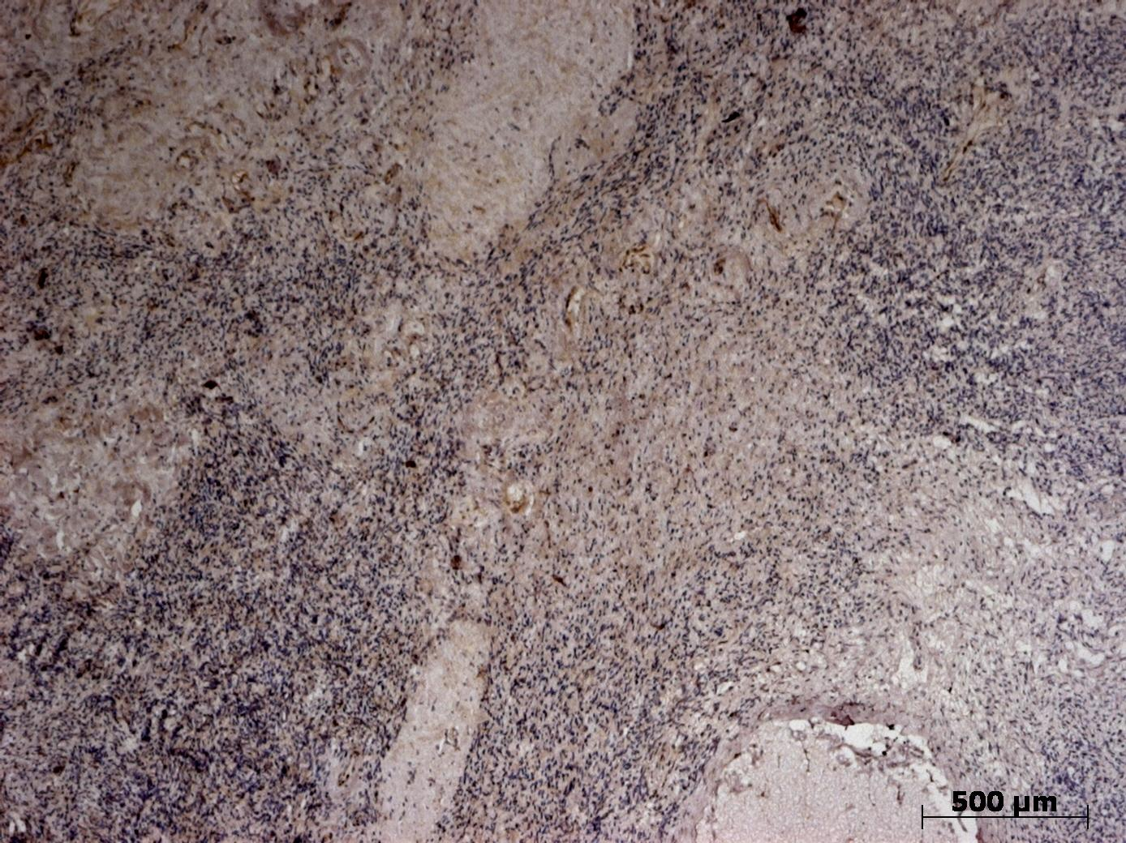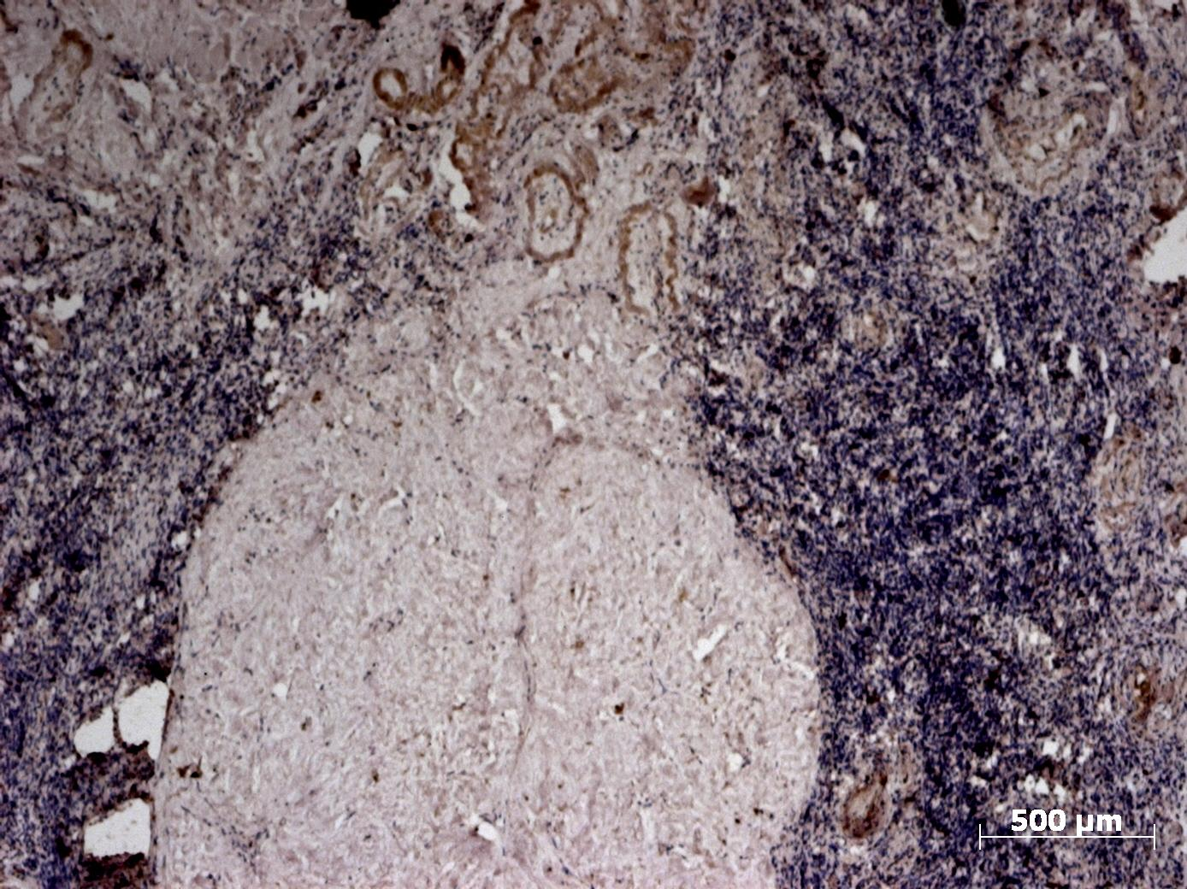
Figure 2: Buffed formalin with vimentin is on the left, Form-Acetic with vimentin is on the right. The pigmentation of the DAB is darker on the Form-Acetic image.

Experience Gained
This project has given me so much experience in the lab and out of it. Improving upon my microtome skills, allowing me to practice various stains and immunohistochemistry, and just getting more comfortable working by myself in a lab setting. I gained confidence in what I was doing and my ability to do relevant research in order to create an action plan for my project. I learned that research doesn’t always go the way you want it to, and you will never really find an answer to the question, just add information to the pool of what we know about human anatomy. It was hard to wrap my head around not having an answer, but this project has given me confidence in my work to be able to accept that. I also gained lots of experience with Excel and data manipulation using RStudio, as well experience working a 9-5 lab job. Overall, my experience was incredibly valuable, and it has become integral in what I will consider for my future.

Please state which Society Winter or Summer Meeting the student is intending to present his/her poster at:

Winter Meeting

Proposed Poster Submission Details (within 12 months of the completion of the project) for an AS Winter/ Summer Meeting – (no more than 300 words)
The poster will include quantitative results analysing the percentage of shrinkage within the H&E stained tissue, and qualitative results of the immunohistochemistry. There will be comparative pictures, and an analysis of real-world applications for the Form-Acetic fixative for postmenopausal ovaries. Previous literature will be referenced, and the pros and cons of the fixative will be included.

Brief Resume of your Project’s outcomes: (no more than 200-250 words).
The title of your project and a brief 200-250 word description of the proposed/completed project. The description should include sufficient detail to be of general interest to a broad readership including scientists and non-specialists. Please also try to include 1-2 graphical images (minimum 75dpi). NB: Authors should NOT include sensitive material or data that they do not want disclosed at this time.

Title: Comparison of Fixation Techniques for Immunohistochemistry and Basic staining of Human Post-Menopausal Ovarian Tissue.

Due to ovarian tissues’ unique structure and high levels of hyaluronic acid, finding a fixative that properly preserves the tissue and allows for histological analysis is important. This project focused on comparing commonly used fixative, neutral buffered formalin (NBF), to Form-Acetic fixative (neutral buffered formalin with 5% acetic acid) when fixing ovarian tissue for histological analysis including basic staining and immunohistochemistry. Form-acetic was developed by Adeniran et al and has been tested on biopsied human ovarian tissue. Our goal was to test how effective Form-Acetic is in fixing post-menopausal cadaveric tissue from fresh frozen cadavers for histological analysis. Through basic H&E staining, the percentage of shrinkage within the tissue was analysed with statistical analysis ongoing. A qualitative approach was taken to analyse the impact of the fixatives on the expression of markers vimentin and FOXL2. Differences in DAB staining following IHC were evaluated to compare the fixatives. Form-Acetic was determined to have clearer staining compared to the NBF, suggesting better preservation of antigenicity with Form-Acetic fixative (Figure 1).
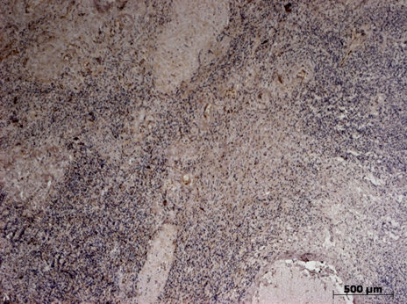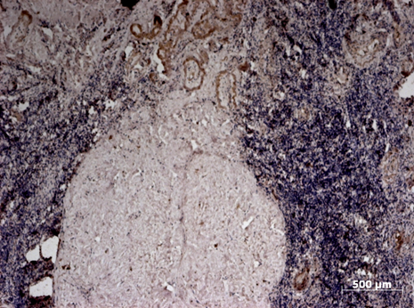
Figure 1: Buffed formalin with vimentin is on the left, Form-Acetic with vimentin is on the right. The pigmentation of the DAB is darker on the Form-Acetic image.

Other comments: (no more than 300 words)
Thank you David Russell for providing guidance on histology and to the donors.

Data Protection/GDPR: I consent to the data included in this submission being collected, processed and stored by the Anatomical Society. Answer YES or NO in the Box below
YES
Graphical Images: If you include graphical images you must obtain consent from people appearing in any photos and confirm that you have consent. A consent statement from you must accompany each report if relevant. A short narrative should accompany the image. Answer N/A not applicable, YES or NO in the box below
YES
Copyright: If you submit images you must either own the copyright to the image or have gained the explicit permission of the copyright holder for the image to be submitted as part of the report for upload to the Society’s website, Newsletter, social media and so forth. A copyright statement must accompany each report if relevant. Answer N/A not applicable, YES or NO in the box below
N/A

Signature of student Katie Kurth Date…17/9/2025

Signature of supervisor Caroline Allen Date..17/9/2025

END OF FORM
----------------------------------------------------------------------------------------------------------------------------------------
File: USVRS Award Letter 2025 TEMPLATE v2 APP CB 160525_Dr Caroline Allen

File: USVRS 202425 Allen and Kurth Final Summary Report Website

