Development of anatomically mimetic biomaterial scaffolds as model systems to interrogate aging effects in the adult human central nervous system
Student: Ashla Copeland¹
Supervisors: Prof Fergal O’Brien^{1,2,}, Dr Adrian Dervan^{1,2},
¹ Tissue Engineering Research Group, Department of Anatomy & Regenerative Medicine, Royal College of Surgeons in Ireland (RCSI), 123 St. Stephen’s Green, Dublin 2.
² Advanced Materials and Bioengineering Research Centre (AMBER), RCSI and TCD, Dublin, Ireland
As the human central nervous system (CNS) ages, its ability to recover after injury declines significantly. At the same time, the likelihood of injury increases. Head injuries for example are five times more common in people over 65 years of age. The global economic burden is also substantial and affected individuals often face long-term disability and reduced quality of life.
Despite this growing need, effective treatments that restore lost neural function remain unavailable. Biomaterial-based neuron replacement therapies are an emerging and promising area of regenerative medicine, but the interaction of transplanted cells with the aged CNS is still poorly understood. A key limitation is that most preclinical studies use young adult animal models, which do not reflect the major structural, molecular, and immune changes that occur with ageing.
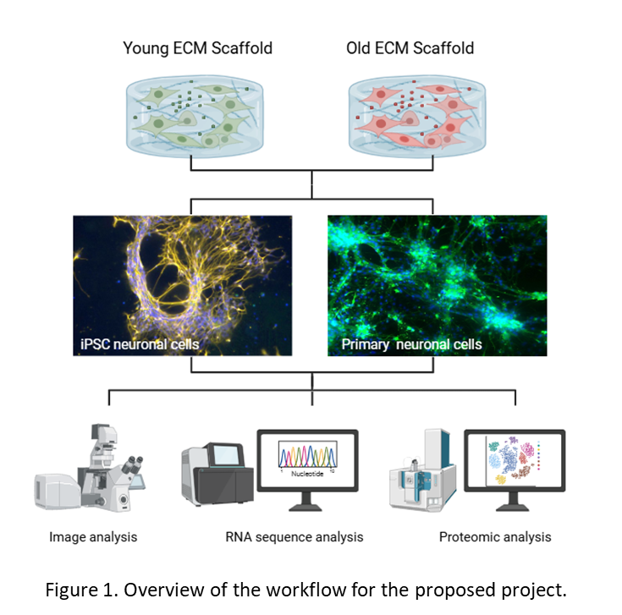
This project aims to develop anatomically relevant in vitro models that capture the unique extracellular matrix signatures of the young and aged human CNS (Fig. 1). It will investigate at the gene and protein level how age-related changes in the composition of CNS extracellular matrix, a key regulator of neuronal plasticity and repair influences neuronal growth, including therapeutic induced pluripotent stem cell (iPSC) neurons. To do so, ECM isolated from young (25yrs) and old (>65 yrs) brain tissues, will be used to develop age-relevant biomimetic 3D in vitro scaffold platforms in which to study ECM-neuronal interactions. Through a detailed comparative investigation, using proteomics and RNA sequencing, the changes in key growth-associated pathways will be identified.
Collectively, this project has the potential to significantly advance the study of CNS ageing by developing a simple, high-throughput model system, with broader applicability to investigate ECM–cell interactions across a range of CNS diseases.

