UNDERGRADUATE SUMMER VACATION SCHOLARSHIP AWARDS – FINAL SUMMARY REPORT FORM 2021/22
NB: This whole report will be posted on the Society’s website therefore authors should NOT include sensitive material or data that they do not want disclosed at this time.

Name of student:
Alexandra Lesayova
Name of supervisor(s):
Dr Thomas Theil
Project Title: (no more than 220 characters)
Primary cilia in human cortical development
Project aims: (no more than 700 words)
Primary cilia are cell surface-associated organellar protrusions that act as cellular antennas implicated in most cell-cell signalling pathways. Their imperial role is highlighted by ciliopathies, a group of syndromes arising by aberrant function and/or structure of primary cilia. Importantly, many ciliopathy patients show neurological symptoms, including cognitive deficiencies and autism spectrum disorder. Since these coincide with cerebral cortex malformations, we aimed to investigate roles of primary cilia in human cortical development. A crucial gap in our understanding how cilia affect human corticogenesis is a lack of knowledge which neural cell types carry cilia. Human developing cortex is subdivided into layers named ventricular zone (VZ), subventricular zone (SVZ), and cortical plate (CP). The VZ and SVZ comprise several neural stem cell types (ventricular and outer radial glial cells (vRGs, oRGs), basal intermediate progenitors (bIPs)), while the CP contains glutamatergic projection neurons and GABAergic interneurons (Fig. 1). Cilia are present on vRGs (Schembs et al., 2022), but the other cell types remain to be investigated. Filling this knowledge gap is crucial for revealing ciliary roles and understanding how ciliary defects underlie neurodevelopmental disorders.
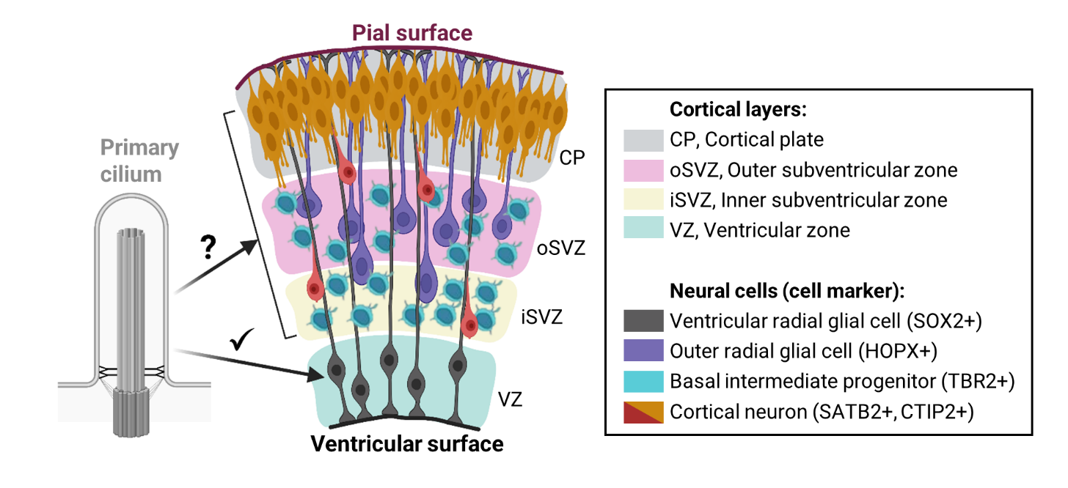
Figure 1: Cell types comprising human foetal cerebral cortex. Proliferative cell populations in the VZ and SVZ produce neurons that migrate basally and mature in the CP. Primary cilia had previously been detected on ventricular radial glial cells, however, presence of cilia on other cortical cell types remained to be characterized.
To characterize primary cilia in human developing cortex, this project focused on two specific approaches:
1. Immunofluorescence staining of tissue sections of human foetal cortex
Primary cilia comprise of a basal body, from which 9 microtubule doublets project and form an axoneme. A transition zone located at the base controls protein entry into and exit out of the cilia, while the intraflagellar transport (IFT) machinery assists in moving proteins within cilia. Immunofluorescence staining against ARL13B and γTUB was aimed to detect axoneme and basal body, respectively. Additionally, neural cell types can be identified by cell type-specific markers, including SOX2 (vRGs and oRGs), HOPX (oRGs), TBR2 (bIPs), SATB2 (layer II-IV neurons), and CTIP2 (layer V neurons). We performed double immunostainings for cilia and cell-type specific markers on sections of postconceptional week 8 (PCW8) and PCW13 human cortices provided by the Human Developmental Biology Resource. A subsequent analysis by confocal microscopy revealed double-positive cells, i.e., specific neural subtypes positive for crucial ciliary components. As such, this identified the cell types carrying cilia.
2. Single-cell sequencing dataset analyses of human foetal cortex
Immunostaining was accompanied by bioinformatic analyses. A single-cell RNA-sequencing (scRNA-seq) dataset on human foetal cortex had been collected by Fan et al. (2020), that we analysed using Seurat, an R package designed to explore scRNA-seq data. Due to the unbiased and high-throughput nature of single-cell profiling, multiple markers were interrogated simultaneously, allowing for a more detailed identification of cilia on specific cell types. The Fan et al. data were particularly useful for the purpose of this project: firstly, transcriptomics had been carried out on human tissue, well-reflecting the in vivo development. Secondly, unsupervised clustering analysis had identified 28 clusters of multiple neural and non-neural cortical cell types, which allowed for wider comparisons and understanding of cell-cell interactions. Lastly, data included embryos ranging from gestational week 9 (GW9) to GW28, facilitating a time-course analysis of ciliary gene expression.
Taken together, the combination of molecular and computational analyses aimed to provide a multi-layer interrogation of human developing cortex for ciliary gene and protein expression. This combined approach would provide insights into the presence and potential roles of primary cilia in normal and pathological corticogenesis.

Project Outcomes and Experience Gained by the Student (no more than 700 words)
Immunostaining of human developing cortex
As a first step to describe the presence of primary cilia in the developing cortex, we immunostained forebrain sections of PCW8 and PCW13 human embryos. Antibodies against ARL13B and γTUB visualized ciliary axoneme and basal body, respectively, while cell type-specific markers identified cortical cell types. At PCW8, SOX2/ARL13B double-positive cells were found in the VZ (Fig 2.A, B), which confirmed that vRGs carry cilia in early developing cortex. Additionally, ARL13B+ cells were detected on SOX2- cells in the SVZ (Fig. 2C) and CP (Fig. 2D). To reveal which SOX2- cells carry cilia, we further explored cortical layers on PCW13 sections. Consistent with PCW8, the ARL13B/γTUB staining revealed abundant cilia along the ventricular surface (Fig. 2E), while the SOX2/ARL13B staining confirmed their presence on vRGs (Fig. 2F, G). Staining against HOPX indicated the presence of cilia on some HOPX+ oRGs, however, we also detected ciliated HOPX- cells (Fig. 2H, I). These could be TBR2+ bIPs, since double-positive cells were found in the TBR2/ARL13B staining (Fig. 2J, K). In the CP, layer II-IV (SATB2+) and V (CTIP2+) neurons were detected, but due to high background staining it remained unclear whether neurons carry cilia (Fig. 2L-O). Overall, immunostainings against cell type- and cilia-specific markers confirmed the presence of cilia on vRGs, and implied cilia on oRGs and bIPs.
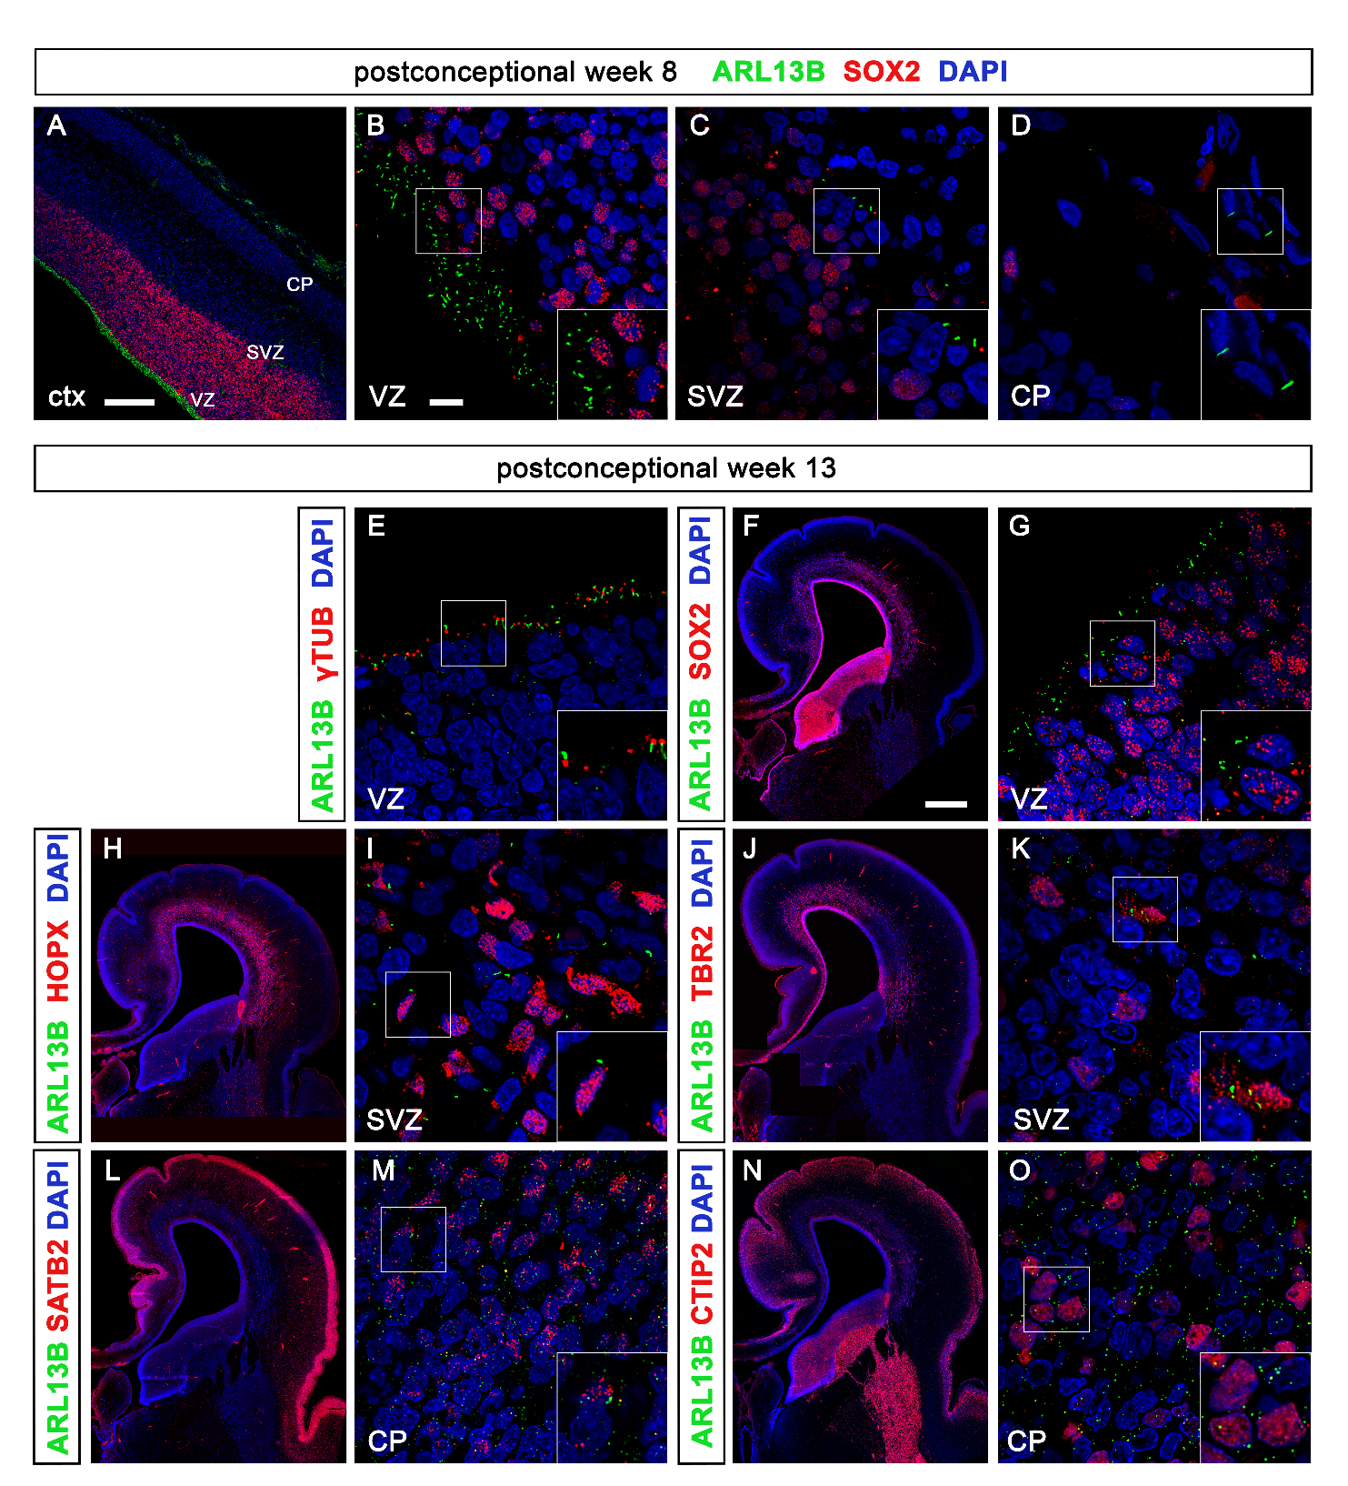
Figure 2: Human PCW8 and PCW13 cortical sections immunostained with the indicated markers. (A-D) SOX2/ARL13B expression from ventricular to pial surface; cilia detected on SOX2+ cells in the VZ and on SOX2- cells in the SVZ and the CP. (E) ARL13B and γTUB co-localized on cilia protruding into the VZ. (F, G) ARL13B+ cilia identified on SOX2+ vRGs. (H, I) ARL13B+ cilia detected on HOPX+ oRGs as well as on HOPX- cells in the SVZ. (J, K) In the SVZ, ARL13B+ cilia are also detected on TBR2+ bIPs. (L-O) Successful detection of layer II-IV (SATB2+) and V (CTIP2+) neurons; ARL13B staining showed high background staining which hindered conclusions on the presence of cilia. ctx, cortex; VZ, ventricular zone; SVZ, subventricular zone; CP, cortical plate. SOX2, HOPX, TBR2, SATB2, CTIP2 stainings shown as overview (left) and high-resolution (right) images. Scale bars, 200 μm (A), 10 μm (B), and 2 mm (F).

ScRNA-seq dataset
Cell types
To predict the presence of cilia on cortical cell types, we used a scRNA-seq dataset, in which several cell clusters had already been identified (Fan et al., 2020) (Fig. 3A). We investigated 23 cortical clusters, including neural progenitors (vRG, oRG, NPC_3, bIP), excitatory neurons (DLN, ULN, MN), Cajal-Retzius cells (CR), interneurons (IN_1/2), astrocytes (Astro_1), oligodendrocytes (Oligo_1/2/3/4), immune cells (MG_1/3/4, T cell, MP_2), endothelial and blood cells (SMC, VEC, Blood). We analysed the expression of ciliary genes characteristic for axoneme, basal body, transition zone and intraflagellar transport (reviewed in Goetz & Anderson, 2010). While not all markers are cilia-specific, we considered that the combined expression of several markers accurately predicted the presence of cilia.
Gene expression was visualized by a dotplot; the dot size encodes the percentage of marker-expressing cells (pct.exp), and the colour indicates the average expression level (avg.exp) (Fig. 3B). Avg.exp, normalized to the avg.exp of several housekeeping genes, and pct.exp values were extracted for principal component analyses, yielding clusters of similar cilia expression characteristics (Fig. 3C). It is known that unlike mature oligodendrocytes, oligodendrocyte progenitors carry cilia. Therefore, vRGs, oRGs, and bIPs that clustered with oligodendrocyte progenitors (Oligo_1/2/3 here) likely carry cilia, consistent with the immunostaining results. Interestingly, NPC_3 was an outlier with high avg.exp and pct.exp. Fan et al. described NPC_3 as a transient state between progenitors and differentiated deep-layer neurons. Hence, further investigation of NPC_3 cilia might better characterize the cell type and its role in corticogenesis-associated signalling.
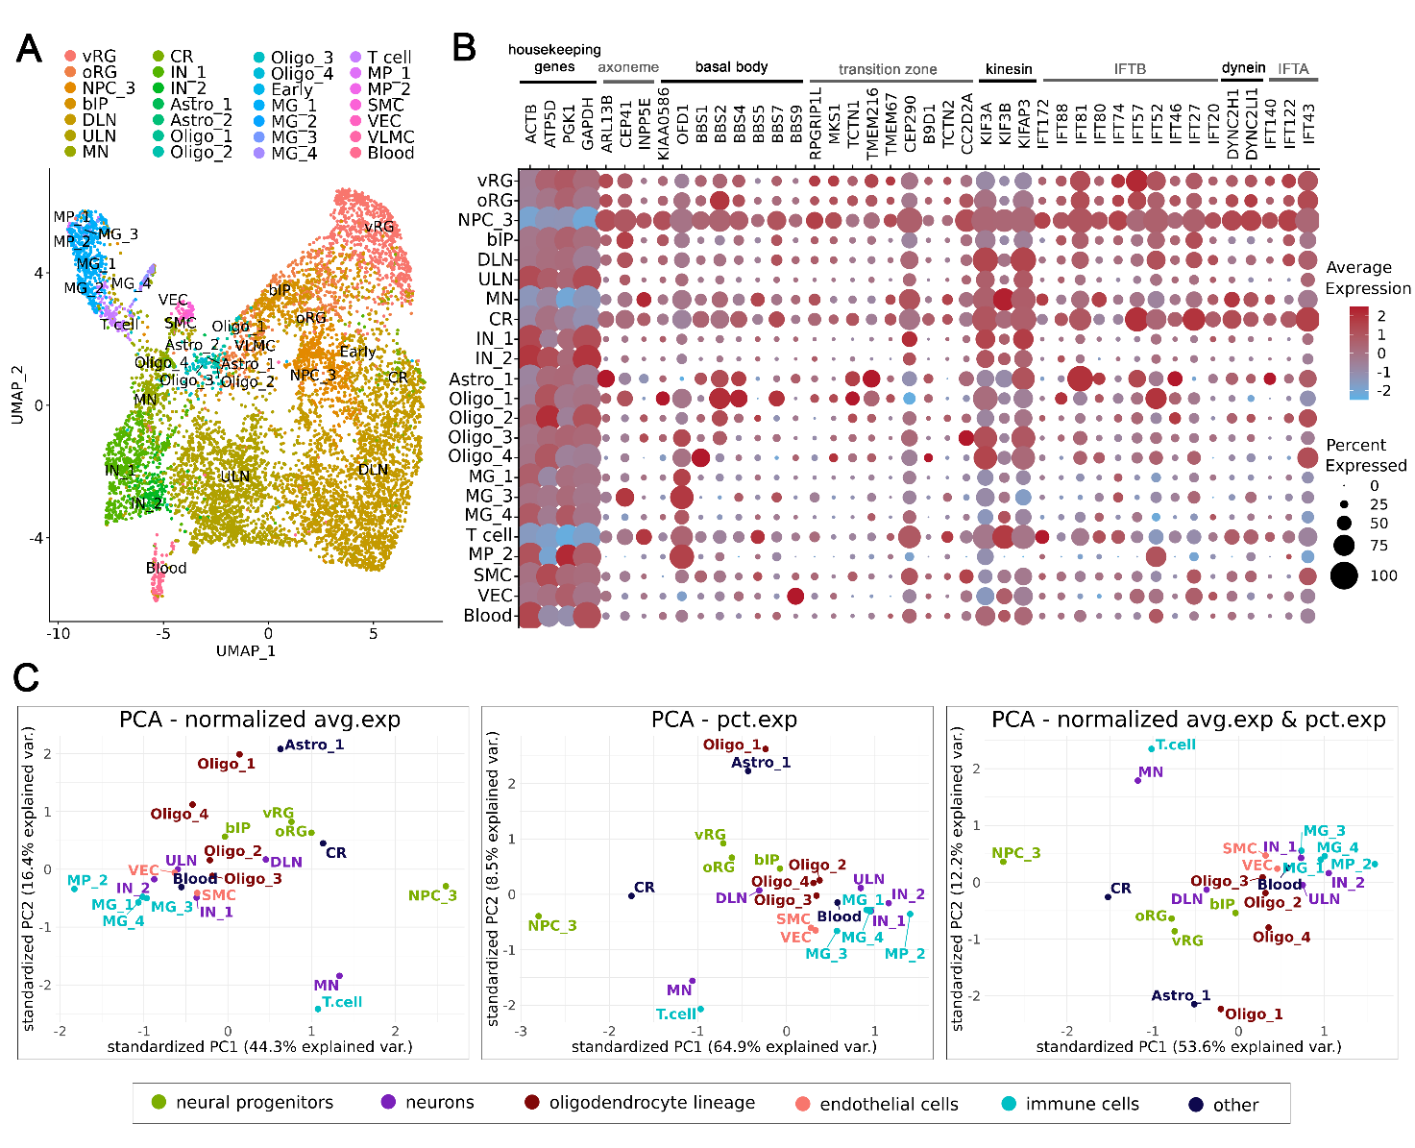
Figure 3: Bioinformatic analyses of cilia on cell types in the human foetal cortex. (A) UMAP plot of the 28 cortical cell types identified by Fan et al. (2020). DLN/ULN/MN, deep-layer/upper-layer/mature neurons; CR, Cajal-Retzius cells; IN, interneurons; Astro, astrocytes; Oligo, oligodendrocytes; MG, microglia; MP, microphages; SMC, smooth muscle cells; VEC, vascular endothelial cells; VLMC, vascular leptomeningeal cells. (B) Dotplot showing the average and percentage expression of housekeeping genes and ciliary markers across cortical cell types. (C) Principal component analyses (PCA) yielded clusters of cell types with similar ciliary expression. Each cell type was characterized by its average ciliary gene expression normalized by housekeeping gene expression (left) or percentage of marker-expressing cells (middle) or both (right).
Time-course analyses
Dataset was also interrogated for ciliary expression across developmental time in neural progenitors (Fig. 4A) and excitatory neurons (Fig. 4B). Expression of the housekeeping gene GAPDH indicated the presence of cell types, while ARL13B, RPGRIP1L, and KIAA0586 reported axoneme, transition zone, and centrosome, respectively. In progenitors, ciliary genes were co-expressed with GAPDH. In mature neurons, however, ciliary genes were expressed with a delay, weeks later than the cell type formed. Consistently high ciliary gene expression was seen in early born deep-layer but not late born upper-layer neurons, suggesting cilia in upper-layer neurons develop later than GW26 or remain absent. Major limitations include low cell numbers per week and limited sequencing depths. Therefore, investigation of datasets with higher cell numbers and greater sequencing depths could prove insighful in the future.
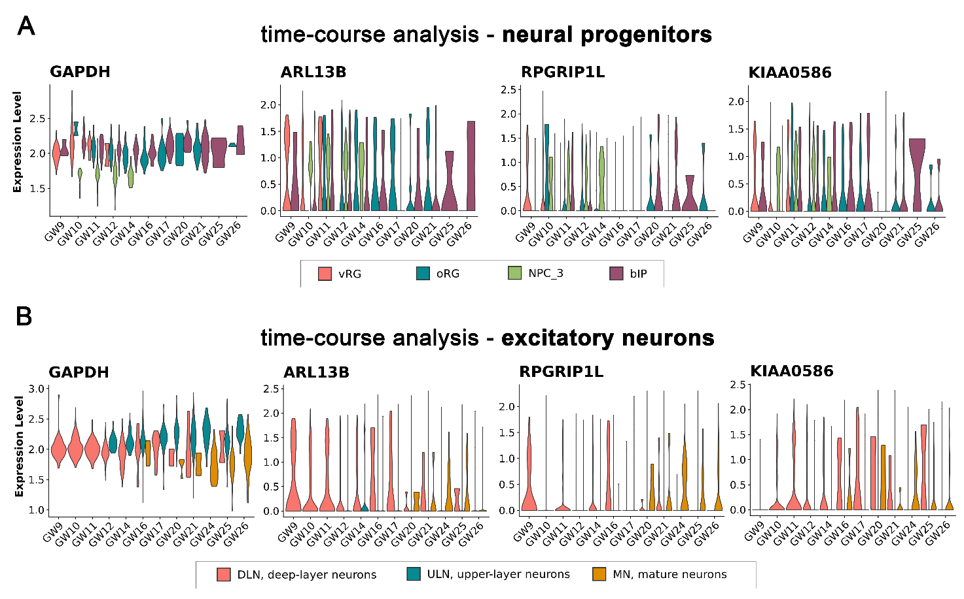
Figure 4: Time-course analyses of cilia expression in human foetal brain. Violin plots showing expression of ARL13B (axoneme marker), RPGRIP1L (transition zone marker), and KIAA0586 (centrosome marker) across gestational weeks. The housekeeping gene GAPDH provides a control reporting the presence of a given cell type. Time-course analyses were carried for (A) neural progenitors and (B) excitatory neurons.
Experience
Through this project, I gained experience in immunostaining, including protocol optimization, appropriate antibody choices, and microscopic visualization. Additionally, my awareness of ethical issues associated with human foetal tissue work has been improved. I have been introduced to Seurat R package for single-cell transcriptomics where I have learned to sort data and generate analyses for qualitative and quantitative insights. Further, my independent working supported by frequent and lively discussions with lab members increased my knowledge, confidence, and interest in neurodevelopmental research. I believe the skills and insights acquired during the project will hugely benefit my Honours project and following postgraduate studies.
Please state which Society Winter or Summer Meeting the student is intending to present his/her poster at:
Summer Meeting 2023

Proposed Poster Submission Details (within 12 months of the completion of the project) for an AS Winter/ Summer Meeting – (no more than 300 words)
Primary cilia in human cortical development
Primary cilia are cell surface-associated protrusions implicated in most cell-cell signalling pathways. Their importance is highlighted by ciliopathies, where patients with aberrant ciliary function and/or structure might display cognitive deficiencies and autism spectrum disorder. Since these symptoms coincide with cerebral cortex malformations, elucidating ciliary roles in corticogenesis is of great interest. Importantly, except for ventricular radial glial cells (vRGs), the presence of cilia remained unexplored among other neural stem cell types (outer radial glial cells (oRGs), basal intermediate progenitors (bIPs)) and neurons in the developing human cortex. This project explored primary cilia expression across different cortical cell types.
First, we performed immunostaining and subsequent confocal microscopy on human foetal cortices using ARL13B and γTUB to visualize cilia, while cell type-specific markers identified vRGs, oRGs, bIPs, and neurons. These stainings confirmed the presence of cilia on vRGs. ARL13B expression was also detected in the subventricular zone implying cilia on oRGs and bIPs. Due to high background staining, it remained unclear whether cortical neurons carry cilia.
Immunostainings were accompanied by investigating a single-cell RNA-sequencing dataset. In total 23 cell types were interrogated for ciliary gene expression. Percentages of gene-expressing cells within cell types and average expression levels were extracted for principal component analyses, which clustered cell types with similar characteristics. While cilia expression was similar among vRGs, oRGs, and bIPs, it was notably higher in neural progenitors named NPC_3. Additionally, high levels of ciliary gene expression were already present in progenitors from the start but delayed in mature neurons. Furthermore, deep-layer but not upper-layer neurons showed high ciliary gene expression.
This multi-layer analysis of the human developing cortex suggests that other neural progenitors besides vRGs carry primary cilia. Further exploration of cortical neurons and datasets with higher cell numbers and greater sequencing depths will provide further insights.

Brief Resume of your Project’s outcomes: (no more than 200-250 words).
The title of your project and a brief 200-250 word description of the proposed/completed project. The description should include sufficient detail to be of general interest to a broad readership including scientists and non-specialists. Please also try to include 1-2 graphical images (minimum 75dpi). NB: Authors should NOT include sensitive material or data that they do not want disclosed at this time.

Primary cilia in human cortical development
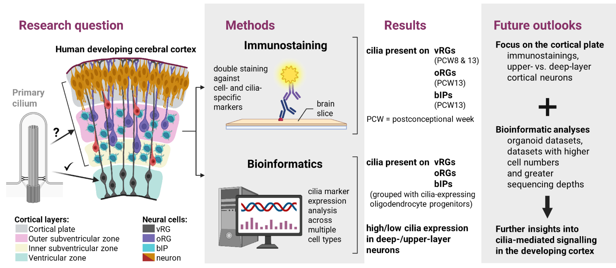
The cerebral cortex provides humans with unique cognition, while cortical malformations underlie several neurological disorders. During development, the cortex is layered into ventricular zone (VZ), subventricular zone (SVZ), and cortical plate (CP). The VZ and SVZ contain ventricular and outer radial glial cells (vRGs, oRGs) and basal intermediate progenitors (bIPs), while the CP comprises neurons. Except for vRGs, it remained unknown which cell types carry primary cilia – cellular protrusions that are critical for cortical development by acting as antennas in signalling between cortical cells. Therefore, we investigated the presence of cilia on cortical cell types. This could shed light on how cell-cell communication facilitates normal cortex formation.
Immunostainings on sections of developing human cortex confirmed the presence of cilia on vRGs. Further-more, cilia were found on a subset of oRGs and bIPs in the SVZ. Due to technical problems, we were unsuccessful to analyse cilia on cortical neurons.
We also used a bioinformatics approach to investigate the presence of cilia in neural and non-neural cortical cell types. This analysis predicted that all neural stem cells, including vRGs, oRGs, and bIPs, carry cilia on their surface, in line with our immunostainings. Additionally, time-course analyses revealed a notably higher ciliary gene activity in neurons that are formed early in development compared to later generated neurons.
Taken together, these results suggest that neural progenitors besides vRGs carry cilia. Moreover, the differences in cilia expression between cortical neurons might add a new level of complexity to signalling in human cortex formation.

Other comments: (no more than 300 words)
Acknowledgements
I would like to thank my supervisor Dr Theil and all members of the Theil lab. Their advice guided me through the project and provided me with significant gains in scientific knowledge and research confidence. The experience was thoroughly enjoyable also because of the Anatomical Society, as the studentship and opportunity for report/poster submission allowed for my full commitment to the project.
References
Fan, X., Fu, Y., Zhou, X., Sun, L., Yang, M., Wang, M., Chen, R. et al. (2020) ‘Single-cell transcriptome analysis reveals cell lineage specification in temporal-spatial patterns in human cortical development’, Sci Adv, 6(34):eaaz2978. doi: 10.1126/sciadv.aaz2978.
Goetz, S.C. & Anderson, K.V. (2010) ‘The primary cilium: a signalling centre during vertebrate development’, Nat Rev Genet, 11(5), pp. 331–344. doi: 10.1038/nrg2774.
Schembs, L., Willems, A., Hasenpusch-Theil, K., Cooper, J.D., Whiting, K., Burr, K., Bøstrand, S.M.K. et al. (2022) ‘The ciliary gene INPP5E confers dorsal telencephalic identity to human cortical organoids by negatively regulating Sonic hedgehog signaling’, Cell Rep, 39(7):110811.
doi: 10.1016/j.celrep.2022.110811.

Data Protection/GDPR: I consent to the data included in this submission being collected, processed and stored by the Anatomical Society. Answer YES or NO in the Box below
YES
Graphical Images: If you include graphical images you must obtain consent from people appearing in any photos and confirm that you have consent. A consent statement from you must accompany each report if relevant. A short narrative should accompany the image. Answer N/A not applicable, YES or NO in the box below
N/A
Copyright: If you submit images you must either own the copyright to the image or have gained the explicit permission of the copyright holder for the image to be submitted as part of the report for upload to the Society’s website, Newsletter, social media and so forth. A copyright statement must accompany each report if relevant. Answer N/A not applicable, YES or NO in the box below
N/A

Signature of student.......ALEXANDRA LESAYOVA..............Date: 18/08/22

Signature of supervisor......THOMAS THEIL...............Date…18/08/2022

END OF FORM
----------------------------------------------------------------------------------------------------------------------------------------

File: USVRS 202122 Project Report Theil and Lesayova – website no sig

