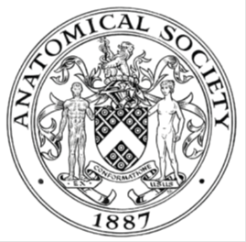
_______________________________________________________________________________________
AWARDEE REPORT FORM
_______________________________________________________________________________________

NAME |  | Dr Zubeyde Bayram-Weston
TWITTER HANDLE* optional |  | @ZBW23
UNIVERSITY |  | Swansea University
NAME OF AWARD |  | Departmental Seminar Award 2025/26 Round 1
PURPOSE OF AWARD conference/event attended/organised (full name) with city and dates.
Dr Andrew O’Malley from University of St Andrews was invited to deliver a departmental seminar within the Faculty of Medicine, Health and Life Science at Swansea University. The seminar, held on 30 April 2026 at the Singleton Campus, Seminar Room, ILS1 Building, Swansea, focused on “Best Practices in Medical Education with a Focus on Generative AI in Anatomy and Health Professions Education.”
This in-person event provided staff and students with the opportunity to engage with current developments and innovative approaches in medical education, particularly the integration of generative AI technologies within anatomy and health professions teaching.

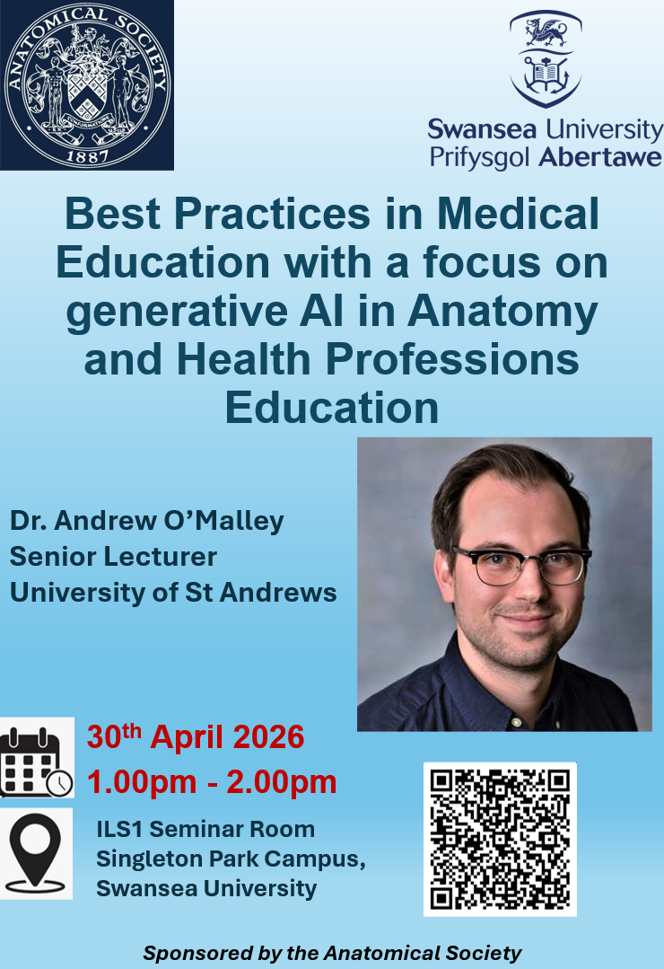

REPORT: What were your anticipated benefits?
Minimum number of words between 200-400. Please write in coherent paragraphs.
Dr Andrew O’Malley is a distinguished scholar in the field of medical education, particularly recognised for his innovative work exploring the use of generative AI in anatomy and health professions education. I first became acquainted with Dr O’Malley during my previous role at University of Southampton, and our professional paths have continued to intersect through shared interests in anatomy teaching and medical education research. This longstanding academic connection provided me with valuable insight into both the quality of his research and his ability to communicate complex educational concepts effectively to a broad audience.

In inviting Dr O’Malley to deliver a seminar within the Faculty of Medicine, Health and Life Science at
Swansea University, I anticipated that the event would provide an intellectually stimulating and highly relevant discussion aligned with current developments in higher education and healthcare training. The seminar was expected to appeal to a diverse academic audience, including principal investigators, postgraduate researchers, undergraduate students, clinicians, and faculty members from disciplines such as medicine, nursing, paramedicine, osteopathy, and healthcare science. Given the rapidly growing interest in the use of generative AI technologies within teaching, assessment, and clinical education, I anticipated strong engagement and meaningful interdisciplinary discussion.

The event also provided an important opportunity for Swansea University staff and students to engage directly with a leading researcher working at the forefront of AI-enhanced medical education. Beyond the educational value of the seminar itself, I expected the visit to encourage future collaboration, stimulate new research ideas, and strengthen professional networks within the field of anatomy and health professions education.

I am pleased to report that the seminar not only fulfilled these expectations but exceeded them. The presentation generated enthusiastic discussion, significant audience engagement, and valuable exchange of ideas regarding the future role of generative AI in anatomy teaching and broader healthcare education.

COMMENTS: Describe your experience at the conference / lab visit / course / seminar/ event.
Minimum number of words between 200-400. Please write in coherent paragraphs.
Dr Andrew O’Malley delivered an outstanding and highly engaging seminar that resonated strongly with the diverse audience described previously, attracting over 25 attendees in person from across the Faculty of Medicine, Health and Life Science at Swansea University.

His presentation was exceptionally well received, combining current evidence, practical applications, and critical reflection on the evolving role of generative AI within anatomy and health professions education. The seminar successfully addressed the interests of a broad multidisciplinary audience, including academic staff, clinicians, researchers, postgraduate students, and undergraduate students from a range of healthcare-related disciplines.

One of the most valuable aspects of the event was the lively and thought-provoking discussion that during and followed the presentation. Attendees engaged enthusiastically with the themes raised during the seminar, asking insightful questions and sharing perspectives from their own teaching, clinical, and research experiences. Dr O’Malley encouraged open dialogue throughout the session, creating an inclusive and intellectually stimulating environment that facilitated meaningful exchange of ideas. In addition to the formal discussion, attendees had further opportunities to interact informally with Dr O’Malley following the seminar, which greatly enhanced networking and collaborative engagement. Dr O’Malley also kindly agreed to share his presentation materials with attendees, allowing participants to further reflect on and apply the ideas discussed during the session.

The visit additionally provided Dr O’Malley with the opportunity to become more familiar with our research environment and facilities in Swansea. During his time at the university, he engaged in productive scientific discussions with colleagues regarding shared research interests and potential opportunities for future collaboration in the areas of anatomy education, medical pedagogy, and the use of AI technologies in healthcare education. Overall, the seminar was an extremely positive and enriching experience for all involved and represented a valuable contribution to our faculty’s academic and research community.

REPORT: In relation to skills, what were the most important things you gained? (does not apply to equipment grant. For public engagement/outreach awards what did your audience gain and how did you evaluate success?
Minimum number of words between 200-400. Please write in coherent paragraphs.
Personally, one of the most valuable outcomes of this seminar was the opportunity to significantly expand my understanding of the use of generative AI within anatomy and medical education, an area in which I previously had limited practical knowledge. Dr Andrew O’Malley’s presentation provided important insights into both the pedagogical potential and the challenges associated with integrating AI technologies into teaching and learning within the health professions. The seminar encouraged me to further explore innovative approaches to anatomy education and to consider how AI-driven tools may enhance student engagement, accessibility, and personalised learning experiences within my own teaching practice.
The event also delivered substantial benefits to the wider audience. Staff and students from a range of disciplines within the Faculty of Medicine, Health and Life Science at Swansea University had the valuable opportunity to learn directly from an internationally recognised expert working at the forefront of AI-enhanced medical education research. Attendees gained a broader understanding of current developments in generative AI, including practical applications within anatomy teaching, assessment, curriculum development, and healthcare education more broadly. The seminar stimulated critical discussion regarding both the opportunities and ethical considerations surrounding the use of AI in higher education and clinical training.
The success of the seminar was evident through the high level of engagement demonstrated throughout the event. Attendees actively participated in discussions and asked numerous thoughtful questions following the presentation. In addition, I received highly positive unsolicited verbal feedback from both staff and students, many of whom commented on the relevance, quality, and timeliness of the topic. Several attendees also requested copies of Dr O’Malley’s presentation materials for further learning and reflection, highlighting the strong interest generated by the seminar.
Importantly, the visit also created opportunities for future interdisciplinary collaboration and networking in the areas of anatomy education, medical pedagogy, and AI-supported learning technologies. Overall, the seminar represented a highly successful and impactful academic event for both personal professional development and the wider university community.

REPORT: How do you think you will put this learning experience into practice in the future? For public engagement/outreach awards how with the materials/knowledge generated by this activity be used in the future?
Minimum number of words between 200-400. Please write in coherent paragraphs.
This seminar has provided valuable insights that I intend to incorporate into both my teaching practice and future educational research activities. In particular, the discussions surrounding the use of generative AI in anatomy and health professions education have encouraged me to explore innovative approaches to curriculum design, student engagement, and assessment within my own modules. I aim to further investigate how AI-supported tools may be integrated responsibly and effectively into anatomy teaching to enhance learning experiences while maintaining academic integrity and critical thinking.
The visit also highlighted the importance of interdisciplinary collaboration in addressing the rapidly evolving challenges and opportunities associated with AI in higher education. Through the seminar discussions and subsequent conversations with Dr Andrew O’Malley, several shared research interests were identified, particularly in relation to anatomy pedagogy, educational innovation, and the ethical implementation of AI technologies in healthcare education. I believe this visit represents an important first step towards establishing a productive and long-term scientific collaboration between colleagues at Swansea University and University of St Andrews.

In the future, I hope to build upon the connections established during this visit through collaborative discussions, joint educational initiatives, and potentially shared research projects focused on medical and anatomy education. The seminar has also inspired further reflection on how emerging technologies can support inclusive and student-centred learning practices across a range of healthcare disciplines. In addition, the presentation materials and ideas shared during the event will continue to serve as valuable resources for staff and students who attended the seminar.
Overall, this experience has strengthened my interest in advancing educational scholarship within anatomy and medical education and has provided a strong foundation for future collaboration, innovation, and professional development in this rapidly developing field.

Data Protection/GDPR: I consent to the data included in this submission being collected, processed and stored by the Anatomical Society. Answer YES or NO in the Box below
Yes
Graphical Images: If you include graphical images you must obtain consent from people appearing in any photos and confirm that you have consent. A consent statement from you must accompany each report if relevant. A short narrative should accompany the image. Answer N/A not applicable, YES or NO in the box below
YES

I can confirm that I have obtained consent from. Dr O’Malley’s for photographs via email.
This image below is used in the LinkedIn feed after the seminar.

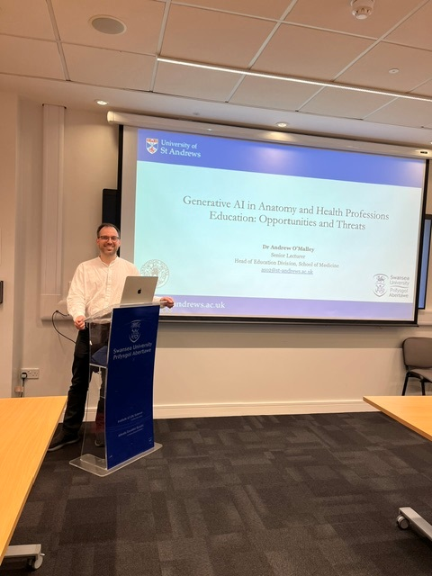

Copyright: If you submit images you must either own the copyright to the image or have gained the explicit permission of the copyright holder for the image to be submitted as part of the report for upload to the Society’s website, Newsletter, social media and so forth. A copyright statement must accompany each report if relevant. Answer N/A not applicable, YES or NO in the box below
YES

SIGNATURE | Zubeyde Bayram-Weston |  | DATE | 07/05/2026
If submitted electronically, a type-written name is acceptable in place of a hand-written signature
File: AS-Award-Report-Form-171023 – International Conference

