
------------------------------------------------------------------------------------------------
ANATOMY RESEARCH DEVELOPMENT AWARD
------------------------------------------------------------------------------------------------------
Final Project Summary Form 2023/24
(1st October 2023 - 30th September 2024) - at the end of the project for publicity

Final Project Summary for the Society’s Website and other publicity channels:
The title of your project and a 400-to-500-word description of the project. The description should include sufficient detail to be of general interest to a broad readership including scientists and non-specialists. Please also try to include 1-2 graphical images (minimum 75dpi) of can be included on the site next to your abstract. Colourful, impressive graphics will further enhance the site.
NB: Authors should NOT include sensitive material or data that they do not want disclosed at this time.

Title: Investigation of effects of folate-depletion on human trophoblast stem cell regulation
Description:
Folate metabolism is critically important for highly proliferative cells undergoing lineage specification and differentiation. It is required for DNA and amino acid synthesis and methylation reactions including epigenetic regulation of gene expression. While it is recognised that maternal dietary folate deficiency increases risk of neural tube congenital defects, it is less well known that folate deficiency also associates with pregnancy complications including fetal growth restriction. While placenta-related complications manifest clinically in the late second trimester, they have their developmental origins in the earliest stages of development. Yet, placenta development is an understudied area of research. Recently derived human trophoblast stem cells can be cultured in vitro and recapitulate self-renewing cytotrophoblast cells and can be induce to differentiate into both syncytiotrophoblast and extravillous trophoblast cells, providing powerful tools to model placenta. Here we devised folate-depleted media and compare the identity of human trophoblast stem cells cultured in depleted conditions compared with controls. Similar to what has been previous described in the mouse, we did not observe an effect on proliferation in response to folate depletion. Assessment of key cytotrophoblast cell markers indicated some reduced expression in response to folate depletion, however this was not apparent at the protein level. Similarly, we did not observe detrimental effects on the ability of cells to undergo syncytialisation. Future work will focus on assessing the impact of folate depletion on extravillous trophoblast differentiation.
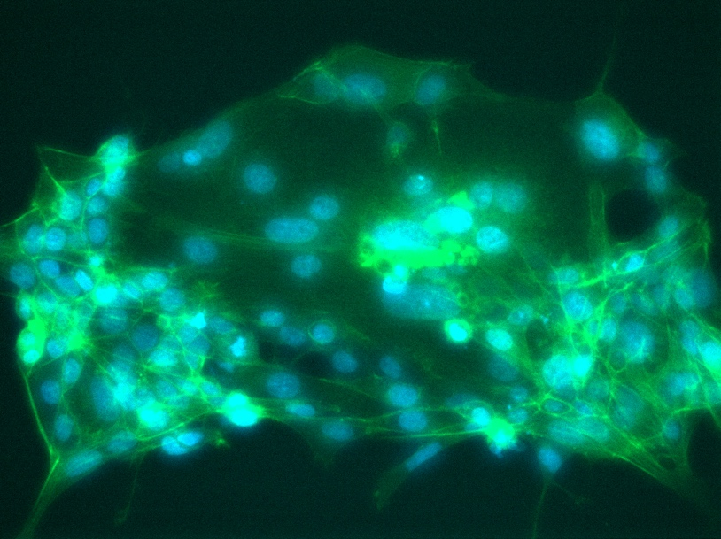
Syncytialisation of human trophoblast stem cells cultured in folate-depleted conditions.

Data Protection/GDPR: I consent to the data included in this submission being collected, processed, and stored by the Anatomical Society. Answer YES or NO in the Box below
Yes

Graphical Images: If you include graphical images you must obtain consent from people appearing in any photos and confirm that you have consent. A consent statement from you must accompany each report if relevant. A short narrative should accompany the image. Answer N/A not applicable, YES or NO in the box below
N/A
Copyright: If you submit images you must either own the copyright to the image or have gained the explicit permission of the copyright holder for the image to be submitted as part of the report for upload to the Society’s website, Newsletter, social media and so forth. A copyright statement must accompany each report if relevant. Answer N/A not applicable, YES or NO in the box below
N/A
SIGNATURE | Dr Nora Fogarty | DATE | 30th August 2025

END

